 | 9am | 11.30am
Thursday 6th Nov | Business Studies – 1 hr 30 mins  H & C – 1 hr 20 mins | English Literature – 1 hr
Friday 7th Nov | Biology – 1 hr 45 mins (T)  - 1 hr 15 mins (C) | RE (Paper 1) – 1 hr 30 mins
Monday 10th Nov | English Language – 2 hrs | Geography (Paper 1) – 1 hr
Tuesday 11th Nov | Maths (Paper 1) – 1 hr 30 mins | PE (Paper 1) – 1 hr 30 mins  * Spanish Listening - 35 mins (F)  - 45 mins (H)
Wednesday 12th Nov | Chemistry - 1 hr 45 mins (T)  - 1 hr 15 mins (C)
Thursday 13th Nov | History (Crime)– 50 mins | PE (Paper 2) – 1 hr 30 mins  Spanish writing – 1 hr 15 mins (F)  & Reading - 1 hr 20 mins (H)
Friday 14th Nov | Spanish Speaking – all day  In the ISU | Spanish Speaking – all day )  in the ISU
Monday 17th Nov | Maths (Paper 2) – 1 hr 30 mins | RE (Paper 2) – 1 hr
Tuesday 18th Nov | Physics – 1hr 45 mins (T)  1 hr 15 mins (C) | History (Cold War) – 55 mins
Wednesday 19th Nov | D & T – 2 hrs  Geography (Paper 2) – 1 hr | History (Germany) – 1 hr 30 mins
Thursday 20th Nov | IT – 1hr 30 mins
* Exam will be in Room 2 and Room 4 - TBC

PPE 1 – November 2025
Version.2
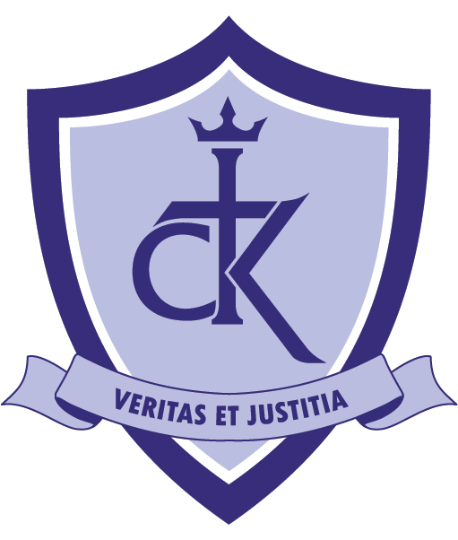

Mock Exams (1) – November 2025

