|  |  |  |
| --- | --- | --- |
|  | **9am** | **11.30am** |
| Thursday 6th Nov | **Business Studies**  – 1 hr 30 mins  **H & C** – 1 hr 20 mins | **English Literature** – 1 hr |
| Friday 7th Nov | **Biology** – 1 hr 45 mins (T)  - 1 hr 15 mins (C) | **RE** (Paper 1) – 1 hr 30 mins |
| Monday 10th Nov | **English Language** – 2 hrs | **Geography** (Paper 1) – 1 hr |
| Tuesday 11th Nov | **Maths** (Paper 1) – 1 hr 30 mins | **PE** (Paper 1) – 1 hr 30 mins  **\* Spanish Listening** - 35 mins (F)  - 45 mins (H) |
| Wednesday 12th Nov | **Chemistry** - 1 hr 45 mins (T)  - 1 hr 15 mins (C) |  |
| Thursday 13th Nov | **History** (Crime)– 50 mins | **PE** (Paper 2) – 1 hr 30 mins  **Spanish writing** – 1 hr 15 mins (F)  **& Reading** - 1 hr 20 mins (H) |
| Friday 14th Nov | **Spanish Speaking** – all day  **In the ISU** | **Spanish Speaking** – all day *)*  **in the ISU** |
| Monday 17th Nov | **Maths** (Paper 2) – 1 hr 30 mins | **RE** (Paper 2) – 1 hr |
| Tuesday 18th Nov | **Physics** – 1hr 45 mins (T)  1 hr 15 mins (C) | **History** (Cold War) – 55 mins |
| Wednesday 19th Nov | **D & T** – 2 hrs  **Geography** (Paper 2) – 1 hr | **History** (Germany) – 1 hr 30 mins |
| Thursday 20th Nov | **IT** – 1hr 30 mins |  |

* Exam will be in Room 2 and Room 4 - TBC

**PPE 1 – November 2025**

**Version.2**

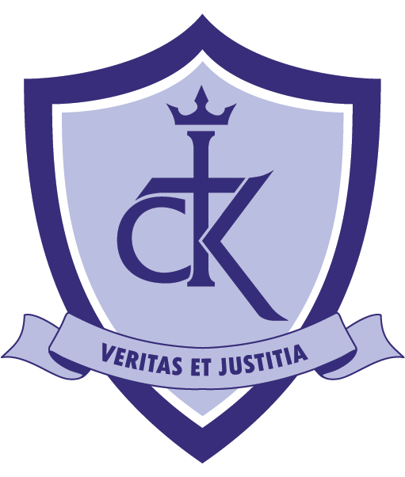

**Mock Exams (1) – November 2025**