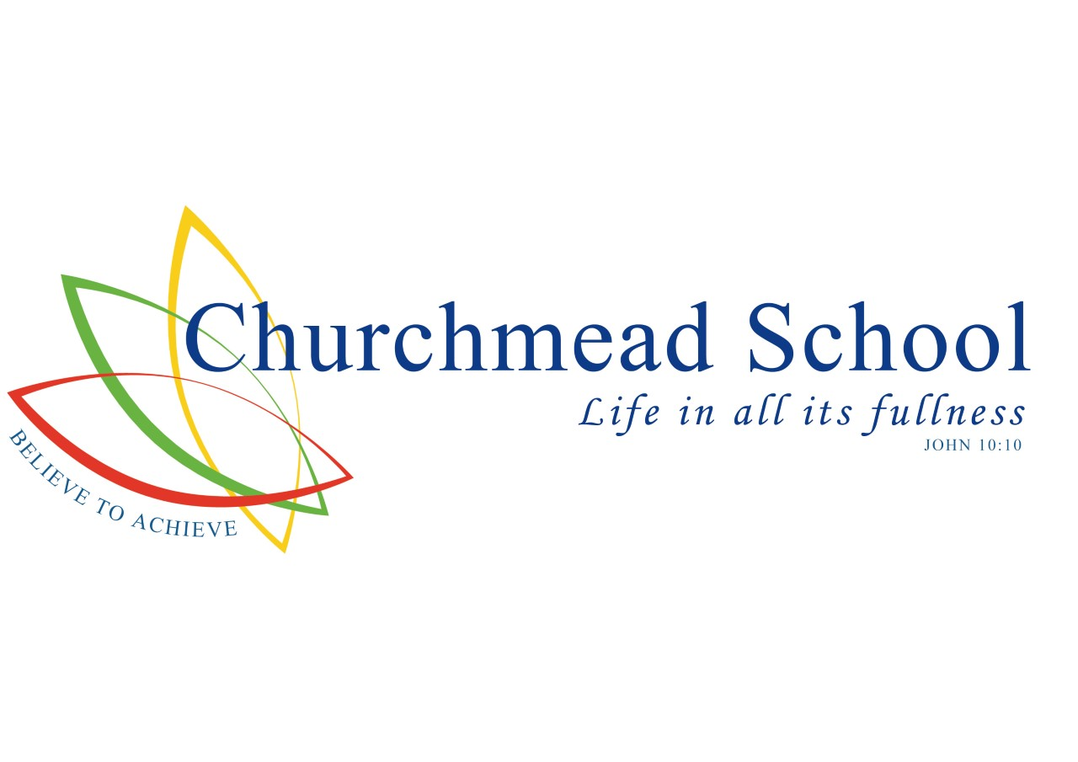
ADMISSIONS POLICY
2026/27

Headteacher
Mr C Tomes BA (Hons), MA

ADMISSION POLICY FOR ENTRY IN ACADEMIC YEAR
SEPTEMBER 2026 – AUGUST 2027
Churchmead School has a distinctive Christian ethos which is at the centre of school life. We provide an inclusive, supportive and caring environment, shaped by Christian values in which children can learn and flourish. We welcome applications from all members of the community without reference to ability or aptitude, and irrespective of whether they are of the Christian faith, another faith or no faith. We expect parents to respect the Christian ethos of our school.
The governing board have made every effort to ensure that these arrangements comply with the School Admissions Code 2021 and all relevant legislation and equal opportunities.

Introduction
Churchmead School is a voluntary aided co-educational comprehensive school and the Governing Body is the Admission Authority for the school.
This policy should be read together with information about your Local Authority’s coordinated admission arrangements and a copy of the School Prospectus. The school will hold open days for prospective parents to attend and details of these can be found on the school website. Additionally, parents may telephone the school for an individual appointment to visit the school.
Pupil Admission Number
There are 120 places (the published admission number or PAN) available.
Admission arrangements to Year 7 in September 2026
Parents (see Note 1) wishing to apply for a Year 7 place in September 2026 must complete the common application form provided by their home local authority (the home LA). The home LA is the LA in whose area the parents live at the time of the application. The form must be returned to that LA no later than 31 October 2025. Applications received after this date will normally only be considered after all those received on or before the cut-off date. Offers and refusals of places will be given to parents on 2 March 2026.

Over-subscription criteria
Children with an Education, Health and Care (EHC) plan, whose needs we can meet, naming Churchmead School will always be offered places.
If there are fewer applications than places available, all children will be offered places. If there is greater demand for admission than there are places available, the following criteria will be applied in the order set out below:
- Looked-after children and children who were previously looked after, including those children who appear to have been in state care outside England but ceased to be so as a result of being adopted. (See Note 2)

- Families who have exceptional medical or social needs that make it essential that their child attends Churchmead School rather than any other. These needs must be fully supported by written evidence from the appropriate professional person involved with the family. (See Note 3)

- Children with a sibling (see Note 5) on the roll of the school at the time of application or whose parent has accepted an offer of a place at the school and who is expected still to be in attendance at the time of entry to the school.

- Children who live in the designated area of the school. (See Note 6 - Designated Area Map).

- Children who attend one of the following feeder schools in year 6:

- Colnbrook CE Primary School
- Datchet St Mary’s CE Primary School
- Foxborough Primary School
- Holy Family Catholic School
- Iver Heath Junior School
- Iver Village Junior School
- Langley Hall Primary Academy
- Marish Primary School
- Pippins Primary School
- Ryvers School
- St Edwards Royal Free Ecumenical Middle School
- St Marys CE Primary School (Slough)
- St Peters Middle School
- Wraysbury Primary School

- Other Children
Proximity of the child’s home, as measured by the straight-line distance (see Note 7) between the home and the school with those living nearer being accorded the higher priority, will serve to differentiate between children in criteria 1 to 5 should the need arise. In the event that two distance measurements are identical, the school will use random allocation to decide which child should be offered the place. The process will be conducted in the presence of a person independent of the school.

All Other Admissions
Admission to the school during the school year depends on whether or not there are places available. Applications must be made directly to the school on a form available from the school.
If there is a vacancy, and there is no child on the relevant waiting list with a higher priority (according to the over-subscription criteria 1-6 above), a place will be offered.
In-year admissions or admissions at the beginning of school years other than Year 7 will only be considered by the Governing Board up to half a term [using the three-term year] in advance of the desired date for entry. For example, for entry in January, the application will not be considered until after the October half term break.

Admission outside normal age group
Requests from parents for places outside a normal age group will be considered carefully, eg for those previously educated abroad or those who have missed education due to ill health. Each case will be considered on its own merits and circumstances and a decision made based on what is in the pupil’s best interests. It is recommended that parents discuss their wishes with the head teacher in advance of applying for a place. The governing board may ask relevant professionals for their opinion. If a place in the requested age group is refused, but one in the normal age group is offered, then there is no right of appeal.

Waiting Lists
The school maintains waiting lists for those children who are not offered a place. For those applying through the normal admissions round for entry, the Waiting List will be maintained from shortly following initial allocation in the year preceding the start of the academic year in September until 31 December following the start of the academic year in their Year 7 year.
The order of priority on the waiting list is the same as the list of criteria for over-subscription and does not depend on the date on which an application is received.

Repeat Applications
Repeat applications will not be considered in the same academic year unless there is a material change of circumstances.

Multiple births
In cases where there is one place available, and the next child on the list is a twin, triplet, etc., we would admit both twins (and all the children in the case of other multiple births) even if this meant exceeding the agreed admission number.

Fair Access
The school participates in Royal Borough of Windsor & Maidenhead’s Fair Access Protocol. Children qualifying under the Fair Access Protocol may be offered a place even if there are no places available in the relevant year group and also take priority for admission over any child on the waiting list.

Appeals
Any parent not offered a place for their child at their preferred school has the right of appeal to an independent appeals panel. Details of appeals arrangements are available from the school, including the date by which an appeal should be submitted. In the event of an unsuccessful appeal against non-admission to the school, the school will not consider any further application for a child in the same school year (1 September–31 August) unless there has been a material change in circumstances, for example a change of address which results in a move from outside the catchment/designated area to inside it.

Further information
Further details / information may be obtained from the Headteacher’s PA, at the school.

Notes
Note 1:
‘Parent’ is defined in law (The Education Act 1996) as either:
- any person who has ‘parental responsibility’ (defined in the Children Act 1989) for the child or young person; or
- any person who has care of the child or young person.

Note 2:
A ‘looked-after child’ is one in the care of a local authority or being provided with accommodation by a local authority in the exercise of its functions. Previously looked after children are children who have been adopted, subject to child arrangement orders or special guardianship orders. Adopted children are those for whom an adoption order is made under the Adoption Act 1976 (Section 12) or the Adoption and Children Act 2002 (Section 46). A ‘child arrangements order’ is one settling the arrangements to be made as to the person with whom the child is to live (Children Act 1989, Section 8, as amended by the Children and Families Act 2014, Section 14). A ‘special guardianship order’ is one appointing one or more individuals to be a child’s special guardian/s (Children Act 1989, Section 14A).
Applications under this criterion must be accompanied by evidence to show that the child is looked after or was previously looked after (eg a copy of the adoption, child arrangements or special guardianship order). A ‘looked-after child’ includes any child who appears to have been in state care outside England if they were in the care of or were accommodated by a public authority, a religious organisation, or any other provider of care whose sole or main purpose is to benefit society.

Note 3:
Applications under criterion 2 (exceptional medical or social needs), must be supported by evidence from an independent professional person which clearly demonstrates why the school is the most suitable and must illustrate the difficulties that would be caused if the child had to attend another school. The person supplying the evidence should be a doctor, heath visitor, social worker, etc. who is aware of the circumstances of the case. The school reserves the right to ask for further evidence or clarification where necessary and may seek the advice of appropriate professionals where necessary.

Note 4:
The home address is where the child normally lives. This will be where the parent or legal carer of the child lives with the child unless it is shown that the child is resident elsewhere with someone else who has legal care and control of them. The address should be a residential property that is owned, leased or rented by the child’s parent/s or person with legal care and control of the child.
Where a child lives with parents with shared responsibility, each for part of a week or month, the address where the child lives will be determined having regard to a joint declaration from the parents stating the exact pattern of residence. If the residence is not split equally, then the relevant address used will be that at which the child spends the majority of the school week. Where there is an equal split or there is any doubt about residence, the home address will be assumed to be the address at which the child is registered with a GP.
Evidence of the normal home address may be requested in the form of a recent bill, for example, the most recent Council Tax bill, utility bill no more than three months old, a current TV licence, buildings and contents insurance, mortgage statement or rent book which shows the address concerned.
If a place at the school is offered, and it later becomes clear that the offer was made on fraudulent or intentionally misleading information (eg a false claim to living in the catchment/designated area), and the school has denied a place to a child with a stronger claim, the school will withdraw the offer of a place. The offer can be withdrawn even after the child has started at the school.
If parents are moving house, evidence of the move will be requested when considering any application for a place. Documentary evidence in the form of a solicitor’s letter to confirm exchange of contracts, or a rental agreement for at least a period of six months will be required.
If parents move house after the application has been made, but before any offer of a place has been made, the home LA must be informed.
An address of a second home with the main home being elsewhere will not be accepted. If there are two or more homes, or where a family is returning from elsewhere, evidence will be required of the main home. An allocation of a place based on an address which might be considered only temporary or where the address given is a second home will not be made.
An address where the child was resident other than with a parent or carer unless this was part of a fostering or formal care arrangement will not be accepted.
There are special arrangements for families of service personnel with a confirmed posting or crown servants returning from overseas. If the application is accompanied by an official letter that declares the relocation date, and if there is a place available, it will be offered even though there is not an intended address or the family is not yet living in the area.

Note 5:
‘Sibling’ means a natural brother or sister, half-brother or sister, adopted brother or sister, step-brother or sister, or the child of the parent’s/carer’s partner where the child for whom the school place is sought is living in the same family unit at the same address as that sibling. It is helpful if parents make it clear on the application form where the sibling has a different family name. Where there is more than one sibling at the school, only the youngest should be listed on the application form.

Note 6
Designated Area Map
Please see link below:

Churchmead_Church_of_England_School(2).png (3720×5261)

Note 7: The straight line distance used to determine proximity of the home to the school will be measured by Royal Borough of Windsor & Maidenhead’s Geographical Information System.

Admission to the Sixth Form [Year 12]

- Introduction

1.1 The school welcomes students from outside Churchmead [external students], as well as current Year 11 students attending Churchmead at the time of application [internal applicants] to apply to join the Sixth Form. Currently there is no limit to the number of external applications. This document sets out the admission arrangements of Churchmead School.

1.2 Students will be admitted into Year 12 on the understanding that they have a desire to benefit from the programmes available to them and a commitment to meet the appropriate study requirements.

1.3 External applicants are expected to be aware of the Church School foundation and ethos of Churchmead School and to be able to work within it.

2. Applications

2.1 Internal applicants must complete a Churchmead Sixth Form application which is available from the school office or school website.

  - External applicants must complete a Churchmead Sixth Form application which is available from the school office or on the school website.

2.3 External applicants should provide verification of their predicted grades, validated by their current school. All applicants must state their chosen subjects.

3. Entry Criteria

3.1 To determine eligibility for admission into the Sixth Form, Churchmead Sixth Form has specific criteria in relation to minimum entrance requirements for Year 12 based on GCSE grades or equivalent or other measures of prior attainment. For studying at level 3 which will be 5 or more GCSE grades 5 - 9 (or equivalent), all of which must be full GCSE courses or equivalent.

3.2 Churchmead also has academic entry requirements for each particular course available based upon GCSE grades or other measures of prior attainment.

3.3 These criteria will be the same for internal and external students and will be published in the Sixth Form course guide.

3.4 Young people who do not meet the grades for their preferred course option will be offered alternative courses in line with their preferences where available.

3.5 In exceptional circumstances (for example, interruptions to study during Key Stage 4 resulting from prolonged illness or due to relocation) the school will reserve the right to admit a student who is not able to demonstrate the normally required level of prior attainment.

3.6 The school will admit any young people whose Education, Health and Care Plan [EHCP] names Churchmead provided they meet the general Sixth Form entry criteria.

4. Oversubscription Criteria

4.1 Oversubscription criteria will be applied if the number of external applicants exceeds the available number of places.

4.2 Offers will be made to applicants who have applied by the deadline, 1st March each year, if:
• There are spaces available on all of the applicant’s chosen courses
• The applicant is predicted to meet the academic requirements for all of the courses for which they have applied, as well as the general entry criteria.

4.3 If both of the above criteria are met, priority will be given according to the order below:

1) Looked-after children and children who were previously looked after, including those children who appear to have been in state care outside England, but ceased to be so as a result of being adopted [see note 2].

2) Applicants whose home address is nearest to the school.

4.4 Any offer of a place will indicate which courses are available to an applicant, and whilst the offer of a place will remain valid, students’ options will be governed by availability in particular subjects.

4.5 The school will do its best to accommodate external students on their preferred courses but courses may become full or not be viable, so an offer of a place cannot guarantee entry to a preferred course of study.

4.6 External students whose applications cannot be accommodated may be placed on a waiting list which will be used to fill any vacancies arising before Year 12 studies commence.

