Task 2:
Year 7- Cubism – Georges Braque
Complete the questions below, these all linked to the art movement Cubism. You will need a computer to research some of the questions.
1, Describe this painting in your own words:

What do you see? How do you think it was painted? What techniques?

Now use the internet to help answer these questions:
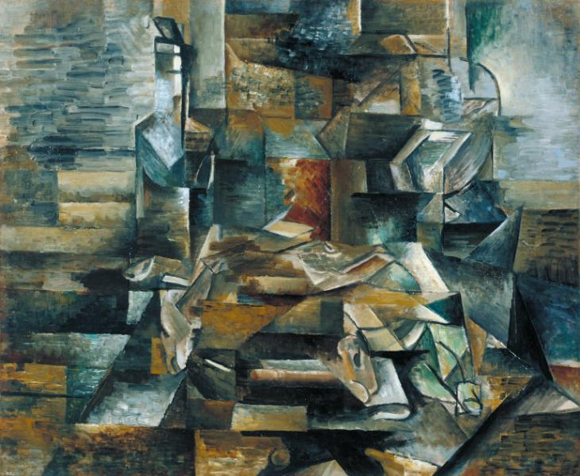

2, In what year was this painted and what is it’s name?

___________________________________________

3, Can you name 3 other painting by the artist, Georges Braque?
1.

2.

3.
4, Georges Braque is an amazing Cubist painter. Research and write down 6 facts you can find about Braque and his art works.
1,
2,
3,
4,
5,
6,

5, What is your personal opinion about Georges Braque’s art work?

