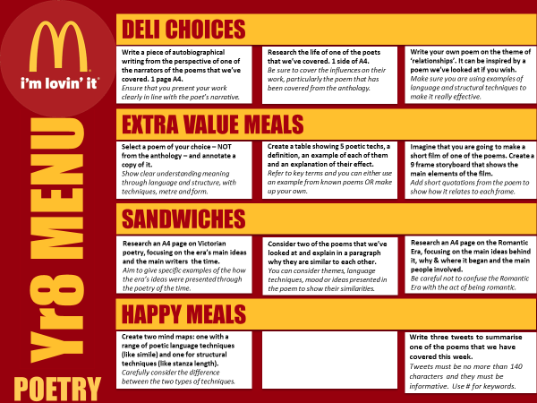
3. Use imagery, metaphors and similes to write a poem about a busy café.
Choose the lyrics from a favourite song. Pick out the metaphors and similes. How do they improve the meaning / description of the song?

Research an A4 page on War Poetry. Focus on the main ideas behind it, why and where it began, and the main people involved.
Imagine that you are going to make a short film of one of the poems you have studied. Create a 9-frame storyboard that shows the main elements of the film. Add short quotations from the poem and how it relates to each frame.
Create a table showing 5 poetic techniques, a definition, an example of each, and an explanation of their effect. Refer to key terms and find your own example or use one from a poem.

Consider two of the poems we have looked at and explain on one side of A4 why they are like each other. Consider theme/mood and language. Use quotes to support your ideas.

1. Research a poem of your choice and annotate it, mentioning all the poetic devices you can find.
Find poetic devices/techniques from a poem we have studied. What are these techniques? What effect do they have on the reader?
Write your own poem using elements from the poems you have studied. Use effective techniques and structure that we have studied.
Consider two of the poems that we’ve studied and compare them. Consider themes, language, techniques and mood to show their similarities. Quote from the poem to prove your ideas.

Write three tweets to summarise one of the poems that we have covered this week. Tweets must be informative. Use # for keywords.

Research William Wordsworth and write 10 facts about his life and poems.

