The Written Exam- Component 3:
Section A- The Crucible by Arthur Miller

(a)(i) You answer this question as a performer- 4 marks

(a)(ii) You answer this question as a performer- 6 marks

(b)(i) You will answer this question as a director in
relation to the given production element. The
production elements could include: Sound, Costume,
Sound, Lighting, Staging, Set- 9 marks

(b)(ii) You answer this question as a director, saying
how a performer would play the given role. You will
be given performance skills to focus on these could
include: voice, physicality, stage directions, levels,
gait, through lines, stage space or gestures - 12 marks

(c) You answer this question as a designer, you will
have a choice of a design element to focus on, this
could include: lighting, props, stage furniture, set,
sound or costume. - 14 marks

Section A Tips:

• Read the extract supplied in the booklet.
Answer the questions in relation to the given extract and showing your
knowledge of the characters and play as a whole.
• Use the correct Drama vocabulary.
• Always write in P.E.E sentences.
• Always give specific examples and link the answers to the extract.
• Learn the different types of stage lights and their functions.
• Learn what each character would wear in The Crucible, including names of fabrics and colours of costumes.
• Remember the play was written in the 1950s but was set in Salem in 1692 (which you can refer to as the 17th Century).

Section B- Live Theatre Review

(a) This question will ask you to analyse a key skill
used in the performance, this could be physical, vocal
skills, body language or gestures - 6 marks

(b) This question will ask you to evaluate how a
design element was used to engage the audience or
create impact within the performance- 9 marks

Section B Tips:
• Use your 500 words of notes wisely, include the names of actors and
designers.
• Make sure you are able to analyse the actor’s costumes for each character.
• Ensure you note down key lighting changes and the names of lights used to
create them.
• Ensure you note down the uses of sound within the performance.

Timings:
1. Open the booklet and find the questions relating to the extract on The Crucible.
2. Scan the whole extract carefully. Highlight stage directions.
3. Read the question. Make a note of the CONTEXT of this extract in the play and as a text.
4. Use QUOTES to support your ideas.

Find the correct extract and read it carefully. Open the question paper and read the questions relating to The Crucible. | 5 mins
Section A – The Crucible Answer Q (a) (i)  (4 marks) | 5 mins
Answer Q (a) (ii)  (6 marks) | 8 mins
Answer Q (b) (i)  (9 marks) | 12 mins
Answer Q (b) (ii)  (12 marks) | 15 mins
Answer Q (c)  (14 marks) | 20 mins
Section B – live theatre evaluation Answer Q (9a)  (6 marks) | 8 mins
Answer Q (9b)  (9 marks) | 12 mins
Check all answers | 5 mins

Making your points in the exam
Use the What/ When/ How/ Why grid:
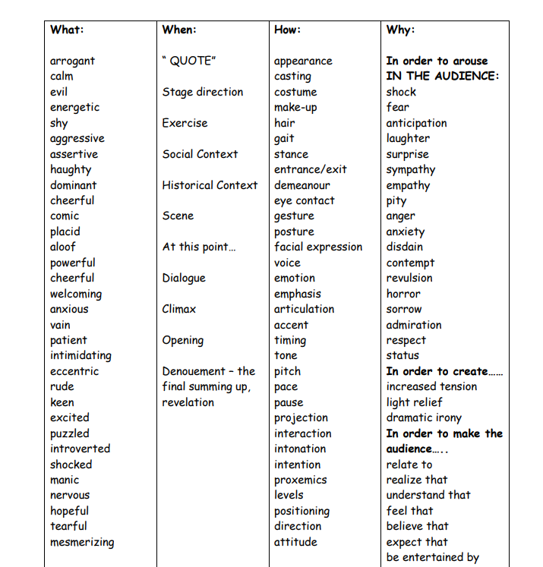

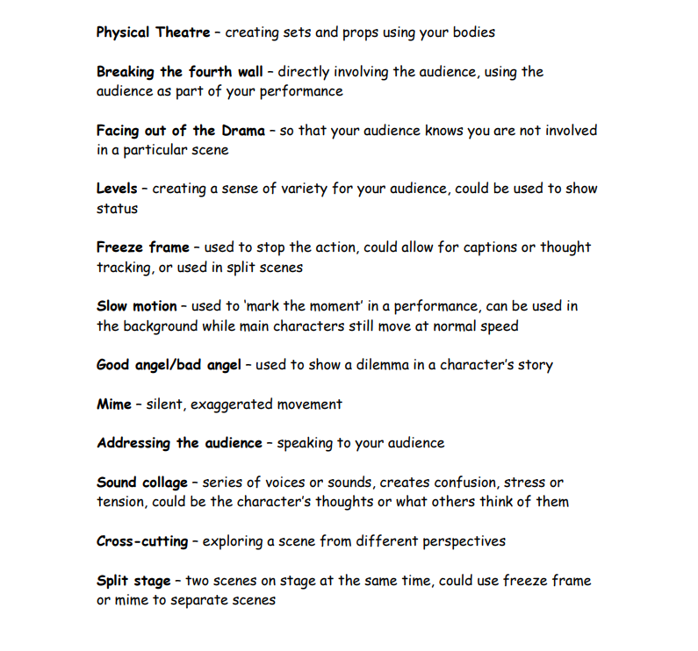
Performance Skills:

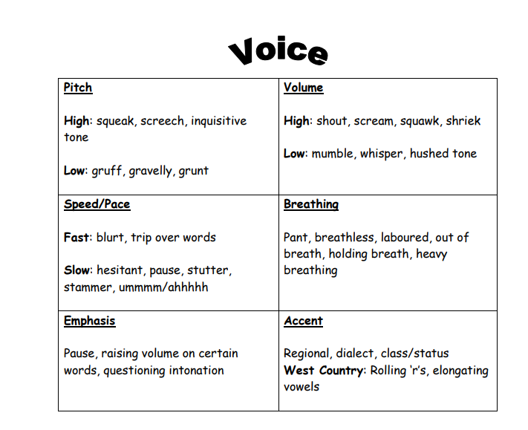

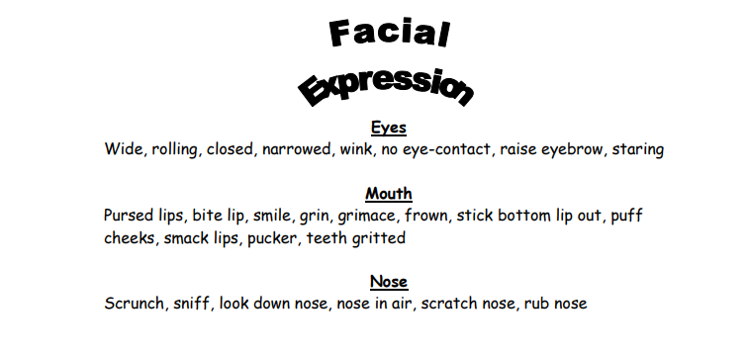

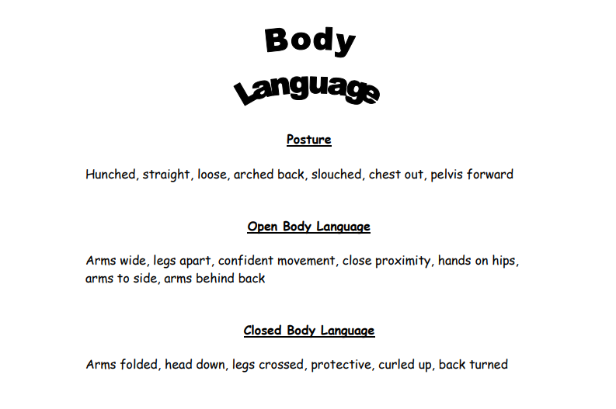

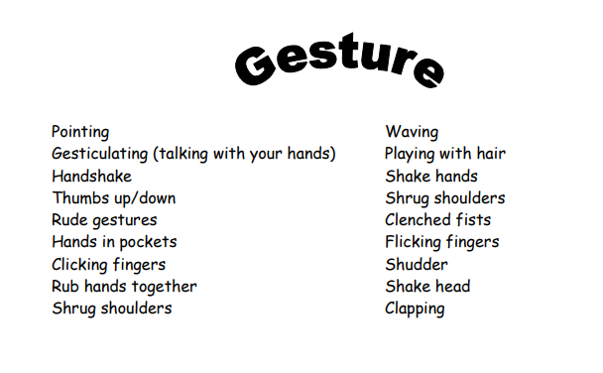

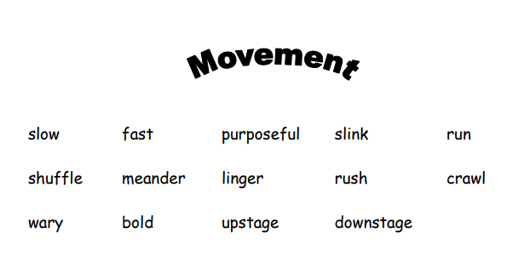

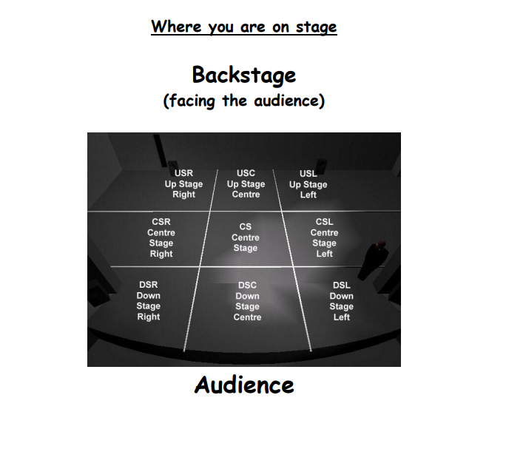

Command Word: What is the question asking you to do? (Discuss, Analyse, Evaluate, Justify?) You will need to discuss how you would use one of the design elements to enhance the production from the extract for the audience, in relation to the given extract.
Key Drama Element: This should provide the content for your answer, the question is asking you to demonstrate knowledge of this area of the specification e.g. ‘design elements’. You could be asked to choose one of the following: Lighting, props/stage furniture, set, sound or costume.

