Component 2- Monologues and Duologues

For your component 2 exam in Year 11, you need to learn and perform two monologues or duologues.

PREPARATION TASK: Please choose the monologue from either Judy or Ed below and learn it, perform it, record it and send it to me. Both monologues are attached, and they are two pages long each.
You have one week- start today!

After the monologues, there is information about the play and the characters to inform your performance and characterisation. There is also the mark scheme so you know what you would be graded on.

Judy:
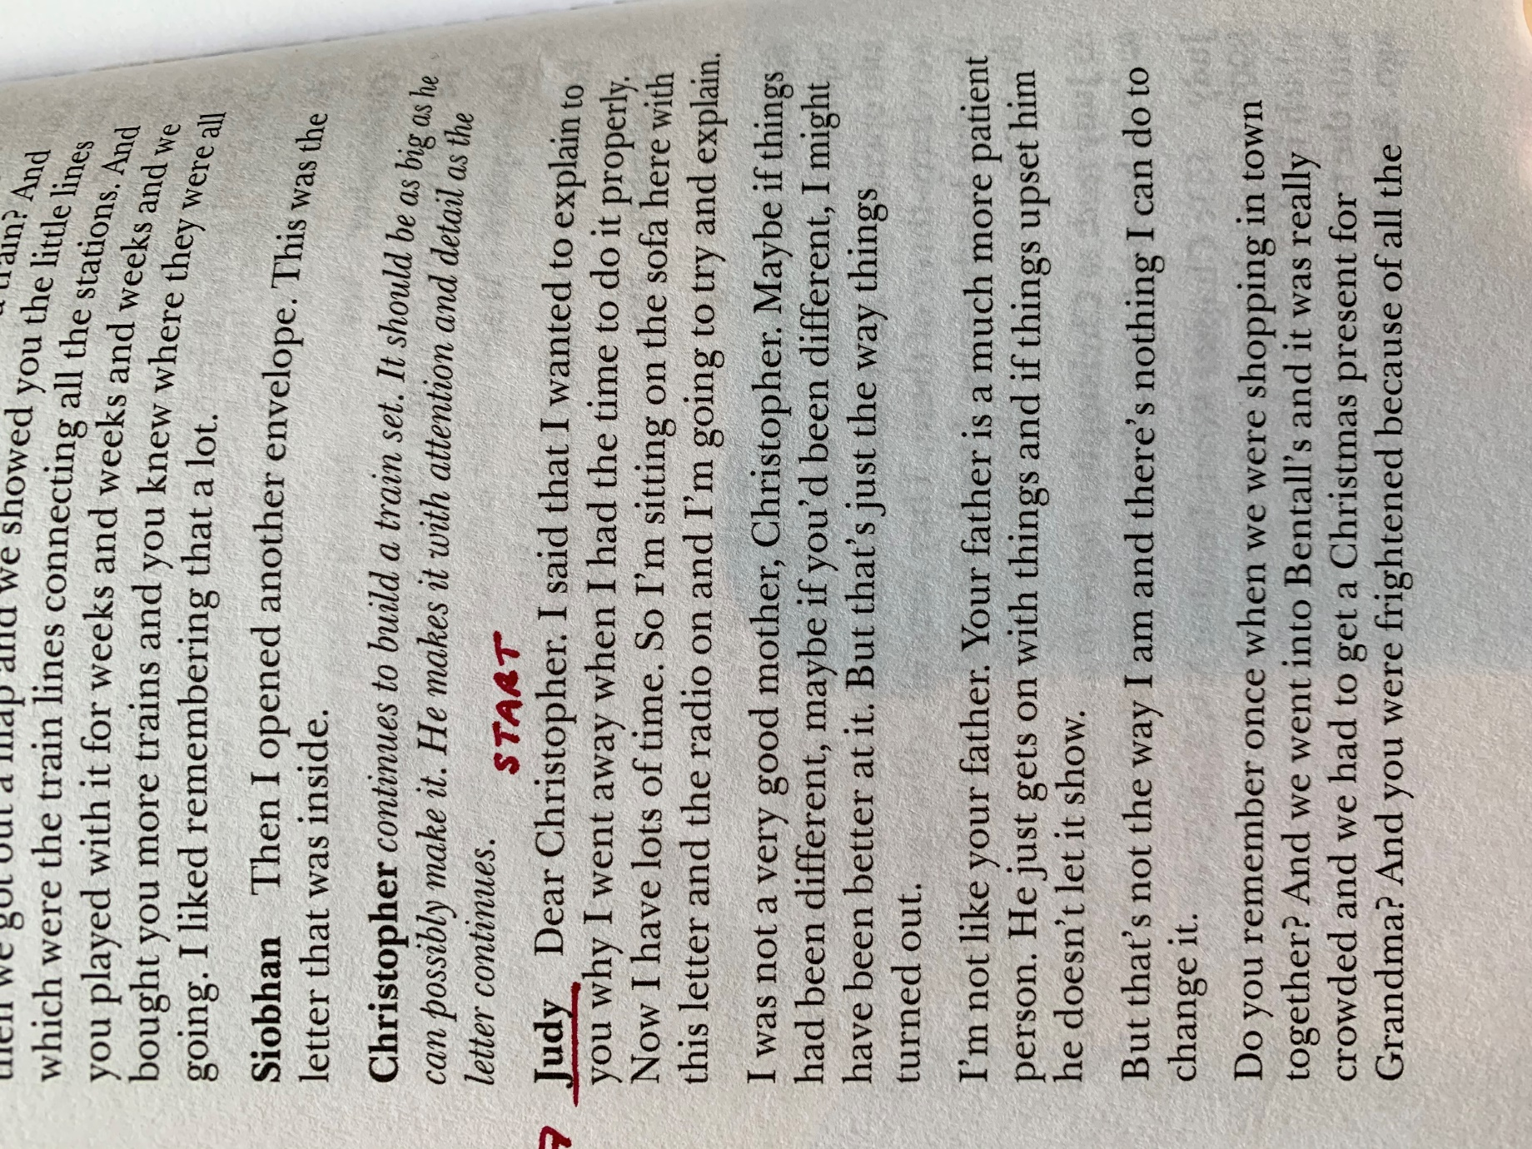

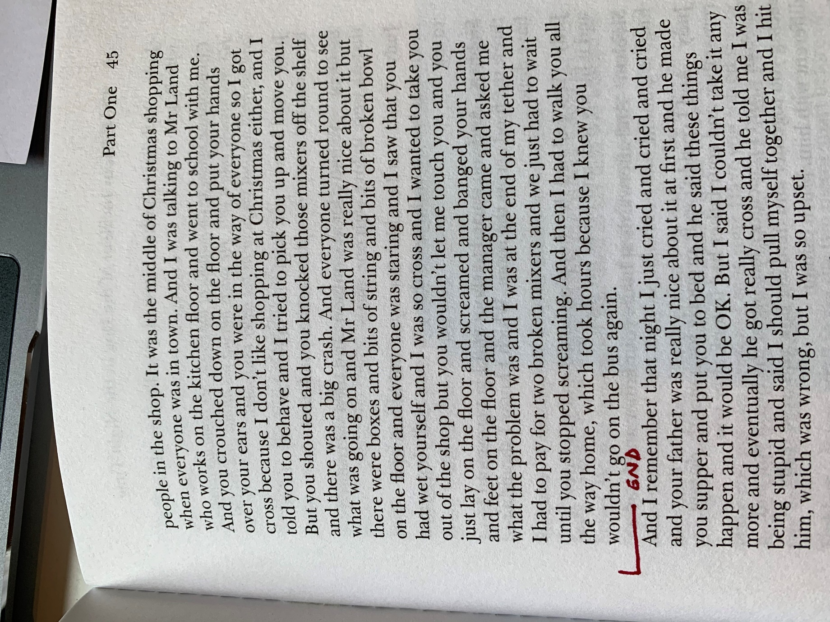

Ed:

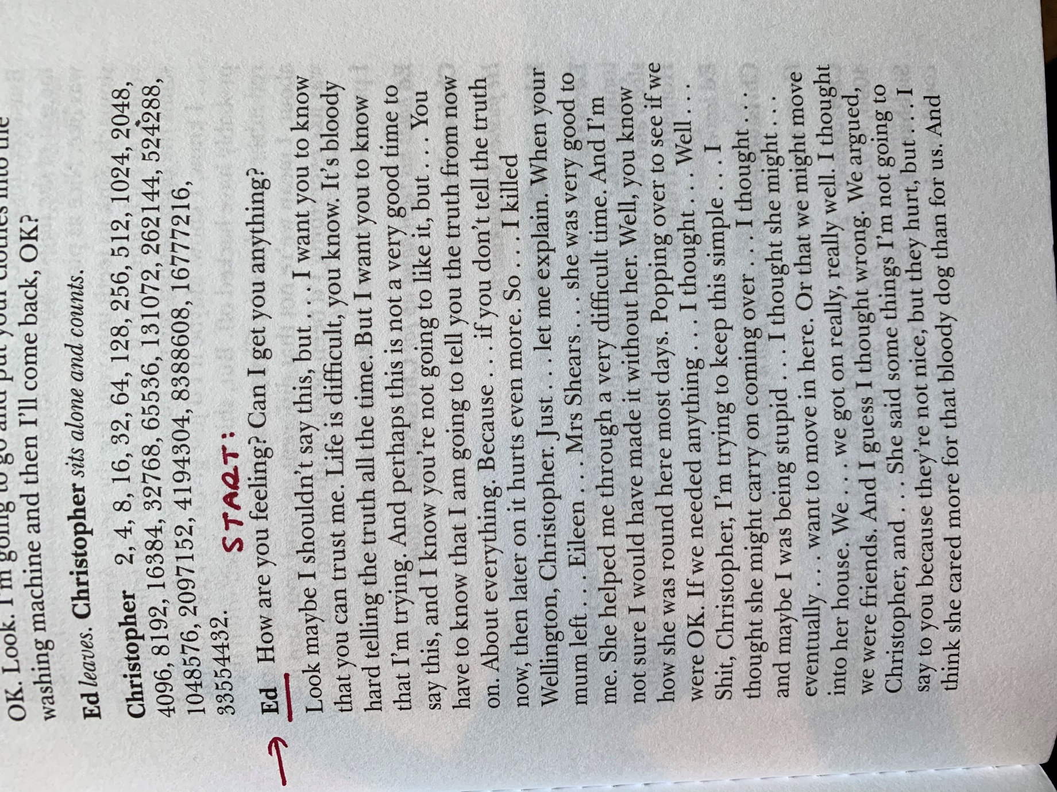

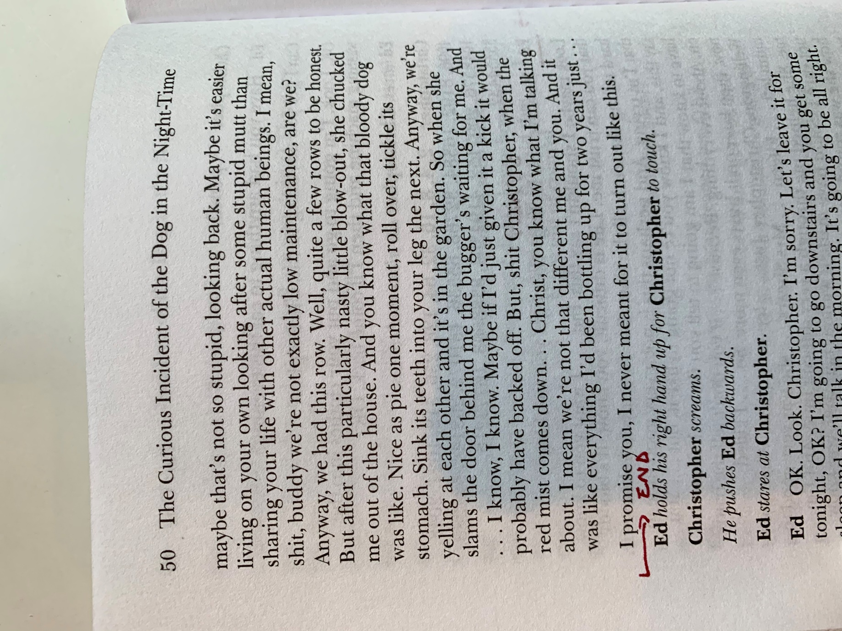

The Curious Incident of the dog in the Night-time:
By Mark Haddon

Summary-

One night, Christopher Boone finds his neighbour’s dog dead in her front yard, with a pitchfork sticking out of it. Eek – we're off to an interesting start, that's for sure. Anyway, Christopher wonders who killed it, and decides to write a book in which he tries to figure it out, like a murder mystery novel.
Christopher has a disability – unspecified in the book, but which has been compared with an autism spectrum disorder called Asperger syndrome – that makes it difficult for him to understand social norms like body language and other forms of human interaction. He is, however, tremendously good at math and more logic-based skills (like writing a crazily-detailed daily schedule, or drawing intricate maps of places he's only visited once).
Christopher's neighbour, Mrs. Shears, finds him with her (now-dead) dog, calls the police, and Christopher has to spend a few hours in a jail cell. Eventually, his father comes to get him, and tells Christopher to not investigate the dog's death any further. So, in response, Christopher thinks of all kinds of ways to interpret his father's demand as specifically as possible… so he can still do all of his detective work while somehow not disobeying him.
He starts asking around the neighbourhood to see if anyone knows anything about the dog's death. He decides that since Mr. Shears left his wife two years ago, perhaps he hates her, and killed her dog to make her sad. (Seems like a stretch, but you never know.) When Christopher's father finds out he's been asking people about the dog, he makes him promise he'll stop. Again. Christopher promises.
So, of course, Christopher continues talking to one of his neighbours, who tells him that his (Christopher's) mother and Mr. Shears were having an affair before he left Mrs. Shears. That's bad news. But Christopher tells her that his mother died two years ago, of a heart attack.
Christopher's father finds the detective book Christopher has been writing, in which he's recorded everything that has happened so far. He's really mad about it, and takes the book away. A few days later, Christopher searches the house for the book, and finds it hidden in his father's bedroom. But here's the kicker: he also finds a big stack of letters addressed to him, from his mother. He reads a few of them, and discovers that – wait for it – she's actually still alive! His father had been lying to him this whole time.
His father apologizes for lying, and also admits that he was the one who killed Mrs. Shears' dog. As it turns out, he has feelings for Mrs. Shears, and was mad that she didn't want to be with him. Whoa.
Christopher decides that living with his father is no longer such a great (or safe) idea – he is a dog-killer after all – and thinks it's best to move to London and live with his mother. Problem is, he's never gone anywhere by himself before, and has difficulty being in busy places and/or around large groups of people. The journey is, as we might then expect, incredibly challenging. First, after he runs away, his father enlists the police to try to find him. He manages to escape anyway, but then he's totally overwhelmed, being on his own like this. He repeatedly vomits and passes out and just feels horribly sick.
Hours and hours later, he arrives at his mother's apartment in London. She's living with none other than Mr. Shears. Christopher tells her that his father said she was dead, and she's horrified to learn this. When Christopher's father comes to find him, she demands he leave and insists that poor Christopher can live with her. But Christopher is afraid of Mr. Shears, and is quite eager to go back home to take an important exam that will help him get into university.
After about a week, he and his mom go back home, and Christopher takes the exam (even though he can't think straight, after not eating or sleeping for days on end). His mother gets a job and a not-so-nice apartment, which Christopher hates. Meanwhile, his father tries very hard to earn back his trust. He buys him a puppy (that's some brownie points right there), and Christopher begins spending some time at his house again.
He receives his exam results, and finds out that he got the best possible score. Having successfully travelled to London on his own, and solved the mystery of who killed the dog, he's sure he can do anything.

Characters:

Judy- Christopher’s mother:

We only hear Judy's name once, when Christopher first arrives in London. Otherwise, we mainly know her as "Mother." For the first half of the book, we think she's dead, since that's what Christopher has been told by his father. In reality, she ran away with the next-door neighbour, Mr. Shears.
So we don't really know much about her until Christopher discovers the letters she's been writing him every week for two years, but that his father has been hiding from him. In the letters, she describes her new life in London and apologizes for leaving him, but also provides some intense self-analysis. She bluntly says, "I was not a very good mother," describing herself as impatient, and admitting she often was really angry with her son. Quite the confession.
When she and Christopher reunite, she's overjoyed to see him again (although horrified that her ex-husband told their son she was dead this whole time). But, despite her best efforts, once tasked with caring for Christopher again, she all-too-quickly shows the same traits she lamented in her letters.
It's through Judy that we get a glimpse of just how challenging it is to care for someone with a social disorder, like when Christopher starts smashing things in a store, or refuses to step onto a bus and insists that they walk miles home. We admire Judy's awareness of her limitations, and her attempts at being a better mother, despite all the difficulties she faces and the craziness spinning around her.

Ed- Christopher’s father:

Does every protagonist need an antagonist? We seem to remember hearing that once. Well if Christopher is the protagonist, then is his father the antagonist? And if his father's the antagonist, does that make him the villain? We guess what we're really asking here is, is Christopher's father a bad dude?
Christopher sure thinks so, from the second half of the book onward at least, after he finds out his father lied about Christopher's mother dying. Before that, he really doesn't seem to have any opinion of his dad at all, although we can't say we get a very good impression of him from what Christopher does tell us.
And what's up with that? This guy takes care of Christopher, while also busy running his own business (43.3). And most of the time he seems really sweet to Christopher: we love the way he asks his son what he feels like eating for dinner (149.40), and tells him his favourite program is on TV (149.60). But Christopher doesn't appear to have any appreciation of this whatsoever. Interestingly, the most flattering image of Christopher's dad appears in the letters written by Christopher's mom (that is, his father's estranged wife). She praises him for being a wonderful parent to Christopher, and everything she wasn't able to be herself.
Okay, look, we admit that he messes up big time by lying to Christopher, telling him his mother is dead – that is seriously not cool. What do we make of his explanation? It seems like he was at least trying to do the right thing. But what could he possibly have been thinking? What assumptions was he making about Christopher's relationship with his mother, and his ability to process the truth (let alone the lie)? Did he think he wouldn't care? Finally, and most importantly, do we forgive him?

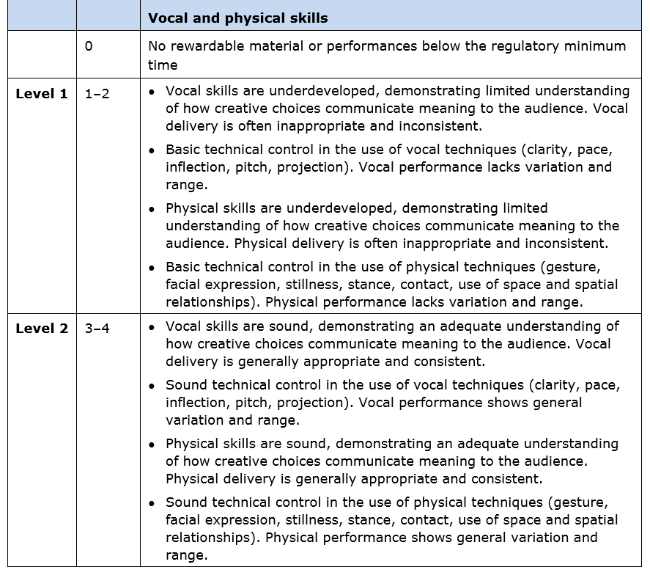
Mark Scheme for the Component 2 Exam: 24 marks in total- scroll down.

