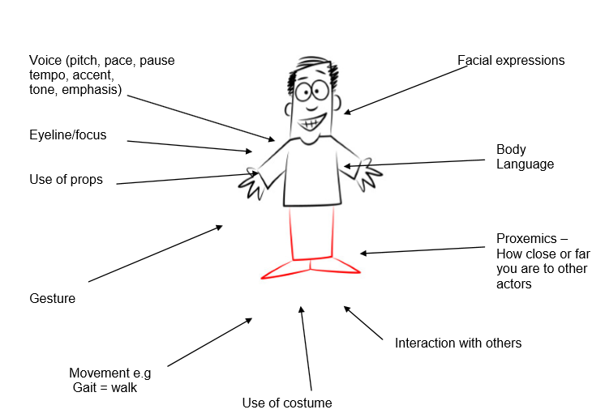

Depending on the question, you could be writing about any of the elements above. In most answers you will refer to more than more than one of these elements, especially in Section A of the paper.
It is really important that you feel confident writing about your set text using Drama vocabulary so revise the language and terms!

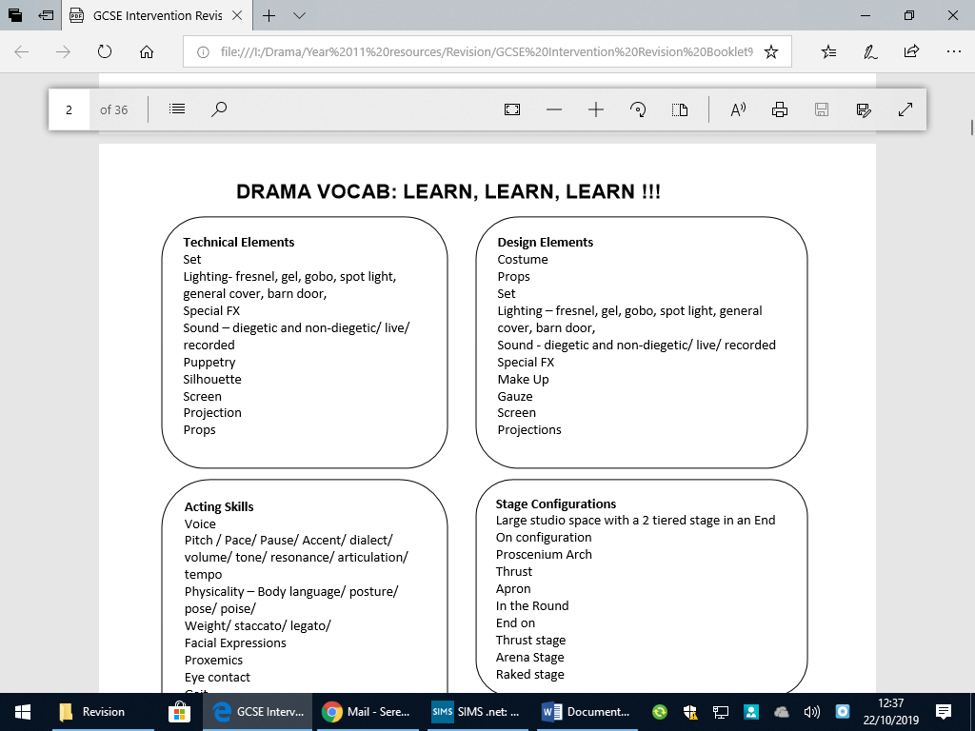

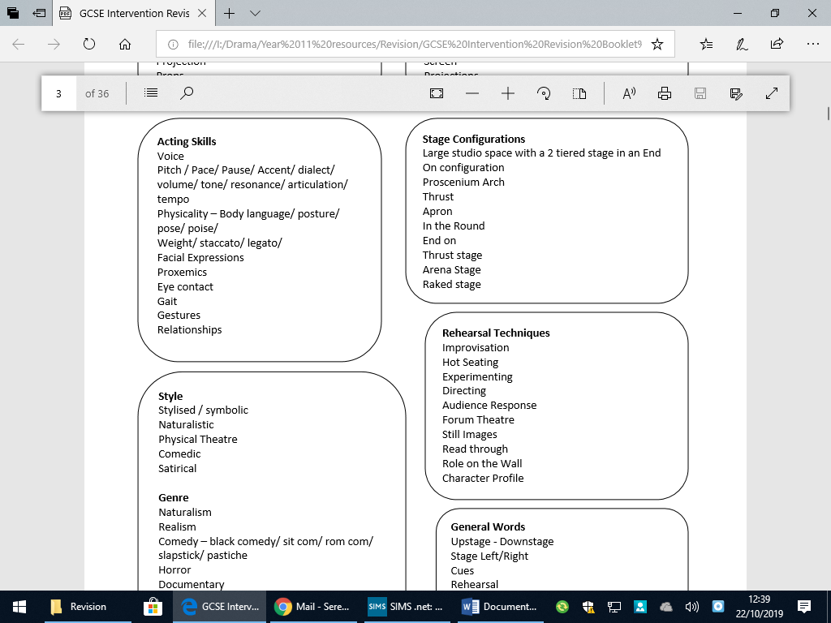

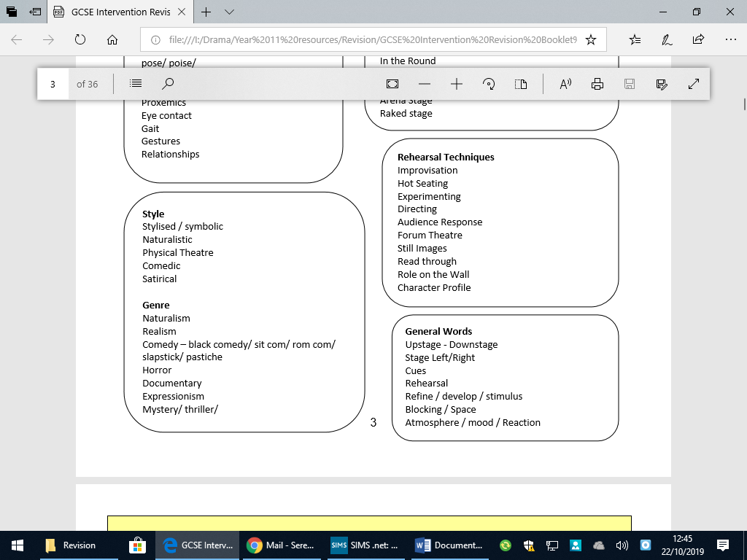

Practice paper:

SECTION A: BRINGING TEXTS TO LIFE The Crucible, Arthur Miller Answer ALL questions.
You are involved in staging a production of this play. Please read the extract after the questions and use it in your answers. USE KEY VOCABULARY FROM REVISION SHEETS! USE PEE… Point/Evidence/Effect

4 (a) (i) You are going to play John Proctor. Explain two ways you would use physical skills to play this character in this extract.
(4 marks)

(ii) You are going to play Mary Warren. She is frightened. As a performer, give three suggestions of how you would use performance skills to show this. You must provide a reason for each suggestion.
(6 marks)

(b) There are specific choices in this extract for a director. (i) As a director, discuss how you would use one of the production elements below to bring this extract to life for your audience. You should refer to the context in which the text was created and first performed.
Choose one of the following:
• staging
• costume
• sound.
(9 marks)

(ii) Elizabeth is both ‘amazed’ and ‘shocked’. As a director, discuss how the performer playing this role might demonstrate this to the audience in this extract and in the complete play.
You must consider:
• voice
• physicality
• stage directions and stage space.
(12 marks)

(c) There are specific choices in this extract for designers. Discuss how you would use one of the design elements below to enhance the production of this extract for the audience. Choose one of the following:
• lighting
• props/stage furniture
• set.
(14 marks)

(Total for Question 4 = 45 marks)

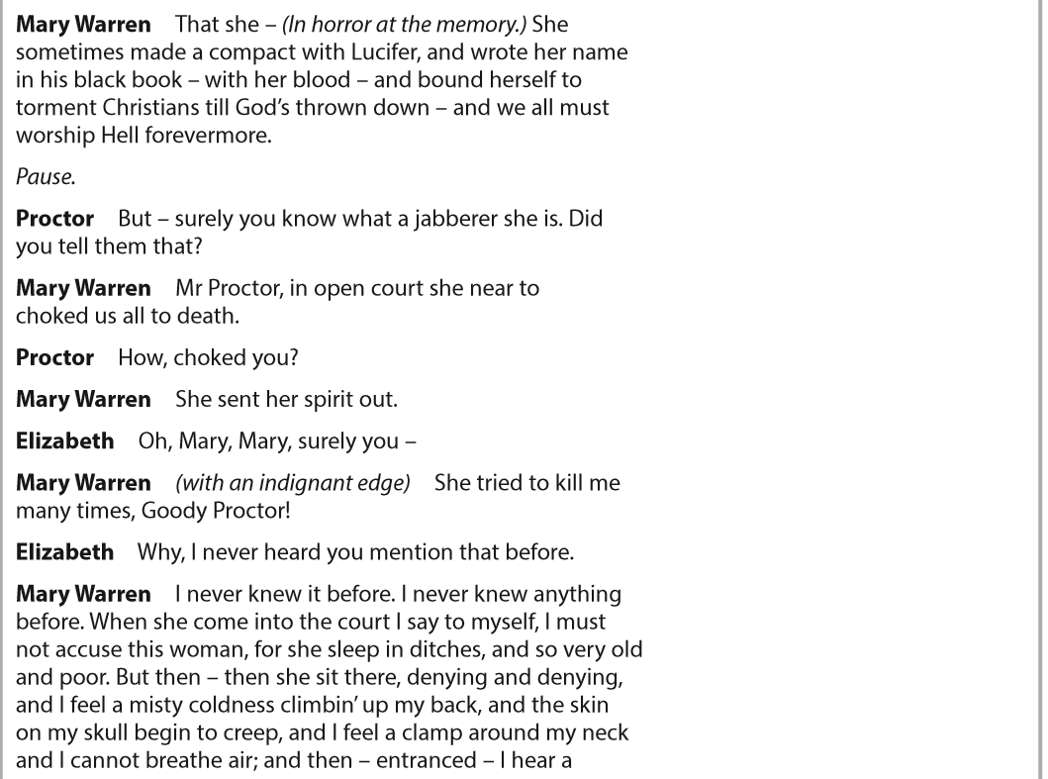
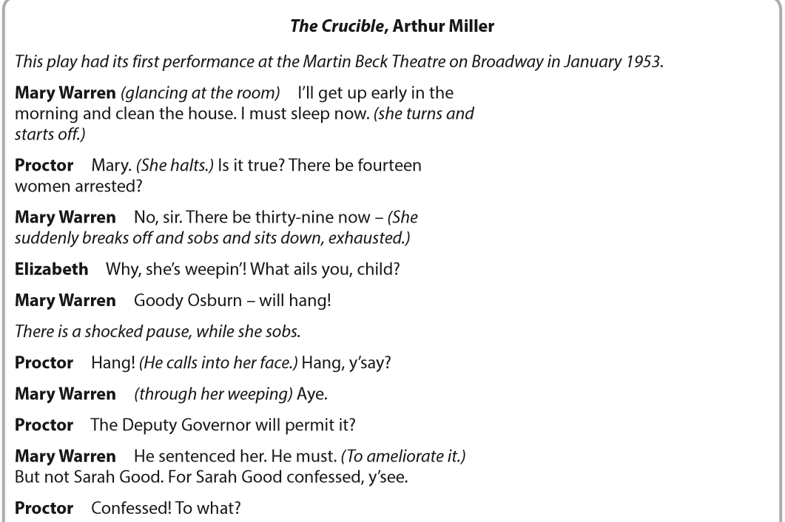

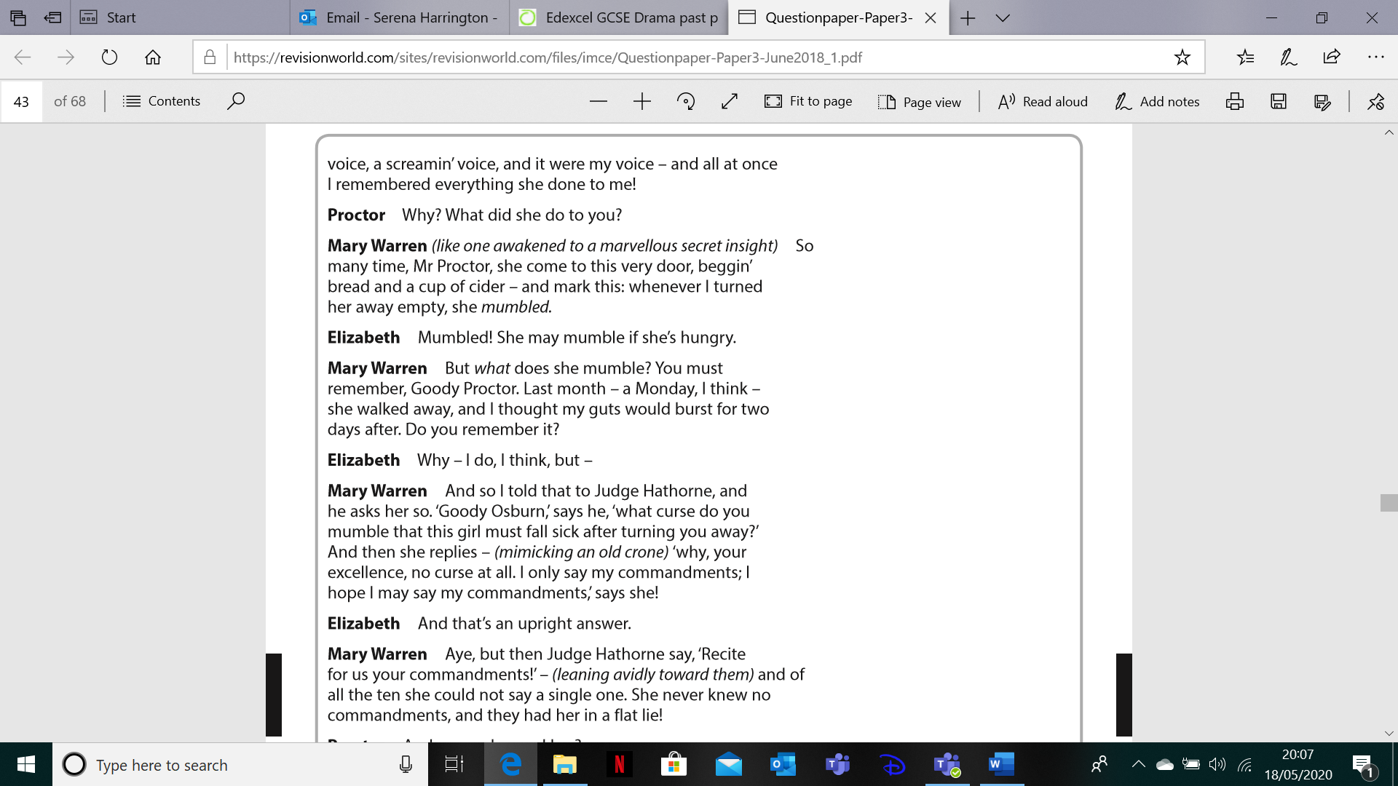

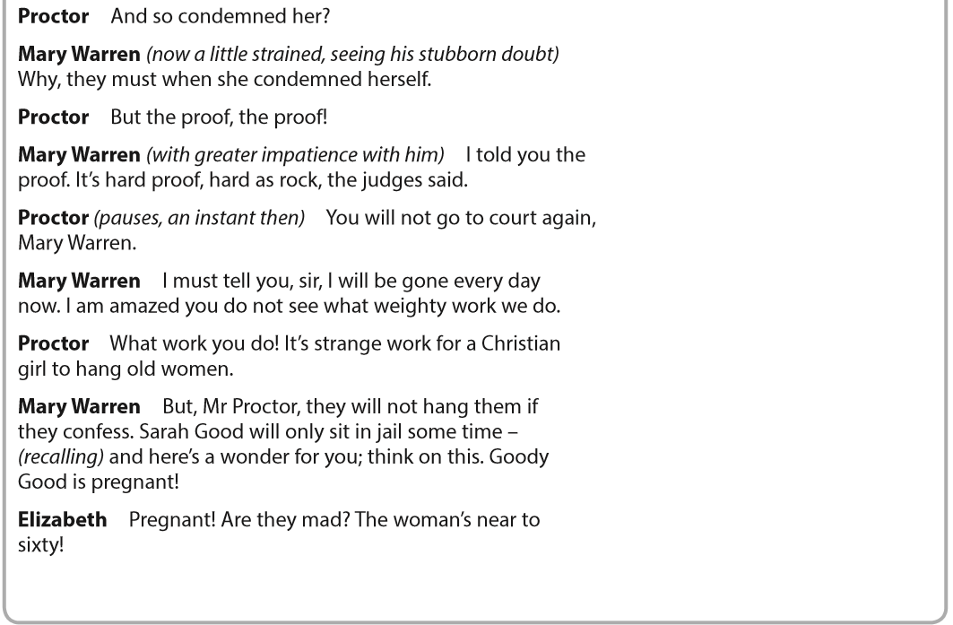

Answers:
________________________________________________________________________________________________________________________________________________________________________________________________________________________________________________________________________________________________________________________________________________________________________________________________________________________________________________________________________________________________________________________________________________________________________________________________________________________________________________________________________________________________________________________________________________________________________________________________________________________________________________________________________________________________________________________________________________________________________________________________
________________________________________________________________________________________________________________________________________________________________________________________________________________________________________________________________________________________________________________________________________________________________________________________________________________________________________________________________________________________________________________________________________________________________________________________________________________________________________________________________________________________________________________________________________________________________________________________________________________________________________________________________________________________________________________________________________________________________________________________________________________________________________________________________________________________________________________________________________________________________________________________________________________________________________________________________________________________________________________________________________________________________________________________________________________________________________________________________________________________________________________________________________________________________________________________________________________________________________________________________________________________________________________________________________________________________________________________________________________________________________________________________________________________________________________________________________________________________________________________________________________________________________________________________________________________________________________________________________________________________________________________________________________________________________________________________________________________________________________________________________________________________________________________________________________________________________________________________________________________________________________________________________________________________________________________________________________________________________________________________________________________________________________________________________________________________________________________________________________________________________________________________________________________________________________________________________________________________________________________________________________________________________________________________________________________________________________________________________________________________________________________________________________________________________________________________________________________________________________________________________________________________________________________________________________________________________________________________________________________________________________________________________________________________________________________________________________________________________________________________________________________________________________________________________________________________________________________________________________________________________________________________________________________________________________________________________________________________________________________________________________________________________________________________________________________________________________________________________________________________________________________________________________________________________________________________________________________________________________________________________________________________________________________________________________________________________________________________________________________________________________________________________________________________________________________________________________________________________________________________________________________________________________________________________________________________________________________________________________________________________________________________________________________________________________________________________________________________________________________________________________________________________________________________________________________________________________________________________________________________________________________________________________________________________________________________________________________________________________________________________________________________________________________________________________________________________________________________________________________________________________________________________________________________________________________________________________________________________________________________________________________________________________________________________________________________________________________________________________________________________________________________________________________________________________________________________________________________________________________________________________________________________________________________________________________________________________________________________________________________________________________________________________________________________________________________________________________________________________________________________________________________________________________________________________________________________________________________________________________________________________________________________________________________________________________________________________________________________________________________________________________________________________________________________________________________________________________________________________________________________________________________________________________________________________________________________________________________________________________________________________________________________________________________________________________________________________________________________________________________________________________________________________________________________________________________________________________________________________________________________________________________________________________________________________________________________________________________________________________________________________________________________________________________________________________________________________________________________________________________________________________________________________________________________________________________________________________________________________________________________________________________________________________________________________________________________________________________________________________________________________________________________________________________________________________________________________________________________________________________________________________________________________________________________________________________________________________________________________________________________________________________________________________________________________________________________________________________________________________________________________________________________________________________________________________________________________________________________________________________________________________________________________________________________________________________________________________________________________________________________________________________________________________________________________________________________________________________________________________________________________________________________________________________________________________________________________________________________________________________________________________________________________________________________________________________________________________________________________________________________________________________________________________________________________________________________________________________________________________________________________________________________________________________________________________________________________________________________________________________________________________________________________________________________________________________________________________________________________________________________________________________________________________________________________________________________________________________________________________________
________________________________________________________________________________________________________________________________________________________________________________________________________________________________________________________________________________________________________________________________________________________________________________________________________________________________________________________________________________________________________________________________________________________________________________________________________________________________________________________________________________________________________________________________________________________________________________________________________________________________________________________________________________________________________________________________________________________________________________________________________________________________________________________________________________________________________________________________________________________________________________________________________________________________________________________________________________________________________________________________________________________________________________________________________________________________________________________________
________________________________________________________________________________________________________________________________________________________________________________________________________________________________________________________________________________________________________________________________________________________________________________________________________________________________________________________________________________________________________________________________________________________________________________________________________________________________________________________________________________________________________________________________________________________________________________________________________________________________________________________________________________________________________________________________________________________________________________________________________________________________________________________________________________________________________________________________________________________________________________________________________________________________________________________________________________________________________________________________________________________________________________________________________________________________________________________________

Mark out of 45:

WWW:

EBI:

NTIW:

NEXT STEPS AFTER YOUR RESULT: Improvement answer(s):
________________________________________________________________________________________________________________________________________________________________________________________________________________________________________________________________________________________________________________________________________________________________________________________________________________________________________________________________________________________________________________________________________________________________________________________________________________________________________________________________________________________________________________________________________________________________________________________________________________________________________________________________________________________________________________________________________________________________________________________________________________________________________________________________________________________________________________________________________________________________________________________________________________________________________________________________________________________________________________________________________________________________________________________________________________________________________________________________________________________________________________________________________________________________________________________________________________________________________________________________________________________________________________________________________________________________________________________________________________________________________________________________________________________________________________________________________________________________________________________________

