Year 9
Creative Writing

Write your own description of a journey in which you describe what the narrator sees and feels. You might choose to make this a frightening or enjoyable journey. You could use one of the images below for inspiration.
 | 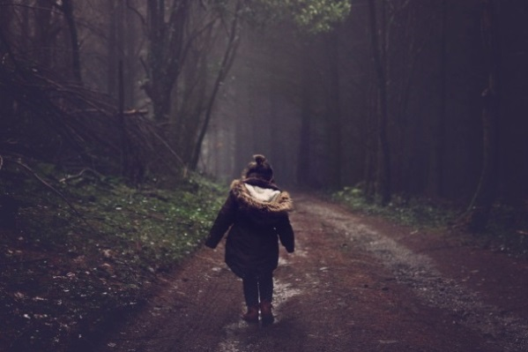
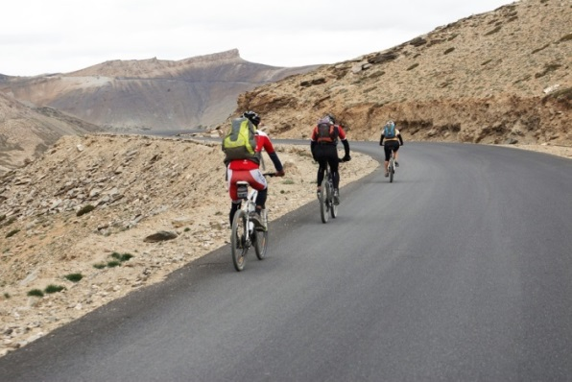 | 