Year 7 Homestudy Project

Non-Fiction reading and Writing


Name:

English Teacher:

Dear Parent/Carer,

This project is designed to prepare students for skills in reading and writing non-fiction texts. As we are stuck at home, we thought it would be nice to virtually travel, so the project is centred on the theme of holidays and foreign travel. Around this theme, pupils are encouraged to respond to non-fiction texts, as well as producing their own. Each task has been designed to target a particular skill, and these are detailed in the Learning Objective for each task.

Some of the tasks encourage pupils to discuss their thoughts and ideas with a family member. Hopefully you will enjoy working together to complete the homework project!

The English Team

Dear Student,

This term, you are studying non-fiction reading and writing. This project has the theme of travel and holidays, and all of the tasks are related to this.

As with your normal English lessons, each of the tasks has a Learning Objective which explains what you are trying to achieve from the activity.

We would like everybody to become independent learners. As such, this project depends upon you to push yourself. Task 1 is compulsory and everyone must complete it. However, it is up to you whether you challenge yourself with tasks 2 and 3.

Good luck!

The English Team
Travel Writing
Learning Objective:
Task 1: To be able to interpret information and ideas from a text.

Task 2: To be able to comment on the writer’s use of language.

Task 3: To be able to produce texts which are appropriate to task, reader and purpose.

Everyone must: Complete task 1

Most should: Complete task 2

Some will: Complete task 3

Pupil comment on task

Parent comment on task

Task 1

Read the following extract from the Lonely Planet – Guide to East Coast Australia:

The East Coast offers the typical, potted, Australian experience. This lush coastal stretch – lined with stunning beaches and dotted with superb national parks – has everything you could want. Catch rays and sunrays, boogie at Sydney’s clubs, hike forested mountains, snorkel over the Great Barrier Reef, spot dolphins and whales and succumb to a prawn-feeding frenzy.

Discuss the passage with a friend or family member and decide what makes it an effective piece of travel writing. Write your ideas below:

Task 2

Complete this table:

Verbs | Adjectives
catch

Look carefully at your table. What impression is being given of Australia through the use of these words?

Where in the writing do you think this passage comes from: the beginning, the middle or the end? What makes you think this?

Task 3
Imagine there is a paragraph in the guide on Sydney, one of Australia’s most famous cities. Research the city and produce a paragraph like the one above. Describe what you can see and do in the city, and try to use the same style as The Lonely Planet Guide.

Writing to persuade
Learning Objective:
Tasks 1 and 2: To begin to identify the writer’s purpose and understand the effect of the text on the reader.

Task 3: To be able to produce texts which are appropriate to task, reader and purpose.

Everyone must: Complete task 1

Most should: Complete task 2

Some will: Complete task 3

Pupil comment on task

Parent comment on task

Task 1

Holiday companies have to advertise their holiday destinations to persuade customers to purchase one of their holidays. Advertisements for holiday destinations don’t just describe the destination though; they use persuasive language to try and make the customer believe they must have their holiday there! How do they do this though? AFOREST is a list of persuasive techniques:

A alliteration, anecdote
F facts
O opinions
R rhetorical questions
E emotive language, exaggeration
S statistics, superlatives
T triples (rule of three)

Read the extracts from holiday brochures (below) and identify which of the AFOREST techniques are being used.

Jamaica: simply the most relaxed destination there is!

For breathtaking beauty, you can’t beat Barbados.

We’re 25% cheaper than our competitors!

Sue, from Preston said: “It was the holiday of my dreams, it was absolutely perfect in every way, and the staff were amazingly helpful.”

Tired, over-worked and underpaid? Holidays on a budget may be able to provide that much-needed break at a fraction of the regular cost.

Task 2

Find an advert or brochure for a holiday destination of your choice. Try looking online. Try to think about how the advert is trying to persuade you, the reader. Look out for any of the AFOREST techniques, as well as the images and the colours that are used. Write your ideas below:

Task 3
Research a destination of your choice. Create a persuasive leaflet to advertise the resort to holiday makers.

Try to include:
- Persuasive techniques AFOREST
- Adventurous vocabulary
- Pictures / drawings to make your leaflet appealing
- Information about accommodation, activities, food, surrounding areas etc... what else can you think of? (prices?)
Hint: Research other resorts on websites such as TUI or Expedia. Ensure your leaflet is eye - catching and interesting – otherwise no one will be persuaded to come!

Writing to inform
Learning Objective:
Task 1: To begin to identify and comment on the writer’s use of language.

Tasks 2 and 3: To understand how to organise texts effectively, sequencing information and ideas.

Task 3: To be able to write with technical accuracy of syntax and punctuation.

Everyone must: Complete task 1

Most should: Complete task 2

Some will: Complete task 3

Pupil comment on task

Parent comment on task

Task 1

Activity holidays are popular, especially for those seeking adventure and thrilling experiences. However, these activities can often be extremely dangerous and require detailed instructions. This task asks you to think about the kind of language and features that would be appropriate for an instructional guide.

Find an instructional guide or manual. Next, with a friend or family member, read through the guide and think about the kind of language that is being used and the way the information has been organised. Write your ideas below:

Task 2

When writing an instructional guide, it is important that you order your information clearly, so that your instructions are easy to follow. You can order your ideas through using time connectives. You can probably guess that time connectives signal to the reader that there has been a change in time. These connectives are particularly useful if you are writing step-by-step instructions, like a recipe, for example. Make a list of as many time connectives as you can (the list has been started for you!) You could ask friends or family if they can think of any time connectives to add to your list.

Time connectives

- Firstly

Task 3

Choose an activity that you are interested in, such as rock climbing, mountain climbing, skiing, hand gliding, abseiling, etc. Write an instructional guide on how to do your ‘activity’ safely.

Try to include:

- Clear language and factual information
- Include information such as a step by step guide and / or equipment needed.
- Time connectives
- A range of punctuation (e.g. : ; ! ? . , ( ) - ...)
- Perhaps a short anecdote ( a brief personal story about one experience from someone who does your activity and how they recall their experience)
- Photographs and/ pictures and / or diagrams of the activity

Writing to describe!

Everyone must: Complete task 1

Most should: Complete task 2

Some will: Complete task 3

Learning Objective: To be able to produce imaginative, interesting and thoughtful texts.

Task 1
Pupil comment on task

Parent comment on task

Find an image of a travel destination that you think would be interesting to describe. Working independently, or with the help of a friend or family member, mind map as many adjectives (describing words) that you can think of to describe your chosen location.

Task 2

Imagine you have been transported to your chosen location. All of your senses are being stimulated by this very different environment. Fill in the grid below with your ideas about what you can see, smell, hear, taste and feel.

SIGHT

SMELL

HEARING

TASTE

TOUCH

Task 3

Write a paragraph describing your chosen location.

Try to include as many of the following as you can:
- Adjectives for description
- Metaphors, similes and personification
- Alliteration
- All five senses
- A range of sophisticated punctuation
- Strong verbs (use a thesaurus)
- Vivid vocabulary

Holiday nightmares!
Learning Objective:

Task 1 and 2: To begin to understand how to produce texts which are appropriate to task, reader and purpose.

Task 3:
To be able to organise and present whole texts effectively, sequencing and structuring information, ideas and events.
To be able to construct paragraphs and use cohesion within and between paragraphs.

Everyone must: Complete task 1

Most should: Complete task 2

Some will: Complete task 3

Pupil comment on task

Parent comment on task

Task 1

Oh dear. Even the best-laid holiday plans can go awry. But what do you do if you’ve just returned home from the holiday from hell? You write a letter of complaint, of course! However, even if you are furious, it is important that your writing is suited to your audience (the person reading your letter), and your purpose (what you are trying to achieve). This is the best way to make sure that you get the outcome you’re after! With a friend or family member, discuss what style you should use to write a letter of complaint, as well as what the letter should contain.

Task 2

Write your ideas below:

Task 3

You have just returned from a very expensive holiday, but have had an absolutely horrible time. You think most of the negative aspects of your holiday were because your hotel was appalling! Write a formal letter of complaint to the hotel manager. You can choose a hotel that actually exists or you can choose to make one up.

Aim to include:
- A clear introduction, explaining you reason for writing
- Two-three middle paragraphs organised by a topic sentence. Each paragraph should only be about one topic.
- A strong conclusion where you repeat the points you made in the introduction
- A range of sophisticated punctuation ( : ; , . ! ? - )
- Strong connectives to link your paragraphs / ideas
- You could outline what was wrong with the hotel, but also suggest solutions or improvements
- You might organise your paragraphs like this: Introduction
Problem 1 and solution
Problem 2 and solution
Problem 3 and solution
Conclusion
Hint: A rude letter will get you nowhere! Be firm but fair! You could ask your parents and friends about bad travel experiences to get some ideas...

Presentational Devices
Learning Objective:

To identify and analyse the use of presentational devices in a range of texts

Everyone must: Complete task 1

Most should: Complete task 2

Some will: Complete task 3

Pupil comment on task

Parent comment on task

Task 1

Look at this holiday advert with a family or friend. Discuss why you think have chosen to design the poster this way.

Think about:
The colours
The pictures
The layout
The text

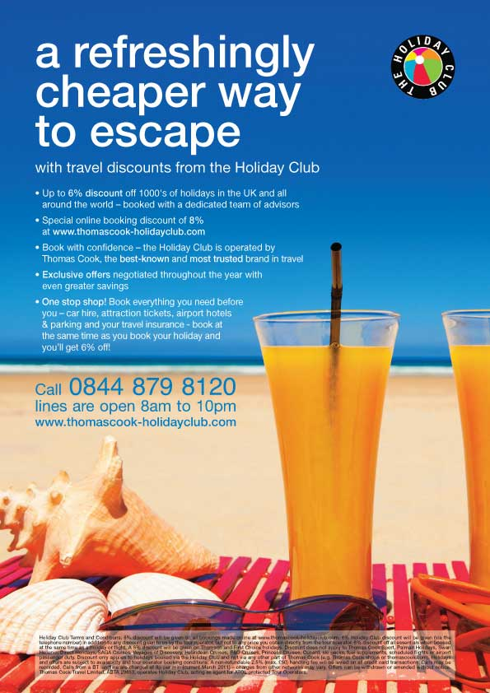

Task 2

Complete this analysis table of the poster. Some features have been picked out for you.

Presentational feature | Effect on the audience
Picture of beach, sea and blue sky

Bright colours (blue, yellow)

Task 3
How does the poster use presentational devices to interest and attract the reader?

Answer this question in full sentences using information from your table to help you.

Create your own poster
Learning Objective:

To be able to create our own poster and use presentational devices for effect

Everyone must: Complete task 1

Most should: Complete task 2

Some will: Complete task 3

Pupil comment on task

Parent comment on task

Task 1
Discuss with a parent or adult a holiday destination or product that you would like to advertise through a poster.

Discuss the choices you might make and the presentational devices you would use and why.

Task 2
Create your poster. Remember to think about all the presentational devices you could use. You can either do this by hand or on the computer.

Task 3
Write a commentary for your poster explaining the choices you have made and why you made them.

Eg) I chose to use the colour yellow because it is a happy colour which makes people think of the summer and enjoying themselves. I want people to associate my holiday company with these positive feelings.

