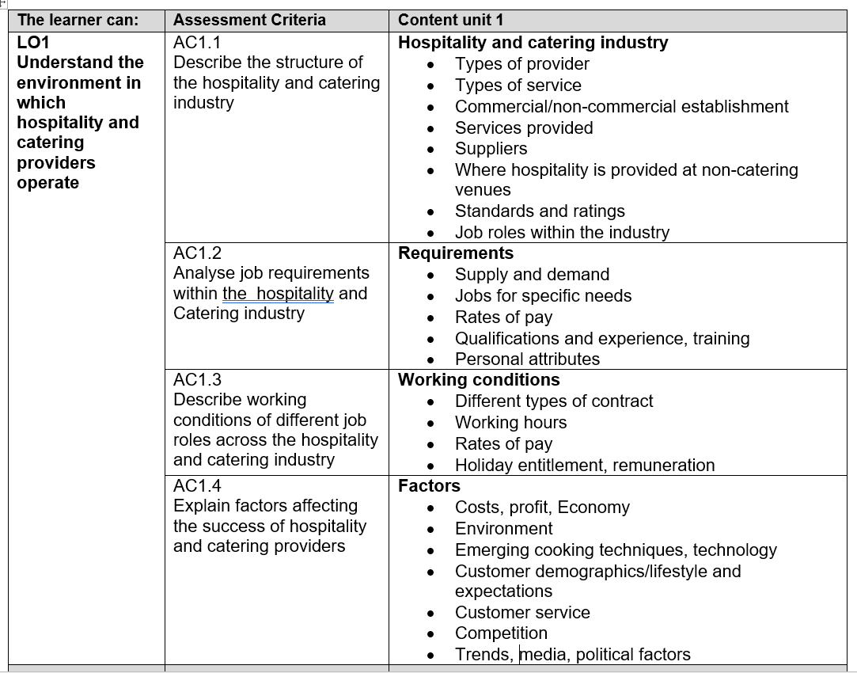

AO1
Understand the environment in which hospitality and catering providers operate
LEVEL 1 / 2 AWARD IN
HOSPITALITY AND CATERING Unit 1
Name

Group

AC1.1 structure of the hospitality and catering industry

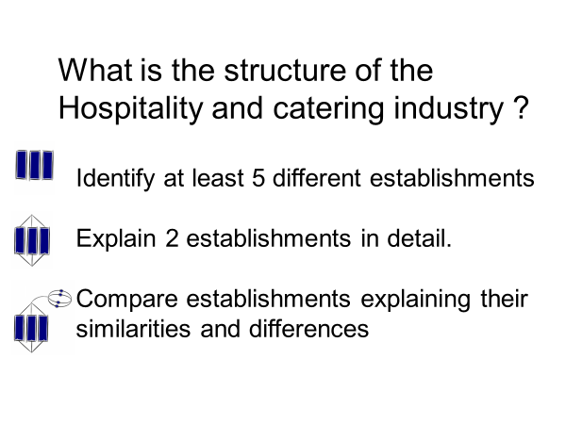
Residential
………………………………………………………………………………………………………………………………
Non-profit
……………………………………………………………………………………………………………………………….
Non-Residential
………………………………………………………………………………………………………………………………

Key Word: | Meaning within the Catering Industry: look these up online
Establishment

Hospitality

Service

Consortium

Chain

Corporate

In-house

Residential

Non-residential

Commercial

Non-commercial

Management

Outlets

Operatives

Types of establishment |  | Features
Hotels
Motels and holiday parks
Bed & breakfasts, guesthouses
Restaurants
Cafes
Fast Food
Takeaways
Public Houses and Bars
Hospitals
Prisons
Military
Care home meals

Comparing different Catering establishments

Use the following words provided to complete a comparison between a 4* Hotel and a Guesthouse or B&B.
Put each statement into the correct column.

Holds more people. Usually family run. Only does a breakfast meal.
Small (just a few rooms). Has more facilities e.g. gym and pool.
Often part of a chain.
Lots of staff work there. Has a bar and restaurant. Has very few facilities.
Might do an evening meal. Meals can be taken in rooms.

Then use your own words to compare a 4* restaurant with McDonalds

4* Hotel | Guesthouse or B & B
4* Restaurant | McDonald’s

Where are you now?

AC1.1.2 Styles of service
Personal service
Counter service
Table service

Travel service
Transported meal service
Tray service
Vending service
Meal delivery
Plate service
Family service
Silver service
Gueridon service
Cafeteria
Self service
Fast food
Take away
Buffet
Carvery

Style of service | Description
Cafeteria / self service
Fast food / take away
Buffet / carvery
Plate service
Family service
Silver service
Gueridon service
Travel service and transported meal service
Tray service
Vending service
Meal delivery
Where are you now?

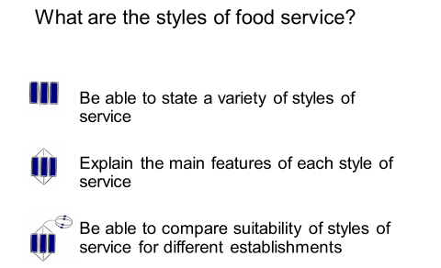

AC1.1.3 Food at non-catering venues

MENU
MENU

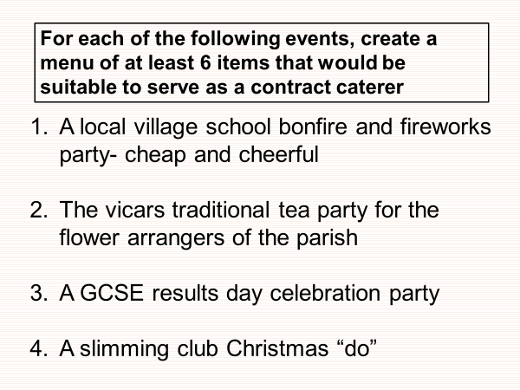

MENU
MENU

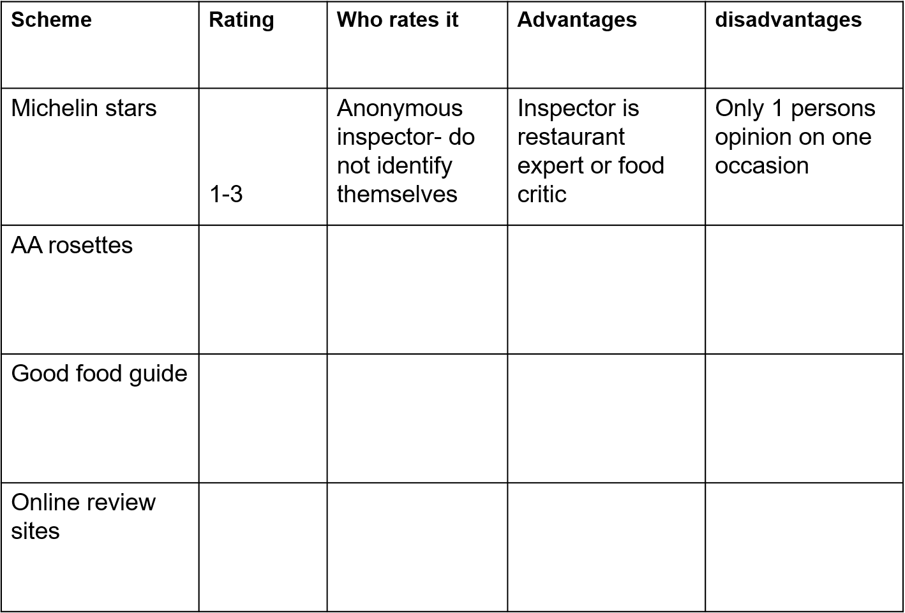

Suppliers to hospitality and catering

Type of supplier | Advantages | Disadvantages
Specialist markets
Local suppliers
Large wholesalers
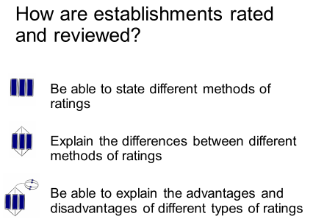
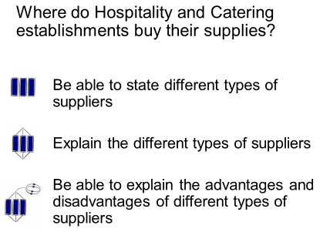

1. The Royal Hotel has decided to offer a buffet service for its New Years Eve Party.
(a) State two advantages of a buffet service to: [4]
the hotel:
(i)

(ii)

the customer:
(i)

(ii)

(b) Describe the role of the wait staff during a buffet service. [4]

Transported Meal Systems

The most well-known type of transported meals is airline food – also known as ‘in-flight’ catering.

Research this type of catering and explain how the airline food system works.

Advantages of in-flight meals: | Disadvantages of in-flight meals:

AC1.2 Job roles in the Hospitality and Catering industry

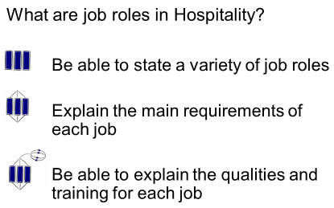
The kitchen brigade

Kitchen assistant
Commis chef
Kitchen porter

Profile – Head chef
Responsibilities

Skills

Qualifications
Salary
Career progression

Profile – Sous chef
Responsibilities

Skills

Qualifications
Salary
Career progression

Profile – Commis chef
Responsibilities

Skills

Qualifications
Salary
Career progression

Profile – Kitchen Assistant
Responsibilities

Skills

Qualifications
Salary
Career progression

Front of house

Describe the job roles of the staff above
Restaurant manager…………………………………………………………………….
…………………………………………………………………………………………….
………………………….…………………………………………………………………
Head waiter/ess…..…………………………………………………………………….
…………………………………………………………………………………………….
…………………….………………………………………………………………………
Wine waiter………..…………………………………………………………………….
…………………………………………………………………………………………….
……….……………………………………………………………………………………
Waiting staff………..…………………………………………………………………….
…………………………………………………………………………………………….
………………………….…………………………………………………………………
Station | Title (French) | Menu items prepared
Pastry chef
Larder chef
Vegetable chef
Sauce chef
Fish chef
Soup chef

AC 1.1 What are the working conditions in the Hospitality and Catering industry ?

When are the busy times for the Hospitality and catering industry?

Times of day Days of week Times of year
…………………………………………………………………………………………………………………………………………………………………………………………………………………………………………………………………………………………………………………………………………………………………………………………………………………………………………



Contracts of employment
Part-time

Full-time
……………………………………………………………………………………………………………………………………………………………………………………………………………………………………………………………………………………………………………………………..……………………………………………………………………………………………………………………………………………………………………………………………………………………………………………………………………………………………………………………………………………………………………………………………
………………………………………………………………………………………………………………………………………………………………………………………………………………………………………………………………………………………………………………………………………………………………………………………………………………………………………………………………………………………………………………………………………………………………………………………………………………………………………….…………………………………………………………………………………
Temporary
Casual
………………………………………………………………………………………………………………………………………………………………………………………………………………………………………………………………………………………………………………………………………………………………………………………………………………………………………………………………
………………………………………………………………………………………………………………………………………………………………………………………………………………………………………………………………………………………………………………………………………………………………………………………………………………………………………………………………

Full-time and Part-time employees must have;

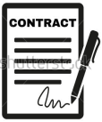


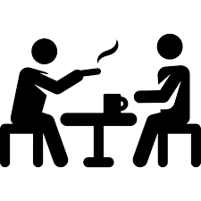
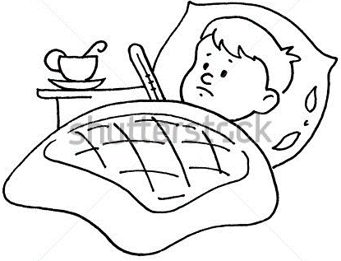

Legislation protecting workers
1…………………………………………………………………………….2…………………………………………………………………………….3…………………………………………………………………………….4…………………………………………………………………………….5…………………………………………………………………………….6…………………………………………………………………………….

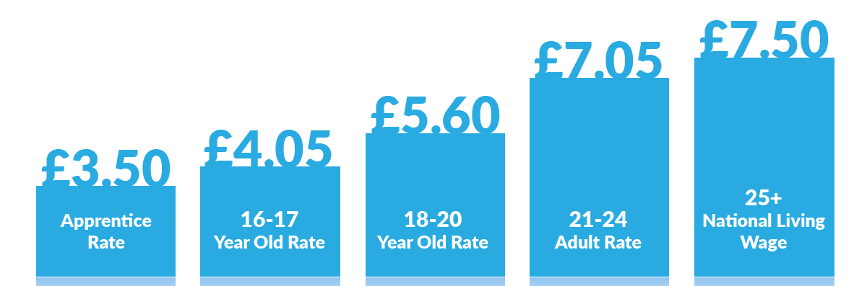

3. The Royal Hotel needs to recruit staff for its busy holiday season, discuss the type of contract that would suit the following interviewees. What are the advantages to the Royal Hotel and the employees
(a) A College student who studies 5 days a week but gets weekends and holidays off college.
Suitable contract ………………………………………………………………………………………………
Advantages for the student ….……………………………………………………………………………….................... ………………………………………………………………………………………………………..………………..………………………………………………………………………….………………………………………………………………………..........................
Advantages for the hotel ………..………………………………………………………………………………......... ……………………………………………………………………………………………………………………………………………………………………………………………………………………………………………………………………......................................
(b) A mother of a 12-year-old who is at school nearby in term time.
Suitable contract ………………………………………………………………………………………………
Advantages for the mother ….……………………………………………………………………………….................... ………………………………………………………………………………………………………..………………..………………………………………………………………………….………………………………………………………………………..........................
Advantages for the hotel ………..………………………………………………………………………………......... ……………………………………………………………………………………………………………………………………………………………………………………………………………………………………………………………………......................................
(c) Where might an establishment find casual staff to work at short notice?
…………………………………………………………………………………………………………………………..….........................................................................................
(d) How much would a 17 year old earn if they worked 8 hours over the weekend?
……………………………………………………………………………………………………………………………......................................................................................…..
(e) What other remuneration could they receive ?
………………………………………………………………………………………………………………….....................................................................................………………
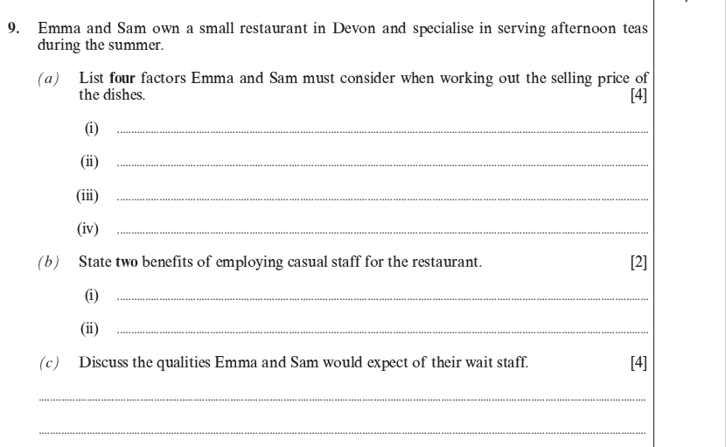
[10]

Sea View Guesthouse
Head Chef required
- You will be responsible for a busy kitchen and 4 kitchen staff.
- The Sea View Guesthouse Restaurant is open Tuesdays to Saturdays for both lunch and evening meals.
- We offer an à la carte menu that needs updating.
- Salary negotiable.

Explain 4 qualities that are essential for a head chef
What sort of salary could a head chef expect?

AC1.4 Factors affecting success of Hospitality and Catering providers.

What are the reasons that Hospitality businesses could fail?
1

2

3

4

5

6

7

8

9

10

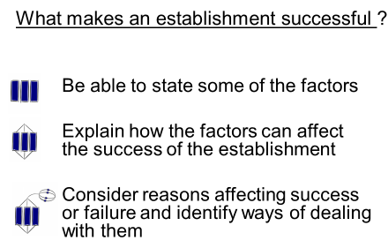
Where are you now?
Factors affecting success of Hospitality and Catering providers
Costs
Economy
Environment
Technology
Cooking techniques
Competition
Customer service
Trends
Political factors
Media

SWOT analysis
Category
Sector
USP
STP
Segment
Target Group
Positioning
SWOT Analysis
Strengths
Weaknesses
Opportunities
Threats
Competition

A hotel/restaurant did not make a profit last year and wants to work out what changes they need to make so that they can make a profit this year. Suggest different ways the hotel/restaurant can improve their profit. (6 marks)
……………………………………………………………………………………………………………………………………………………………………………………………………………………………………………………………………………………………………………………………………………………………………………………………………………………………………………………………………………………………………………………………………………………………………………………………………………………………………………………………………………………………………………………………………………….
NB – you can choose the type of hotel or restaurant.

