
Geog your memory...
Define these key terms:  Urbanisation –  Rural-urban migration –  Megacity – | Draw the DTM here:  Include examples and characteristics/info for each stage.
  Births and deaths per 1000 per year | Stage 1 | Stage 2 | Stage 3 | Stage 4 | Stage 5
  Eg.
  Info

Explain how these factors increase hazard risk:  - Large urban population ____________________________________ ____________________________________ ____________________________________  - No evacuation/warning system in place ____________________________________ ____________________________________ ____________________________________  - Large scale poverty ____________________________________ ____________________________________ ____________________________________ | Explain how these plants have adapted to live in the rainforest.
  Buttress Roots:  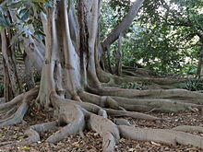 | Lianas:  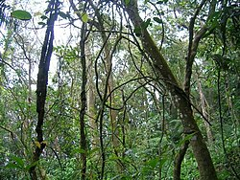

Case Study – Typhoon Haiyan
Location: __________________________________________________________________________________
Date: ________________ Wind speed: _____________ Number of people affected: _____________
Colour code grid to show primary effects, secondary effects and immediate and long term responses. Don’t forget a key.

6300 people killed, most drowned in storm surge. | French, Belgian and Israel set up field hospitals to help. | 1200 evacuation centres set up to help homeless. | 400mm of rain caused widespread flooding.
New homes built away from areas at risk of flooding. | 600,000 people left homeless and 40,000 homes destroyed. | Looting and violence broke out in Tacloban. | Rebuilding of roads, bridges and airport facilities.
UN and other countries including UK donated financial aid & medical supplies. | Red Cross delivered food aid, clean water and search and rescue teams. | Tacloban airport so badly damaged it stayed closed for 6 days. | Power supplies cut off due to collapsed buildings – for over a month.
14 million people affected, many left homeless and 6 million lost jobs. | 30,000 fishing boats damaged in wind so people lost jobs/money. | Rice farming and fishing quickly re-established to ensure people got income. | Flooding causes landslides which blocked aid supplies to some areas.
Exam Question: using an example you have studied, discuss how the immediate and long term responses helped to reduce its effects. (9 marks)

