Name

Class
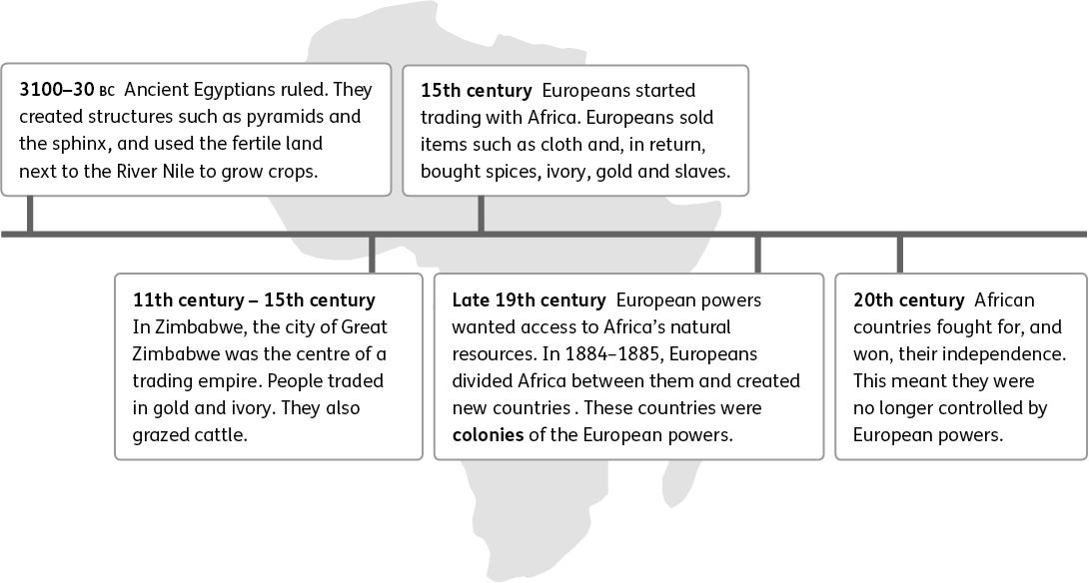
1. ‘Trade formed a key part of Africa’s history.’ How do we know? Give two pieces of evidence from the text to support this statement.
Since the 11th century

C
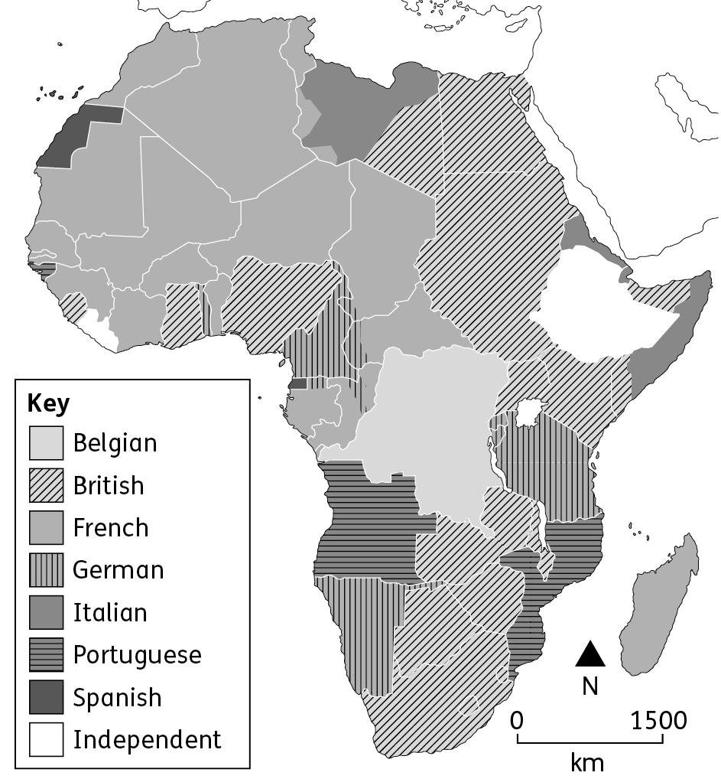
European colonies in Africa, 1913
2. Using an atlas and map C, state which European powers colonised:
(a) Sudan B
(b) Angola P
(c) Mali. F
3. In many African countries, the population speaks several different languages. Suggest one benefit and one problem caused by this.
Benefit:

Problem:

Tip!

Official languages are used by the government and on legal documents, so look at Europe’s role in Africa’s history.
4. Explain why European languages
are the official languages in many
African countries.

E
Country | Urban population in 1960 (%) | Urban population in 2017 (%)
Niger | 6 | 16
Tanzania | 5 | 33
Algeria | 31 | 72
Urban populations in some African countries
5. Using table E, calculate the percentage increase in urban population between 1960 and 2017 for Niger and Algeria.
Niger:
Algeria:

Farming in Tanzania
67% of Tanzania’s population live in rural areas. Most of these people are farmers. Many are subsistence farmers.

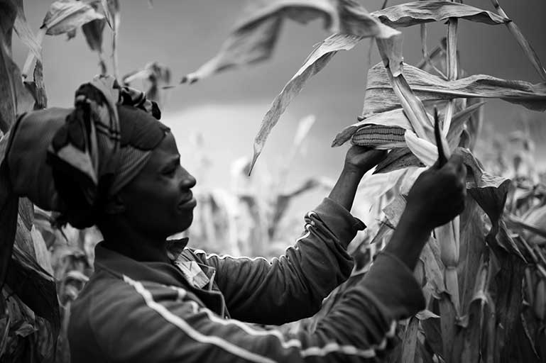
F
‘Our farm is about two acres in size. We grow crops like bananas and maize, which we use to feed our family. We don’t spend much because we eat the food we grow.
We don’t make much money from selling crops. At the moment, we use hand hoes to till the soil. If we had more money, we would buy a tractor.
Some of our neighbours do other jobs to earn more money. One of them mends motorbikes and sells soft drinks at a little stall.’
Farming maize in Tanzania
6. Look at photo F and the related text. Suggest two ways life can be hard for a subsistence farmer.
1

2

Subsistence farmers only grow food to feed themselves and their families.

Tip!

I
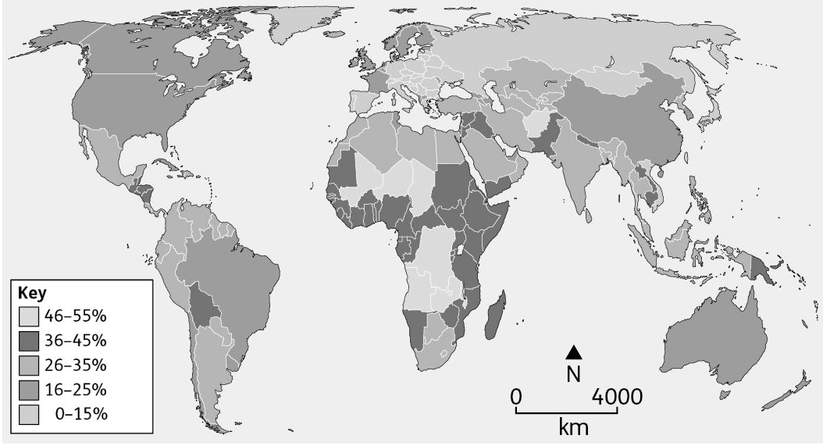
The percentage of population under 15 years of age

7. Make a true and false game based on map I.
You will also need an atlas, map I and a partner.

You will need to know why the false facts you write are false! For example:
Fact: Greenland has a high percentage of people under 15.
Answer: False. The percentage under 15 is only 0–15%, which is low compared to other countries.

Tip!
(a) Write five facts based on the map. Some of the facts should be true and others false.
(b) When you have finished, ask your partner to say whether each fact is true or false.
(c) If it is false, they must say why.
(d) Then switch roles.

8. ‘The growing size of Africa’s young population is an opportunity.’ Evaluate this statement, saying whether you agree or disagree, and why.

