Name
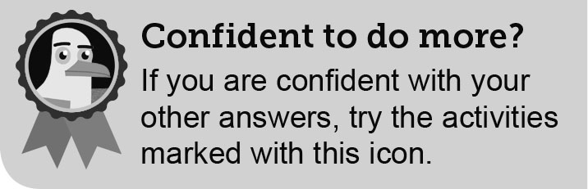
Class
B
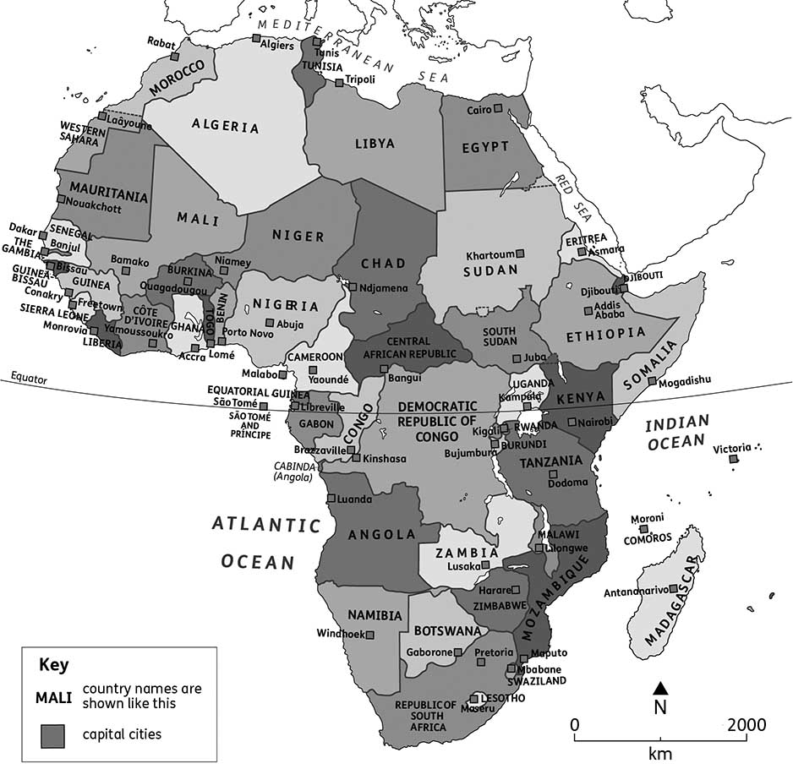
The countries in Africa and their capital cities
1. Which country am I? Use map B to identify each one below.
(a) I am the biggest country in Africa. My name begins with A.

(b) The Equator goes through me. My capital city is Libreville.

(c) I completely surround the country of Lesotho.

(d) I am a small country on the west coast and am surrounded by Senegal.

2. ‘In Africa, there is a lot of diversity.’ Explain what that sentence means. (You can use the Glossary to find a definition of ‘diverse’.) Justify your ideas with at least one example.
Africa is described as having lots of diversity because

Understanding command words is essential if you are to be successful in examinations. For example, explain is all about giving reasons – hence often using ‘because’ in the answer; and justify is about accounting for your answer. The evidence (examples) you use to support your answer is very important.

Tip!

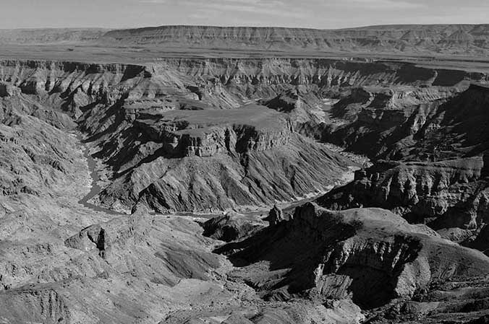
D

Large areas of Namibia are desert and mountainous
3. Use photo D to explain why it would be difficult to live in this part of Namibia.
It would be difficult to live in this part of Namibia because


4. Each country in Africa has its own flag. The different parts of the flags all have a meaning.
Research the flag of one of these three African countries:
Botswana, The Gambia and Kenya.
Draw the flag using the correct colours, then explain what the parts of the flag mean using either annotations or writing your answer on the lines provided.
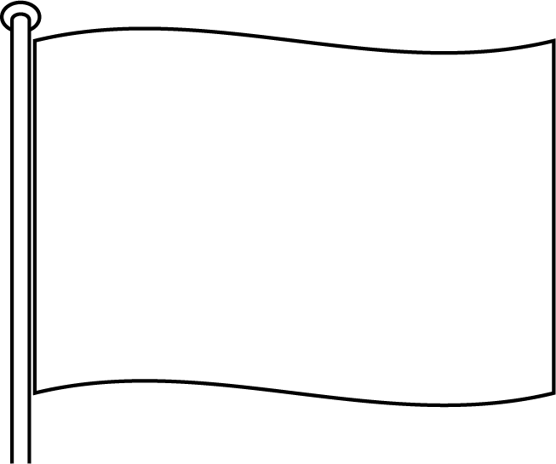

5. Look at the six landscape photos E–J. Describe the landscapes, using no more than three sentences for each photo.
F
E
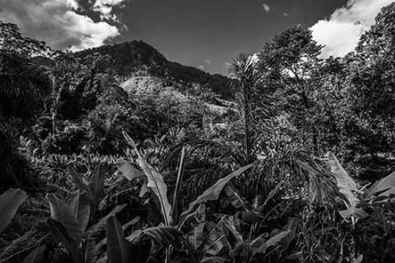
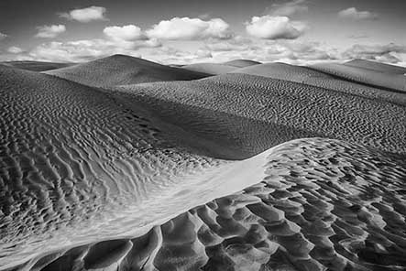

The Sahara Desert Madagascar
The Sahara Desert shows a landscape of Madagascar shows a landscape of

H
G
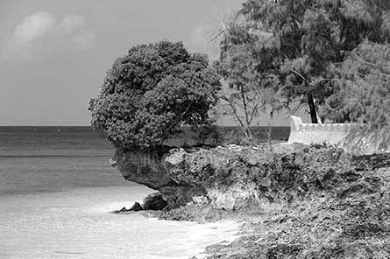
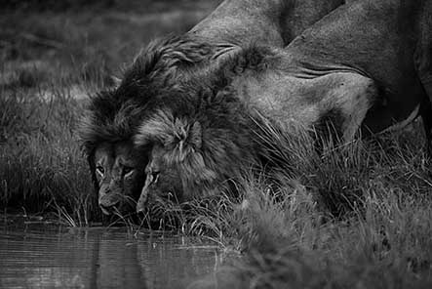

Kruger National Park, South Africa Zanzibar, Tanzania

J
I
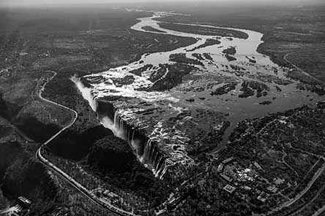
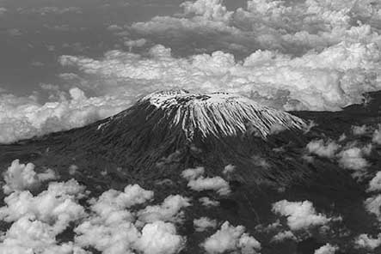

Kilimanjaro, Tanzania Victoria Falls, Zambia

Landscape descriptions are all about putting into words what you see. Imagine describing the features, colours, conditions, vegetation (plants), etc. to a friend on the phone.

Tip!

6. Give the names of the two oceans that border Africa.
1
2
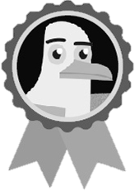
7. Give the names of the two deserts in the south of Africa.
1
2

K
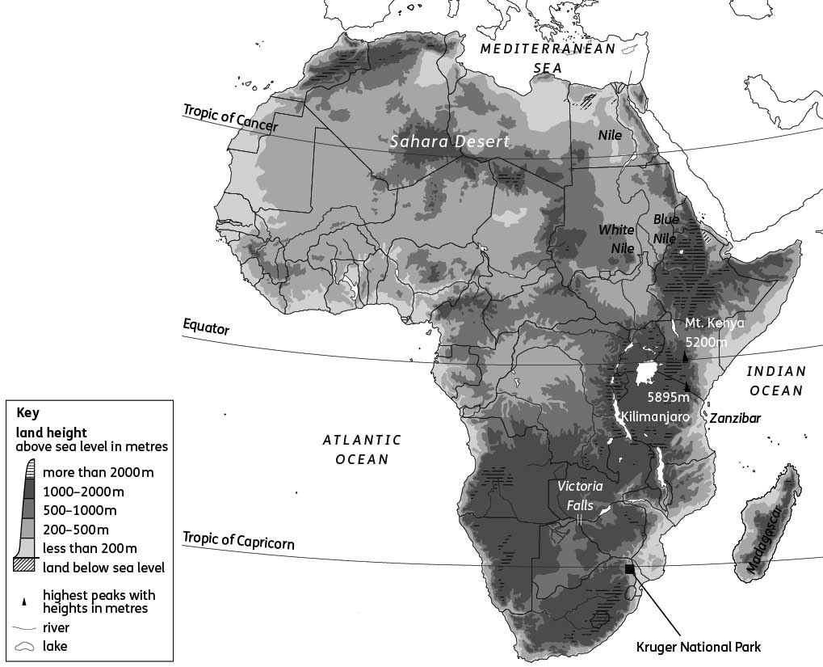
The physical features of Africa
8. The River Nile starts in the south and flows north. Use map K to answer these questions about the Nile.
(a) Which sea does the Nile flow into?

(b) Give the names of the two tributaries that flow into the Nile.
W B
(c) Use map B to name three countries that the Nile flows through.

9. Produce a leaflet to compare two countries in Africa – one from the north and one from the south. Use a separate piece of paper for this. For example, South Africa and Algeria could be used. In your leaflet, describe six ways the countries are different. For example, consider:
landscapes
cultures
languages
religions
biomes
climates.
10. ‘Natural resources are important to Africa.’ Evaluate this statement, using information from this unit to support your answer.

Evaluate is a command word asking you to consider different options, ideas or arguments before coming to your own conclusion/opinion. Your conclusion, about how true you feel this statement is, must be supported by evidence.

Tip!

Natural resources are materials from Earth that can be used by people, such as gold or oil.

Tip!

