Name …………………………………………………………

Grade 4 consolidation

No. | Question | √ | No. | Question | √
1 | Calculations & Estimations (C) |  | 20 | Inequalities (B)
2 | Prime Factors, HCF, LCM (C) |  | 21 | Plotting Graphs (C)
3 | Fractions ( x and - ) (C) |  | 22 | Plotting Graphs 2 (C/B)
4 | Compound Interest (C) |  | 23 | Grouped distributions & finding the median (C)
5 | Similar shapes & ratio (B) |  | 24 | Sequences & the nth term (C)
6 | Standard Form (C/B) |  | 25 | Scattergraphs (C)
7 | Algebra (simplifying, expanding, factorising)(C) |  | 26 | Estimated Mean (C)
8 | Algebra (expressions 1) (C) |  | 27 | 2 way tables (C)
9 | Algebra (expressions 2) (C/B) |  | 28 | Cumulative Frequency (B)
10 | Substitution & Changing subject of a formula (C/B) |  | 29 | Circles (C)
11 | Trial & Improvement (C) |  | 30 | Similar Triangles (C/B)
12 | Expand, Simplify & Factorise (C) |  | 31 | Transformations: Rotations (C)
13 | Expressions & Solving (C) |  | 32 | Pythagoras (C)
14 | BIDMAS (C) |  | 33 | Probability 1 (C)
15 | Solving Equations (C) |  | 34 | Probability 2 (C)
16 | Simultaneous Equations (B) |  | 35 | Angles (D/C)
17 | Straight Line graphs (C) |  | 36 | Volume (D)
18 | Factorising quadratics (B) |  | 37 | Bearings (C)
19 | Stem & Leaf Diagrams (C) |  | 38 | Trigonometry (B)

—————————————————————————————————————————

Question 1

Tom uses his calculator to multiply 17.8 by 0.97.
His answer is 18.236.

(a) Without finding the exact value of 17.8 × 0.97, explain why his
answer must be wrong. (1 mark)

Sally estimates the value of :

to be 8.

(b) Write down three numbers Sally could use to get her estimate.

………….. × …………….
…………….. (2 marks)

(c) Calculate the value of
21.7 × 32.1
16.20 − 2.19
Give your answer correct to 3 significant figures (3 marks)

—————————————————————————————————————————

Question 2

(a) The number 175 can be written as a product of its prime factors

175 = 5² × 7

Write as a product of its prime factors

(i) 50

(ii) 140 (4 marks)

(b) Find the Highest Common Factor of 75 and 90.

...............................
(2 marks)

(c) Find the Lowest Common Multiple of 75 and 90.

...............................
(2 marks)

—————————————————————————————————————————

Question 3

Give your answer as a fraction in its simplest form.
...............................
(2 marks)

...............................
(2 marks)

—————————————————————————————————————————

Question 4

(a) £5000 is invested for 3 years at 4% per annum compound interest.

Work out the total interest earned over the three years.
£ ........................
(3 marks)

(b)


£ ............................
(3 marks)

—————————————————————————————————————————

Question 5

BC is parallel to DE.
AB is twice as long as BD.

AD = 36 cm and AC = 27 cm.

(a) Work out the length of AB.
AB = ............... cm
(2 marks)

(b) Work out the length of AE.
AE = ............... cm
(3 marks)

—————————————————————————————————————————

Question 6

p = 8 × 10³
q = 2 × 10⁴

(a) Find the value of p × q.
Give your answer in standard form. (2 marks)

(b) Find the value of p + q.
Give your answer as an ordinary number. (2 marks)

—————————————————————————————————————————

Question 7

(a) Simplify y³ × y⁴
...............................
(1 mark)

(b) Expand and simplify 5(2x + 3) − 2(x − 1)
...............................
(2 marks)

(c) (i) Factorise 4a + 6
...............................

(ii) Factorise completely 6p² − 9pq
...............................
(3 marks)

(d) Find the value of

(i) 10⁻² ...............................

(ii) 7⁰ ...............................
(2 marks)

—————————————————————————————————————————

Question 8

The perimeter of the pentagon is 200 cm.

Work out the value of x. (3 marks)

—————————————————————————————————————————

Question 9

In the diagram, each side of the square ABCD is (3 + x) cm.

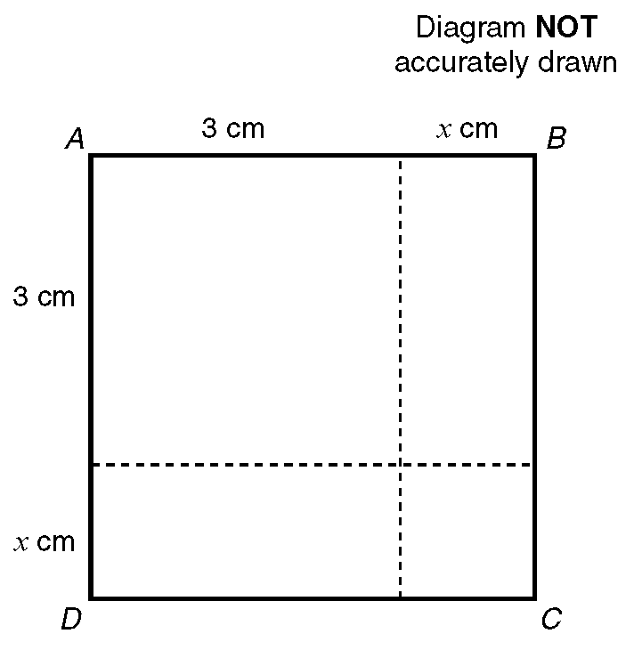

(a) Write down an expression in terms of x for the area, in cm², of the square ABCD.

The actual area of the square ABCD is 10cm².
(b) Show that x ² + 6x = 1

—————————————————————————————————————————

Question 10

(a) Calculate the value of v when u = −6, a = 5 and s = 0.8 using the formula:
v ² = u ² + 2as

Give your answer to one significant figure.

(b) Make u the subject of the formula v ² = u ² + 2as.

—————————————————————————————————————————

Question 11

The equation

x³ − 5x = 38

has a solution between 3 and 4.
Use a trial and improvement method to find this solution.
Give your answer correct to 1 decimal place.
You must show ALL your working.
x = .....................
(4 marks)

—————————————————————————————————————————

Question 12

(a) Expand and simplify

(x + 5)(x − 3) (2 marks)

(b) Factorise completely

6a² − 9ab (2 marks)

(c) Simplify (i) 2a + 4b + a − 2b

Expand (ii) 3(a + 2) (3 marks)

(d) Expand and simplify

2(x − 1) + 3(2x + 1) (2 marks)

—————————————————————————————————————————

Question 13

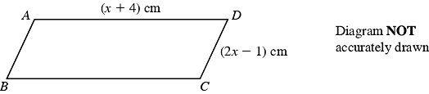

ABCD is a parallelogram.
AD = (x + 4) cm,
CD = (2x − 1) cm.
The perimeter of the parallelogram is 24 cm.

(i) Use this information to write down an equation, in terms of x.

.......................................................
(1 mark)

(ii) Solve your equation.

x = ........................
(2 marks)

—————————————————————————————————————————

Question 14

Tayub said, "When x = 3, then the value of 4x² is 144".
Bryani said, "When x = 3, then the value of 4x² is 36".

(a) Who is right?
Explain why. (2 marks)

(b) Work out the value of 4(x + 1)² when x = 3.
...............................
(1 mark)

—————————————————————————————————————————

Question 15

Solve the equations:
(a) 3y + 7 = 28

(b) 2(3p + 2) = 19

(c) 3t − 4 = 5t − 10

—————————————————————————————————————————

Question 16

(a) Solve the simultaneous equations
3x + 2y = 11
x − y = 7

(b) Solve the simultaneous equations

6x + 2y = 21
4x + 3y = 19

x = ……………………
y = …………………….
(4 marks)

—————————————————————————————————————————

Question 17

(a) On the grid below, draw the graphs of
i) x + y = 4
ii) y = x + 2
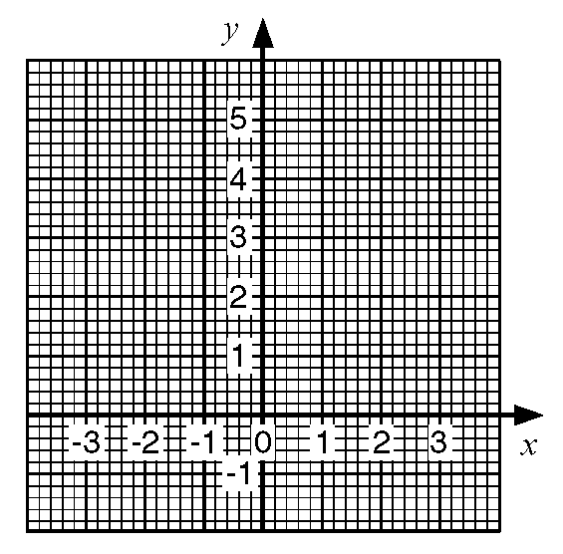
(b) Use the graphs to solve the simultaneous equations
x + y = 4
y = x + 2

—————————————————————————————————————————

Question 18

(2 marks)

(b) i) Factorise x² + 4x − 12

Hence, or otherwise,
ii) Solve x² + 4x − 12 = 0 (4 marks)

—————————————————————————————————————————

Question 19

Here are the times, in minutes, taken to change some tyres.

5 10 15 12 8 7 20 35 24 15

20 33 15 25 10 8 10 20 16 10

(a) Draw a stem and leaf diagram to show these times. (3 marks)

—————————————————————————————————————————

Question 20

y is an integer and −2 < y ≤ 2.

(a) Write down all the possible values of y. (2 marks)

(b) i) Solve the inequality 3n > −8.
ii) Write down the smallest integer which satisfies the inequality
3n > −8. (2 marks)

(c) −2 < x ≤ 1 y > −2 y < x + 1

x and y are integers.

On the grid, mark with a cross (×), each of the six points which satisfies
all these 3 inequalities.

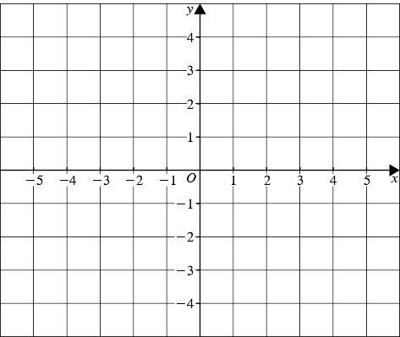

(3 marks)
—————————————————————————————————————————

Question 21

(a) Complete this table of values for
y = 3x − 1

(2 marks)

(b) On the grid below, draw the graph of y = 3x − 1

(2 marks)

(c) Use your graph to find the value of x when y = 6.5
x = ......................
(1 mark)

—————————————————————————————————————————

Question 22

(a) Complete the table of values for y = 2x²
(2 marks)

(b) On the grid draw the graph of y = 2x²

(2 marks)
(c) Use your graph to find

(i) the value of y when x = 2.5,
y = …………………

(ii) the values of x when y = 12.
x = …………… or x = ……………..
(2 marks)
—————————————————————————————————————————

Question 23

A garage keeps records of the costs of repairs to its customers' cars.
The table gives information about the costs of all repairs which were less than £250
in one week.

(a) Find the class interval in which the median lies

...............................
(2 marks)

There was only one further repair that week, not included in the table.
That repair cost £1000.

Dave says 'The class interval in which the median lies will change.'

(b) Is Dave correct? Explain your answer.

..............................................................................................................................

..............................................................................................................................
(1 mark)

The garage also sells cars.
It offers a discount of 20% off the normal price for cash.

Dave pays £5200 cash for a car.

(c) Calculate the normal price of the car.

£ ............................
(3 marks)

—————————————————————————————————————————

Question 24

The first five terms of an arithmetic sequence are

2, 5, 8, 11, 14

Write down, in terms of n, an expresson for the nth term of this sequence.

...............................
(2 marks)

—————————————————————————————————————————

Question 25

The table lists the weights of twelve books and the number of pages in each one.

This information is presented below as a scatter graph.

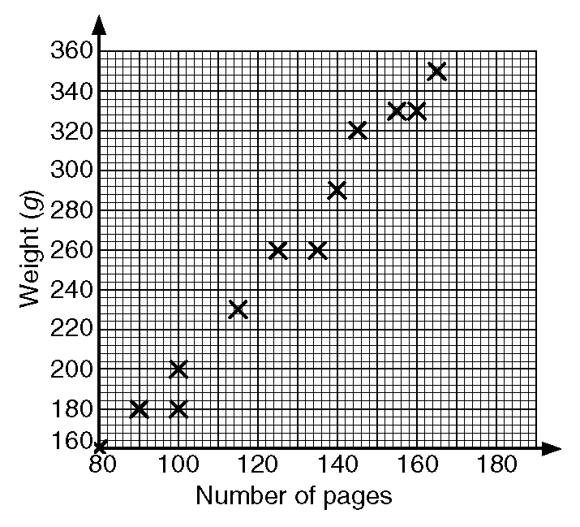

(a) Draw a line of best fit on your scatter graph.

(b) Use your line of best fit to estimate
i) the number of pages in a book of weight 280 g,
ii) the weight, in grams, of a book with 110 pages.

—————————————————————————————————————————

Question 26

Jason grows potatoes.
He weighed 100 potatoes and recorded the weights to the nearest gram.
The table shows information about the weights (w) of the 100 potatoes.

(a) Work out an estimate for the mean weight of these potatoes.
.................... g
(4 marks)

(b) Find the class interval that contains the median. (2 marks)

—————————————————————————————————————————

Question 27

200 adults were asked which one of English, Mathematics or Science they enjoyed most.

The two-way table shows some information about their answers.

Complete the two-way table. (3 marks)

—————————————————————————————————————————

Question 28

(a) On the grid draw a cumulative frequency graph for the table.

(b) Use your cumulative frequency graph to estimate the interquartile range of
the floor areas of the houses.

—————————————————————————————————————————

Question 29

A circle has a radius of 32 cm.

Work out the circumference of the circle.
Give your answer correct to the nearest centimetre.
.................. cm
(2 marks)

—————————————————————————————————————————

Question 30

Triangle ABC is similar to triangle PQR.

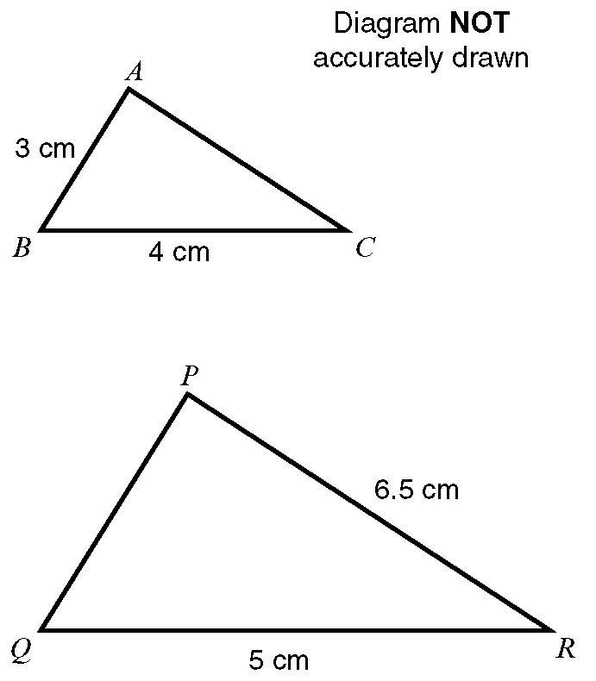

Angle ABC = angle PQR.
Angle ACB = angle PRQ.

Calculate the length of:
i) PQ
ii) AC

—————————————————————————————————————————

Question 31

(a) Describe fully the single transformation that maps shape P onto shape Q.
(2 marks)

(b) Rotate shape P 90° anticlockwise about the point A (1, 1). (2 marks)

—————————————————————————————————————————

Question 32

Calculate the length of AB.

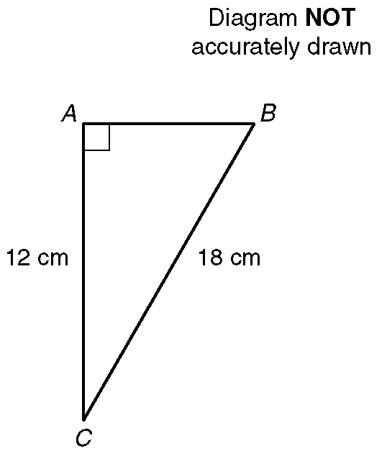

Give your answer correct to 1 decimal place.

—————————————————————————————————————————

Question 33

Martin bought a packet of mixed flower seeds.
The seeds produce flowers that are Red or Blue or White or Yellow.
The probability of a flower seed producing a flower of a particular colour is:

(a) Write down the most common colour of a flower. (1 mark)

Martin chooses a flower seed at random from the packet.
(b) i) Work out the probability that the flower produced will be White.

ii) Write down the probability that the flower produced will be Orange.

(3 marks)

—————————————————————————————————————————

Question 34

The probability that it will snow in London on Christmas Day in any year is 0.08

(a) Work out the probability that it will not snow in London on Christmas Day.

...............................
(1 mark)

(b) Work out an estimate for the number of Christmas Days in the next
50 years on which it will snow in London.

...............................
(2 marks)

—————————————————————————————————————————

Question 35

In the diagram PQ and RS are straight lines.
(a) i) Work out the value of a.

ii) Give a reason for your answer.

(b) i) Work out the value of b.

ii) Give a reason for your answer.

(c) i) Work out the value of c.

ii) Give a reason for your answer.

—————————————————————————————————————————

Question 36

In this question you must write down the units of your answer.

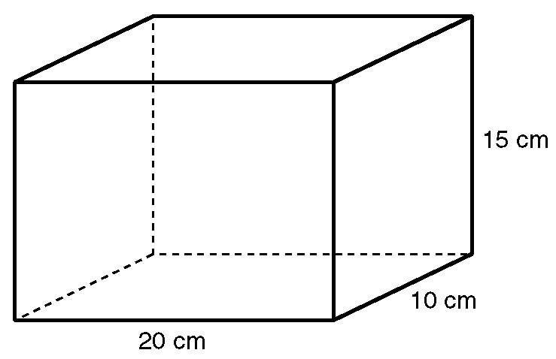

(a) Work out the area of the base of the solid shape.

(b) i) Work out the volume of the solid shape.

ii) Write this volume in litres.

—————————————————————————————————————————

Question 37

The diagram shows the position of Colwyn Bay and the position of Blackpool.

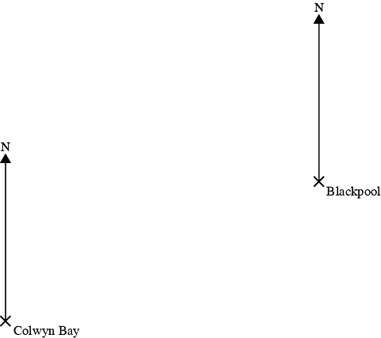

The bearing of a ship from Colwyn Bay is 032º.
The bearing of the ship from Blackpool is 290 º .

In the space above, draw an accurate diagram to show the position of the ship.

Mark this position with a cross (X). Label it S. (3 marks)
—————————————————————————————————————————

Question 38

The diagram represents a rectangle which is 6 cm long.
A diagonal makes an angle of 23 º with a 6 cm side.

Calculate the length of a diagonal.
Give your answer correct to 3 significant figures. (3 marks)

