Name …………………………………………………………

Starters (Foundation)

No. | Question | √ | No. | Question | √
1 | Using a calculator |  | 17 | Stem & Leaf diagrams
2 | Prime Factors, HCF, LCM (C) |  | 18 | Probability
3 | Fractions ( x and - ) (C) |  | 19 | Plotting Graphs 1
4 | Multiples, factors, squares & cubes |  | 20 | Plotting Graphs 2
5 | Calculations (without a calculator) |  | 21 | Naming Shapes
6 | Ordering numbers |  | 22 | Angles in Triangles
7 | Algebra (simplifying, expanding) |  | 23 | Scattergraphs
8 | Algebra (expressions 1) |  | 24 | Mode and Median
9 | Scales |  | 25 | 2 way tables (C)
10 | Algebra: substituting solving |  | 26 | Area (estimating)
11 | Distance Time graphs |  | 27 | Circles (C)
12 | Coordinates |  | 28 | Area (compound shapes)
13 | Collecting & presenting data (Piecharts) |  | 29 | Area of rectangles
14 | Questionnaires |  | 30 | Pythagoras (C)
15 | Pictograms |  | 31 | Angles
16 | Mean & Range |  | 32 | Volume
—————————————————————————————————————————

Question 1

(a) Use a calculator to work out

(b) Joy works for 35 hours and gets paid £2.50 per hour.

She pays income tax of £3.75 and National Insurance of £1.75.

She earns a bonus of £5.

Work out her take home pay
—————————————————————————————————————————

Question 2

(a) The number 175 can be written as a product of its prime factors

175 = 5² × 7

Write as a product of its prime factors

(i) 50

(ii) 140 (4 marks)

(b) Find the Highest Common Factor of 75 and 90.

...............................
(2 marks)

(c) Find the Lowest Common Multiple of 75 and 90.

...............................
(2 marks)

—————————————————————————————————————————

Question 3

Give your answer as a fraction in its simplest form.
...............................
(2 marks)

...............................
(2 marks)

—————————————————————————————————————————

Question 4

Write down two numbers from the list above which

(a) are both multiples of 12, (1 mark)

(b) are both factors of 12, (1 mark)

(c) are both square numbers, (1 mark)

(d) are both cube numbers
—————————————————————————————————————————

Question 5

Work out

41.3 × 100
...............................
(1 mark)

(b) Work out

0.4 × 0.6
...............................
(1 mark)

(c) Work out

5.2 − 1.37
...............................
(1 mark)

—————————————————————————————————————————

Question 6

Write these numbers in order of size.
Start with the smallest number

(a) 75, 56, 37, 9, 59
...............................................................................................
(1 mark)

(b) 0.56, 0.067, 0.6, 0.65, 0.605
...............................................................................................
(1 mark)

(c) 5, −6, −10, 2, −4
...............................................................................................
(1 mark)

...............................................................................................

—————————————————————————————————————————

Question 7

(a) Simplify (i) 2a + 4b + a − 2b

Expand (ii) 3(a + 2) (3 marks)

(b) Expand and simplify

2(x − 1) + 3(2x + 1) (2 marks)

(c) Simplify y³ × y⁴
...............................
(1 mark)

(d) Simplify y¹⁰ ÷ y⁶
...............................
(1 mark)

—————————————————————————————————————————

Question 8

The perimeter of the pentagon is 200 cm.

Work out the value of x. (3 marks)

—————————————————————————————————————————

Question 9

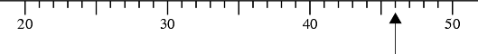

(a) Write down the number marked with an arrow. ...............................
(1 mark)

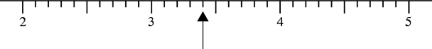

(b) Write down the number marked with an arrow. ...............................
(1 mark)

(c) Find the number 430 on the number line.
Mark it with an arrow (↑). (1 mark)

(d) Find the number 3.7 on the number line.
Mark it with an arrow (↑). (1 mark)

—————————————————————————————————————————

Question 10

(a) P = 2l +2w
l =12 and w = 8

Work out the value of P.

Solve
(a) 3x = 15 (1 mark)

(b) 4y + 6 =26 (2 marks)

(c) 3(z - 4) = 30 (2 marks)

—————————————————————————————————————————

Question 11

Mark drives 30 miles to his friend's house.
The travel graph shows Mark's journey.

(a) How long does the journey take? (1 mark)

Mark stays with his friend for one hour, He then travels home at 30 miles per hour.

(b) Complete the graph to show this information.
—————————————————————————————————————————

Question 12

(a) Write down the co-ordinates of the point
i) A
ii) B
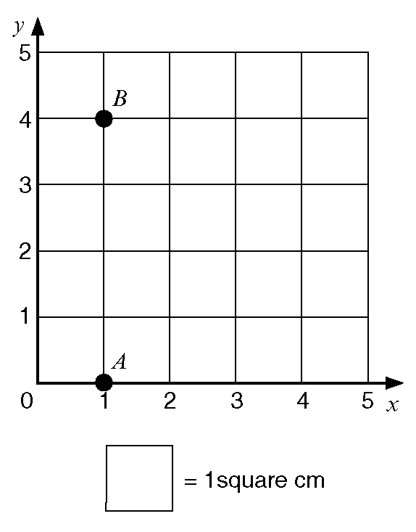

(b) On the grid plot and label the points

C (3, 4) and D (3, 2).

(c) Work out the area of the shape ABCD.

—————————————————————————————————————————

Question 13
30 people used a Sports Centre one evening.
Here is a list of the activities in which they took part.

Gym Swimming Squash Swimming Aerobics
Swimming Aerobics Aerobics Aerobics Gym
Aerobics Gym Gym Gym Squash

Squash Gym Squash Gym Gym
Gym Aerobics Aerobics Squash Gym
Gym Aerobics Squash Gym Aerobics

(a) Complete the table to show this information

(3 marks)

(b) Draw a pie chart to show this information (5 marks)

—————————————————————————————————————————

Question 14

Grace and Gemma were carrying out a survey on the food people eat in the
school canteen.

Grace wrote the question
"Which foods do you eat?"
Gemma said that this question was too vague.

Write down two ways in which this question could be improved. (2 marks)

—————————————————————————————————————————

Question 15

The pictogram shows the number of golfers who played at the local golf club
last week.

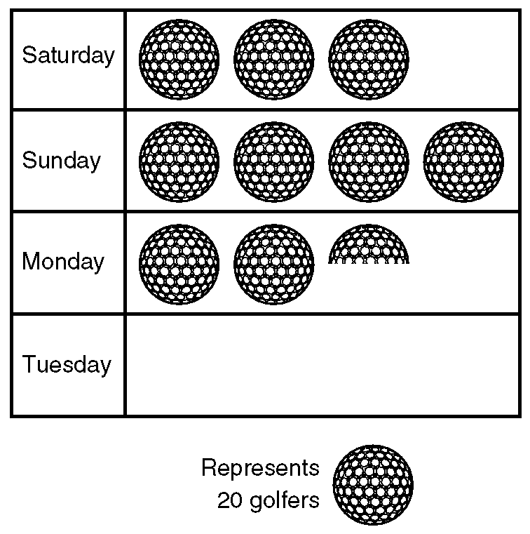

(a) How many golfers played on Sunday?

(b) How many golfers played on Monday?

On Tuesday 35 golfers played
(c) Complete the pictogram to show this.

—————————————————————————————————————————

Question 16

Here are the numbers of people living in the different houses in a short road.

4, 2, 3, 4, 5, 1, 3, 2

(a) Work out the mean number of people per house.

(b) Work out the range of the number of people living in a house.

One of the houses is to be chosen at random.

(c) On the probability line below, mark with a letter X the probability that the
house chosen will be the one with 5 people.

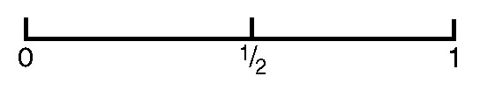

—————————————————————————————————————————

Question 17

Here are the times, in minutes, taken to change some tyres.

5 10 15 12 8 7 20 35 24 15

20 33 15 25 10 8 10 20 16 10

(a) Draw a stem and leaf diagram to show these times. (3 marks)

—————————————————————————————————————————

Question 18

Asif has a box of 25 pens.

12 of the pens are blue.
8 of the pens are black.
The rest of the pens are red.

Asif chooses one pen at random from the box.

What is the probability that Asif will choose

(i) a blue pen ..........................

(ii) a red pen? .......................... (2 marks)

—————————————————————————————————————————

Question 19

(a) Complete the table of values for x + y = 5

(2 marks)

(b) On the grid, draw the graph of x + y = 5

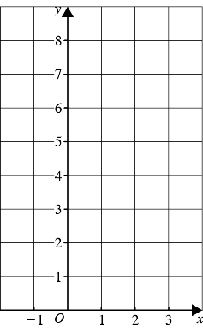
(2 marks)
—————————————————————————————————————————

Question 20

(a) Complete this table of values for
y = 3x − 1

(2 marks)

(b) On the grid below, draw the graph of y = 3x − 1

(2 marks)

(c) Use your graph to find the value of x when y = 6.5
x = ......................
(1 mark)

—————————————————————————————————————————

Question 21

(a) Write down the mathematical name of each of the following shapes.

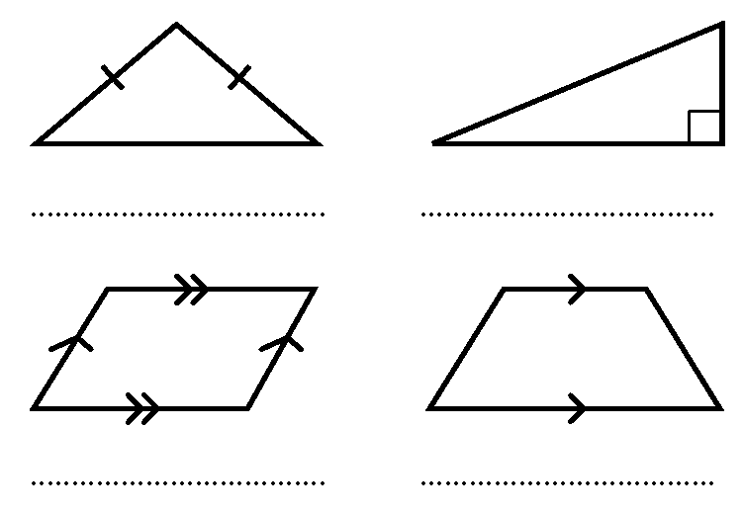

(b) Write down the mathematical name of each of the following solid shapes.

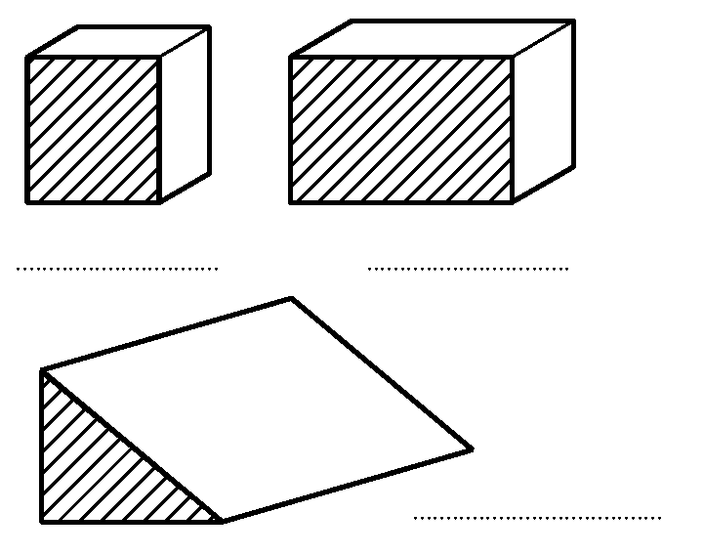

—————————————————————————————————————————

Question 22

In triangle ABC, AB = AC and angle C = 50°.

(a) Write down the special name for triangle ABC. (1 mark)

(b) Work out the value of y. (2 marks)

————————————————————————————————————Question 23
The table lists the weights of twelve books and the number of pages in each one.

This information is presented below as a scatter graph.

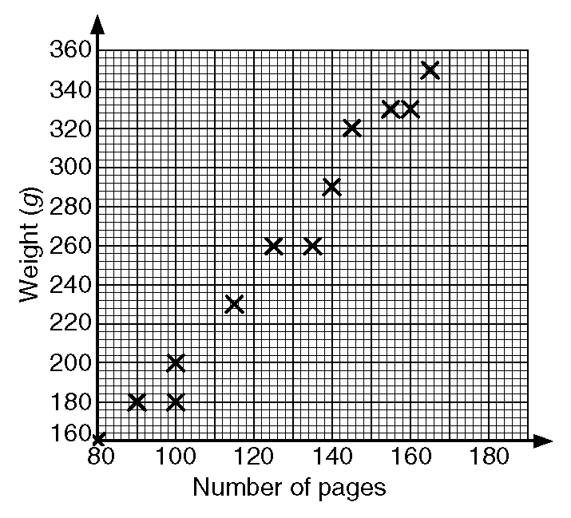

(a) Draw a line of best fit on your scatter graph.

(b) Use your line of best fit to estimate
i) the number of pages in a book of weight 280 g,

ii) the weight, in grams, of a book with 110 pages.

—————————————————————————————————————————

Question 24

Mrs Chowdery gives her class a maths test.
Here are the test marks for the girls.

7, 5, 8, 5, 2, 8, 7, 4, 7, 10, 3, 7, 4, 3, 6

(a) Work out the mode. (1 mark)

(b) Work out the median. (2 marks)

The median mark for the boys was 7 and the range of the marks of the boys was 4. The range of the girls' marks was 8.

(c) By comparing the results explain whether the boys or girls did better in the test.
(2 marks)

—————————————————————————————————————————

Question 25

200 adults were asked which one of English, Mathematics or Science they enjoyed most.

The two-way table shows some information about their answers.

Complete the two-way table. (3 marks)

—————————————————————————————————————————

Question 26

The diagram represents the surface of a lake in winter. The lake is shaded on the grid.
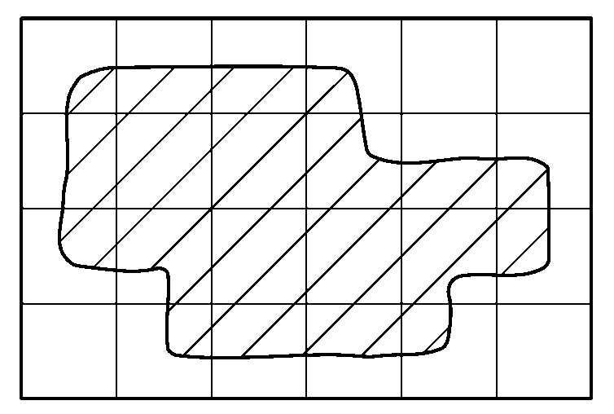

(a) Estimate the area, in cm², of the diagram that is shaded.

Each square on the grid represents a square with sides of length 100m.

(b) Work out the area, in m², represented by one square on the grid.

(c) Estimate the area, in m², of the lake.

In summer the area of the lake decreases by 15%.

(d) Work out the area, in m², of the lake in summer.

—————————————————————————————————————————

Question 27

A circle has a radius of 32 cm.

Work out the circumference of the circle.
Give your answer correct to the nearest centimetre.
.................. cm
(2 marks)

—————————————————————————————————————————

Question 28

This diagram shows the floor plan of a room.

Work out the area of the floor.
Give the units with your answer. (4 marks)

—————————————————————————————————————————

Question 29
Three different rectangles each have an area of 28 cm².

The lengths of all the sides are whole numbers of centimetres.

For each rectangle work out the length of the two sides.

Write your answers on the diagrams.

(3 marks)

—————————————————————————————————————————

Question 30

Calculate the length of AB.

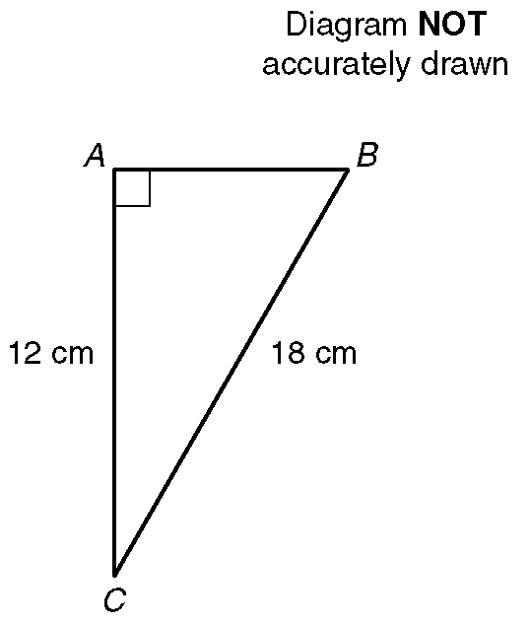

Give your answer correct to 1 decimal place.

—————————————————————————————————————————

Question 31

In the diagram PQ and RS are straight lines.
(a) i) Work out the value of a.

ii) Give a reason for your answer.

(b) i) Work out the value of b.

ii) Give a reason for your answer.

(c) i) Work out the value of c.

ii) Give a reason for your answer.

—————————————————————————————————————————

Question 32

In this question you must write down the units of your answer.

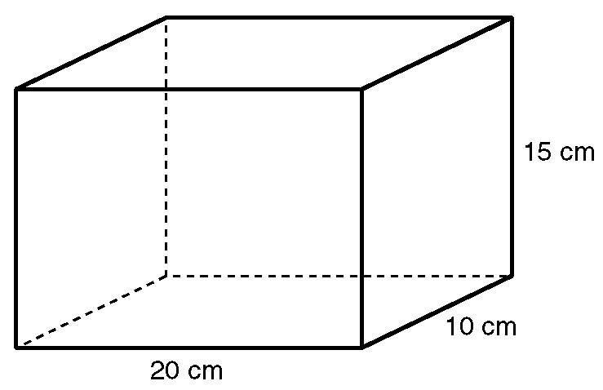

(a) Work out the area of the base of the solid shape.

(b) i) Work out the volume of the solid shape.

ii) Write this volume in litres.

