Name …………………………………………………………

Starters (Higher)

No. | Question | √ | No. | Question | √
1 | Calculations & Estimations (C) |  | 21 | Stem & Leaf Diagrams (C)
2 | Calculations & Estimations (C/B) |  | 22 | Inequalities (B)
3 | Prime Factors, HCF, LCM (C) |  | 23 | Distance-Time Graphs (B)
4 | Fractions ( x and - ) (C) |  | 24 | Plotting Graphs (C/B)
5 | Compound Interest (C) |  | 25 | Plotting Graphs 2 (C/B)
6 | Similar shapes & ratio (B) |  | 26 | Real Life Graphs (B/A)
7 | Standard Form (C/B) |  | 27 | Y = mx + c (and parallel lines) (B)
8 | Algebra (simplifying, expanding, factorising) (C) |  | 28 | Grouped distributions & finding the median (C)
9 | Algebra (expressions 1) (C) |  | 29 | Sequences & the nth term (C)
10 | Algebra (expressions 2) (C/B) |  | 30 | Surveys & Histograms (B/A)
11 | Substitution & Changing the subject of a formula (B) |  | 31 | Scattergraphs (C)
12 | Dimension Theory (B/A) |  | 32 | Estimated Mean (C)
13 | Trial & Improvement (C) |  | 33 | 2 way tables (C)
14 | Expand, Simplify & Factorise (C) |  | 34 | Probability Trees (B)
15 | Expressions & Solving (C) |  | 35 | Cumulative Frequency (B)
16 | BIDMAS (C) |  | 36 | Vectors (A)
17 | Solving Equations (C) |  | 37 | Circles (C)
18 | Simultaneous Equations (B) |  | 38 | Similar Triangles (C/B)
19 | Straight Line graphs (C) |  | 39 | Transformations: Rotations (C)
20 | Factorising quadratics (B) |  | 40 | Pythagoras & Trigonometry (C/B)
—————————————————————————————————————————

Question 1

Tom uses his calculator to multiply 17.8 by 0.97.
His answer is 18.236.

(a) Without finding the exact value of 17.8 × 0.97, explain why his
answer must be wrong. (1 mark)

Sally estimates the value of :

to be 8.

(b) Write down three numbers Sally could use to get her estimate.

………….. × …………….
…………….. (2 marks)

(c) Calculate the value of
21.7 × 32.1
16.20 − 2.19
Give your answer correct to 3 significant figures (3 marks)

—————————————————————————————————————————

Question 2

Imran uses this formula to calculate the value of F.
Imran estimates the value of F without using a calculator.

a = 49.8 and b = 30.6

(a) i) Write down approximate values for a and b that Imran could use
to estimate the value of F.
ii) Work out the estimate for the value of F that these approximations give.
iii) Use your calculator to work out the accurate value for F.
Use a = 49.8 and b = 30.6.
Write down all the figures on your calculator display. (4 marks)

—————————————————————————————————————————

Question 3

(a) The number 175 can be written as a product of its prime factors

175 = 5² × 7

Write as a product of its prime factors

(i) 50

(ii) 140 (4 marks)

(b) Find the Highest Common Factor of 75 and 90.

...............................
(2 marks)

(c) Find the Lowest Common Multiple of 75 and 90.

...............................
(2 marks)

—————————————————————————————————————————

Question 4

Give your answer as a fraction in its simplest form.
...............................
(2 marks)

...............................
(2 marks)

—————————————————————————————————————————

Question 5

(a) £5000 is invested for 3 years at 4% per annum compound interest.

Work out the total interest earned over the three years.
£ ........................
(3 marks)

(b)


£ ............................
(3 marks)

—————————————————————————————————————————

Question 6

BC is parallel to DE.
AB is twice as long as BD.

AD = 36 cm and AC = 27 cm.

(a) Work out the length of AB.
AB = ............... cm
(2 marks)

(b) Work out the length of AE.
AE = ............... cm
(3 marks)

—————————————————————————————————————————

Question 7

p = 8 × 10³
q = 2 × 10⁴

(a) Find the value of p × q.
Give your answer in standard form. (2 marks)

(b) Find the value of p + q.
Give your answer as an ordinary number. (2 marks)

—————————————————————————————————————————

Question 8

(a) Simplify y³ × y⁴
...............................
(1 mark)

(b) Expand and simplify 5(2x + 3) − 2(x − 1)
...............................
(2 marks)

(c) (i) Factorise 4a + 6
...............................

(ii) Factorise completely 6p² − 9pq
...............................
(3 marks)

(d) Find the value of

(i) 10⁻² ...............................

(ii) 7⁰ ...............................
(2 marks)

—————————————————————————————————————————

Question 9

The perimeter of the pentagon is 200 cm.

Work out the value of x. (3 marks)

—————————————————————————————————————————

Question 10

In the diagram, each side of the square ABCD is (3 + x) cm.

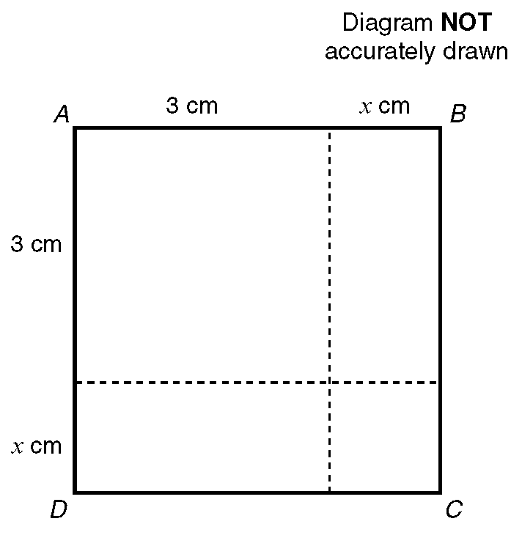

(a) Write down an expression in terms of x for the area, in cm², of the square ABCD.

The actual area of the square ABCD is 10cm².
(b) Show that x ² + 6x = 1

—————————————————————————————————————————

Question 11

(a) Calculate the value of v when u = −6, a = 5 and s = 0.8 using the formula:
v ² = u ² + 2as

Give your answer to one significant figure.

(b) Make u the subject of the formula v ² = u ² + 2as.

—————————————————————————————————————————

Question 12

Here are 3 expressions.

r, l and h are lengths.
π, 2, 3 and 4 are numbers and have no dimension.

Put a tick in the correct column to show whether the expression can be used for
length, area, volume or none of these. (3 marks)

_____________________________________________________

Question 13

The equation

x³ − 5x = 38

has a solution between 3 and 4.
Use a trial and improvement method to find this solution.
Give your answer correct to 1 decimal place.
You must show ALL your working.
x = .....................
(4 marks)

—————————————————————————————————————————

Question 14

(a) Expand and simplify

(x + 5)(x − 3) (2 marks)

(b) Factorise completely

6a² − 9ab (2 marks)

(c) Simplify (i) 2a + 4b + a − 2b

Expand (ii) 3(a + 2) (3 marks)

(d) Expand and simplify

2(x − 1) + 3(2x + 1) (2 marks)

—————————————————————————————————————————

Question 15

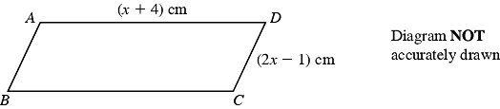

ABCD is a parallelogram.
AD = (x + 4) cm,
CD = (2x − 1) cm.
The perimeter of the parallelogram is 24 cm.

(i) Use this information to write down an equation, in terms of x.

.......................................................
(1 mark)

(ii) Solve your equation.

x = ........................
(2 marks)

—————————————————————————————————————————

Question 16

Tayub said, "When x = 3, then the value of 4x² is 144".
Bryani said, "When x = 3, then the value of 4x² is 36".

(a) Who is right?
Explain why. (2 marks)

(b) Work out the value of 4(x + 1)² when x = 3.
...............................
(1 mark)

—————————————————————————————————————————

Question 17

Solve the equations:
(a) 3y + 7 = 28

(b) 2(3p + 2) = 19

(c) 3t − 4 = 5t − 10

—————————————————————————————————————————

Question 18

(a) Solve the simultaneous equations
3x + 2y = 11
x − y = 7

(b) Solve the simultaneous equations

6x + 2y = 21
4x + 3y = 19

x = ……………………
y = …………………….
(4 marks)

—————————————————————————————————————————

Question 19

(a) On the grid below, draw the graphs of
i) x + y = 4
ii) y = x + 2
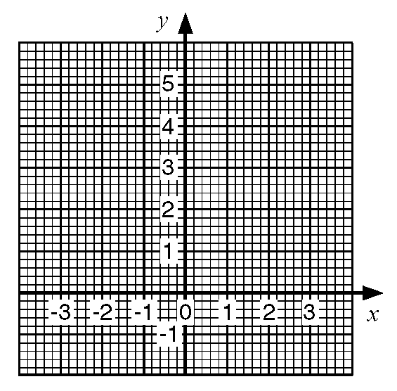
(b) Use the graphs to solve the simultaneous equations
x + y = 4
y = x + 2

—————————————————————————————————————————

Question 20

(2 marks)

(b) i) Factorise x² + 4x − 12

Hence, or otherwise,
ii) Solve x² + 4x − 12 = 0 (4 marks)

—————————————————————————————————————————

Question 21

Here are the times, in minutes, taken to change some tyres.

5 10 15 12 8 7 20 35 24 15

20 33 15 25 10 8 10 20 16 10

(a) Draw a stem and leaf diagram to show these times. (3 marks)

—————————————————————————————————————————

Question 22

y is an integer and −2 < y ≤ 2.

(a) Write down all the possible values of y. (2 marks)

(b) i) Solve the inequality 3n > −8.
ii) Write down the smallest integer which satisfies the inequality
3n > −8. (2 marks)

(c) −2 < x ≤ 1 y > −2 y < x + 1

x and y are integers.

On the grid, mark with a cross (×), each of the six points which satisfies
all these 3 inequalities.

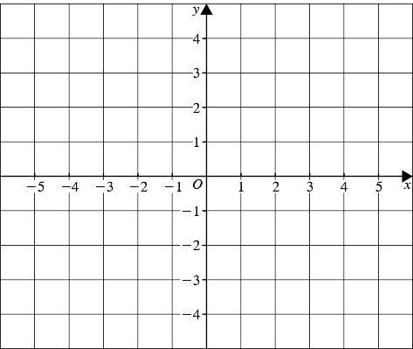

(3 marks)
—————————————————————————————————————————

Question 23

The diagram shows part of a distance/time graph for a bus after if had left a bus stop.

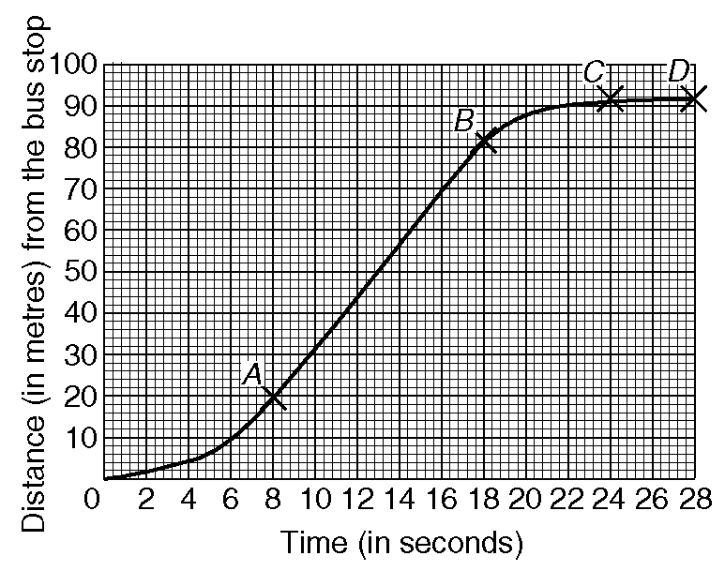

(a) Use the graph to find the distance the bus travelled in the first 20 seconds after
it had left the bus stop.

(b) Describe fully the journey of the bus represented by the parts AB,BC and CD
of the graph.

—————————————————————————————————————————

Question 24

(a) Complete this table of values for
y = 3x − 1

(2 marks)

(b) On the grid below, draw the graph of y = 3x − 1

(2 marks)

(c) Use your graph to find the value of x when y = 6.5
x = ......................
(1 mark)

—————————————————————————————————————————

Question 25

(a) Complete the table of values for y = 2x²
(2 marks)

(b) On the grid draw the graph of y = 2x²

(2 marks)
(c) Use your graph to find

(i) the value of y when x = 2.5,
y = …………………

(ii) the values of x when y = 12.
x = …………… or x = ……………..
(2 marks)
—————————————————————————————————————————

Question 26

The diagram shows four empty containers.

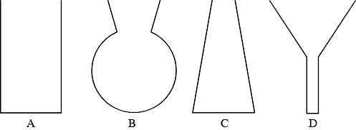

Water is poured at a constant rate into each of these containers.

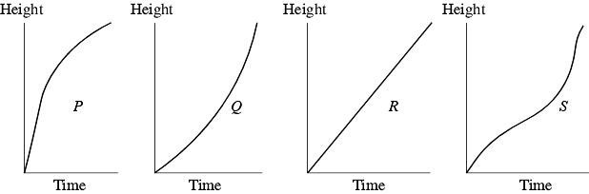

Each sketch graph shows the relationship between the height of water in a container and the time as the water is poured in.

Write the letter of each graph in the correct place in the table.

(3 marks)

—————————————————————————————————————————

Question 27

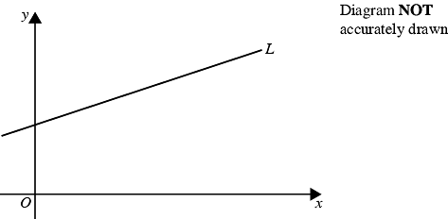

The straight line L is parallel to the line with equation 2y = x + 60.

(a) Find the gradient of line L.
...............................
(2 marks)

The straight line L passes through the point (0, 7).

(b) Find an equation for the line L.
...............................
(2 marks)

—————————————————————————————————————————

Question 28

A garage keeps records of the costs of repairs to its customers' cars.
The table gives information about the costs of all repairs which were less than £250
in one week.

(a) Find the class interval in which the median lies

...............................
(2 marks)

There was only one further repair that week, not included in the table.
That repair cost £1000.

Dave says 'The class interval in which the median lies will change.'

(b) Is Dave correct? Explain your answer.

..............................................................................................................................

..............................................................................................................................
(1 mark)

The garage also sells cars.
It offers a discount of 20% off the normal price for cash.

Dave pays £5200 cash for a car.

(c) Calculate the normal price of the car.

£ ............................
(3 marks)

—————————————————————————————————————————

Question 29

The first five terms of an arithmetic sequence are

2, 5, 8, 11, 14

Write down, in terms of n, an expresson for the nth term of this sequence.

...............................
(2 marks)

—————————————————————————————————————————

Question 30

Alan is doing a survey of the heights of boys and girls in Year 7.
He first takes a random sample of 70 boys from Year 7.

(a) Suggest a suitable method that Alan could use to take a
random sample. (2 marks)

The table and the incomplete histogram show information about the boys' heights
in this sample of 70 boys.

(b) Use the information in the table to complete the histogram. (3 marks)

—————————————————————————————————————————

Question 31

The table lists the weights of twelve books and the number of pages in each one.

This information is presented below as a scatter graph.

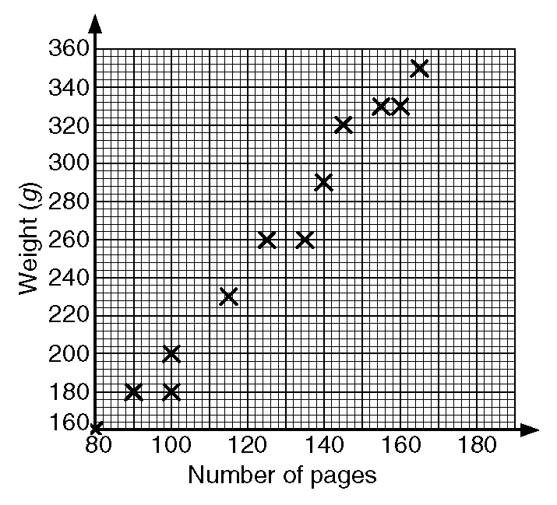

(a) Draw a line of best fit on your scatter graph.

(b) Use your line of best fit to estimate
i) the number of pages in a book of weight 280 g,
ii) the weight, in grams, of a book with 110 pages.

—————————————————————————————————————————

Question 32

Jason grows potatoes.
He weighed 100 potatoes and recorded the weights to the nearest gram.
The table shows information about the weights (w) of the 100 potatoes.

(a) Work out an estimate for the mean weight of these potatoes.
.................... g
(4 marks)

(b) Find the class interval that contains the median. (2 marks)

—————————————————————————————————————————

Question 33

200 adults were asked which one of English, Mathematics or Science they enjoyed most.

The two-way table shows some information about their answers.

Complete the two-way table. (3 marks)

—————————————————————————————————————————

Question 34

A bag contains 3 black beads, 5 red beads and 2 green beads.
Gianna takes a bead at random from the bag, records its colour and replaces it.
She does this two more times.

Work out the probability that, of the three beads Gianna takes, exactly two are
the same colour.

...............................
(5 marks)

—————————————————————————————————————————

Question 35

(a) On the grid draw a cumulative frequency graph for the table.

(b) Use your cumulative frequency graph to estimate the interquartile range of
the floor areas of the houses.

The houses on the estate with the greatest floor areas are called luxury houses.
10% of the houses are luxury houses.

(c) Use your graph to estimate the minimum floor area for a luxury house.

—————————————————————————————————————————

Question 36

Q is the midpoint of the side PR and T is the midpoint of the side PS of triangle PRS.

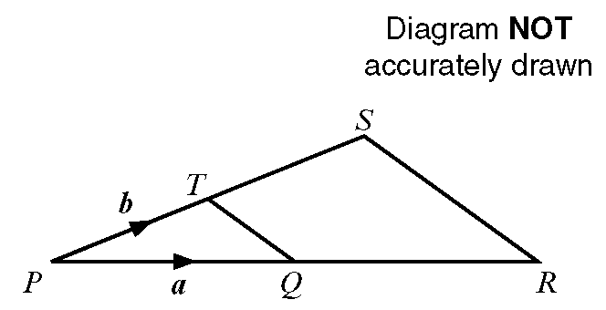

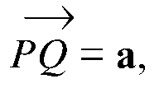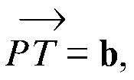

(a) Write down, in terms of a and b, the vectors

i) 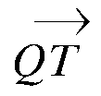

ii) 

iii) 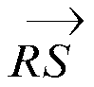

(b) Write down one geometrical fact about QT and RS which could be deduced
from your answers to part (a).

—————————————————————————————————————————

Question 37

A circle has a radius of 32 cm.

Work out the circumference of the circle.
Give your answer correct to the nearest centimetre.
.................. cm
(2 marks)

—————————————————————————————————————————

Question 38

Triangle ABC is similar to triangle PQR.

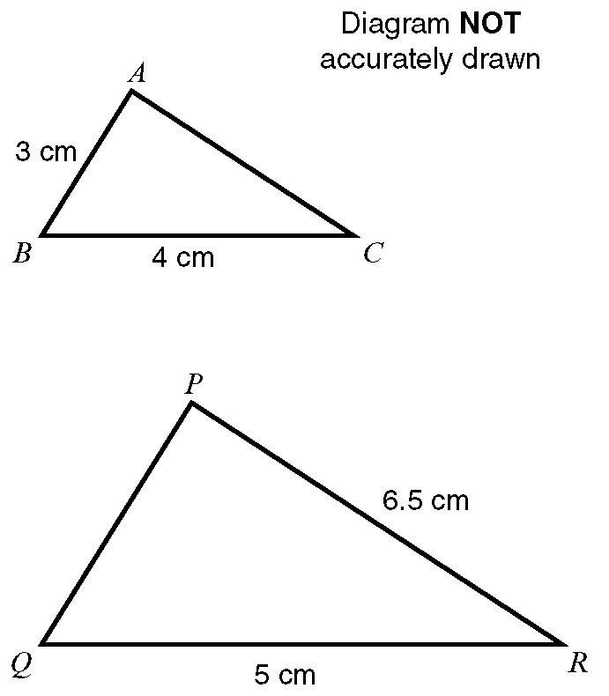

Angle ABC = angle PQR.
Angle ACB = angle PRQ.

Calculate the length of:
i) PQ
ii) AC

—————————————————————————————————————————

Question 39

(a) Describe fully the single transformation that maps shape P onto shape Q.
(2 marks)

(b) Rotate shape P 90° anticlockwise about the point A (1, 1). (2 marks)

—————————————————————————————————————————

Question 40

Calculate the length of AB.

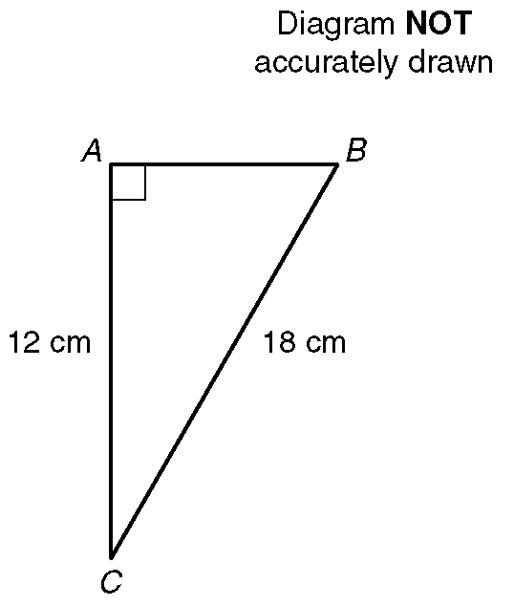

Give your answer correct to 1 decimal place.

---------------------------------------------------------------------------------------------------------------------------------

The diagram represents a rectangle which is 6 cm long.
A diagonal makes an angle of 23° with a 6 cm side.

Calculate the length of a diagonal.
Give your answer correct to 3 significant figures. (3 marks)

