Worksheet 2.1.7 Calculating pressure

1 How much pressure? >
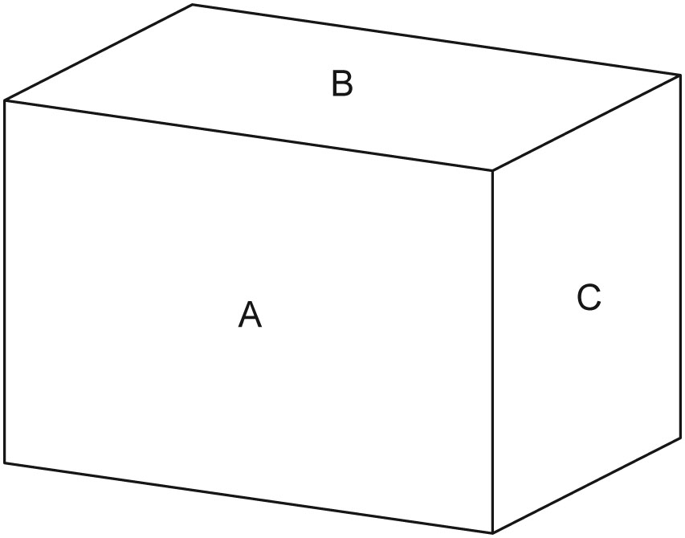
The cuboid shown measures 4 m across,
3 m high and 2 m front to back.

a) Calculate the area of each of the three faces visible
in the diagram.
b) If the cuboid is pressing down on a surface with
a force of 10 N, what pressure is exerted when
it is:
i) as shown in the diagram
ii) standing on end C
iii) resting on face A?

2 Camels on sand >>
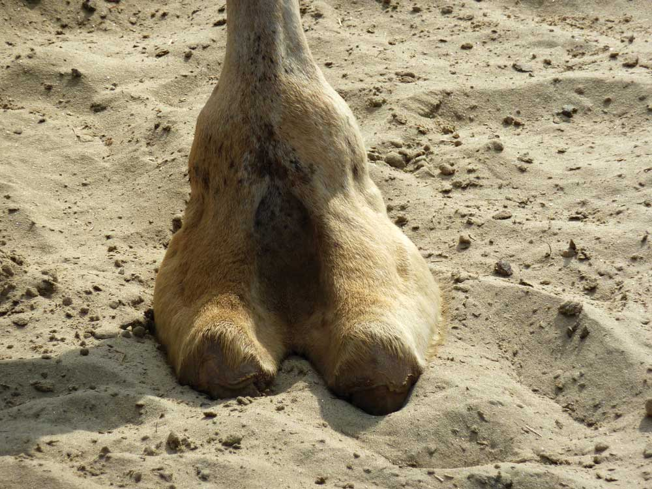
Where camels stand on very soft sand, they can easily sink into it. Imagine a situation where two different camels, one weighing 4000 N and the other 5000 N, are standing on soft sand where the maximum pressure without sinking is 26 000 Pa.

a) Calculate the pressure exerted by each camel if they each had a total foot area of 0.2 m².
b) Calculate how much load (in N) each camel could carry without sinking.

3 Designing a car roof rack >>>
When engineers design a roof rack they need to consider the maximum force that it has to withstand and the pressure that is exerted on the contact points.
a) Sketch a simple design for a roof rack showing where it exerts pressure on the car.
b) Explain how you could calculate the pressure exerted on the body of the car when the rack is carrying a load.
c) How could you improve the design of a bike rack in order to reduce the pressure on a car body?
d) Stronger racks and those that reduce the pressure on the car body may be more complex, and cost more to design and build. However, they have the advantage that there is less chance of the rack failing or of damage to the car.
i) What information would you need to help you decide on the design of a rack?
ii) Explain why making a rack stronger is a good idea.

