
Name: ____________________________
Date: _____________________________


   Compare the running costs of fluorescent and filament light bulbs.
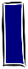  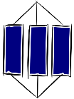  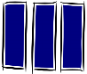  Know - |  |  | Apply  2  1
Ideas
K1 | We pay for our domestic electricity usage based on the amount of energy transferred. |  | A1 | Compare the amounts of energy transferred by different foods and activities.
K2 | Electricity is generated by a combination of resources which each have advantages and disadvantages. |  | A2 | Compare the energy usage and cost of running different home devices.
 |  |  | A3 | Explain the advantages and disadvantages of different energy resources.
Skill |  |  | A3
K3 | Calculate the cost of home energy usage, using the formula:  cost = power (kW ) x time (hours) x price (per kWh). |  | A4 | Represent the energy transfers from a renewable or non-renewable resource to an electrical device in the home.
Facts
K4 | Food labels list the energy content of food in kilojoules (kJ).
Key words
K6  K5 | Power: How quickly energy is transferred by a device (watts).
 | Energy resource: Something with stored energy that can be released in a useful way.
K7 | Non-renewable: An energy resource that cannot be replaced and will be used up.
K8 | Renewable: An energy resource that can be replaced and will not run out. Examples are solar, wind, waves, geothermal and biomass.
K9 | Fossil fuels: Non-renewable energy resources formed from the remains of ancient plants or animals. Examples are coal, crude oil and natural gas.
3 | Extend |  |  | 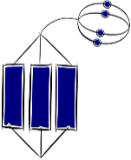
E1 | Evaluate the social, economic and environmental consequences of using a resource to generate electricity, from data.
E2 | Suggest actions a government or communities could take in response to rising energy demand.
E3 | Suggest ways to reduce costs, by examining data on a home energy bill.
E4
E5

