Worksheet 1.10.1 Looking more closely at variation

page 1/3

1 Observing variation >
Work with your group to answer parts a) and b).
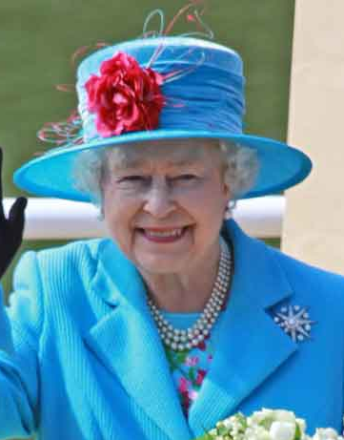
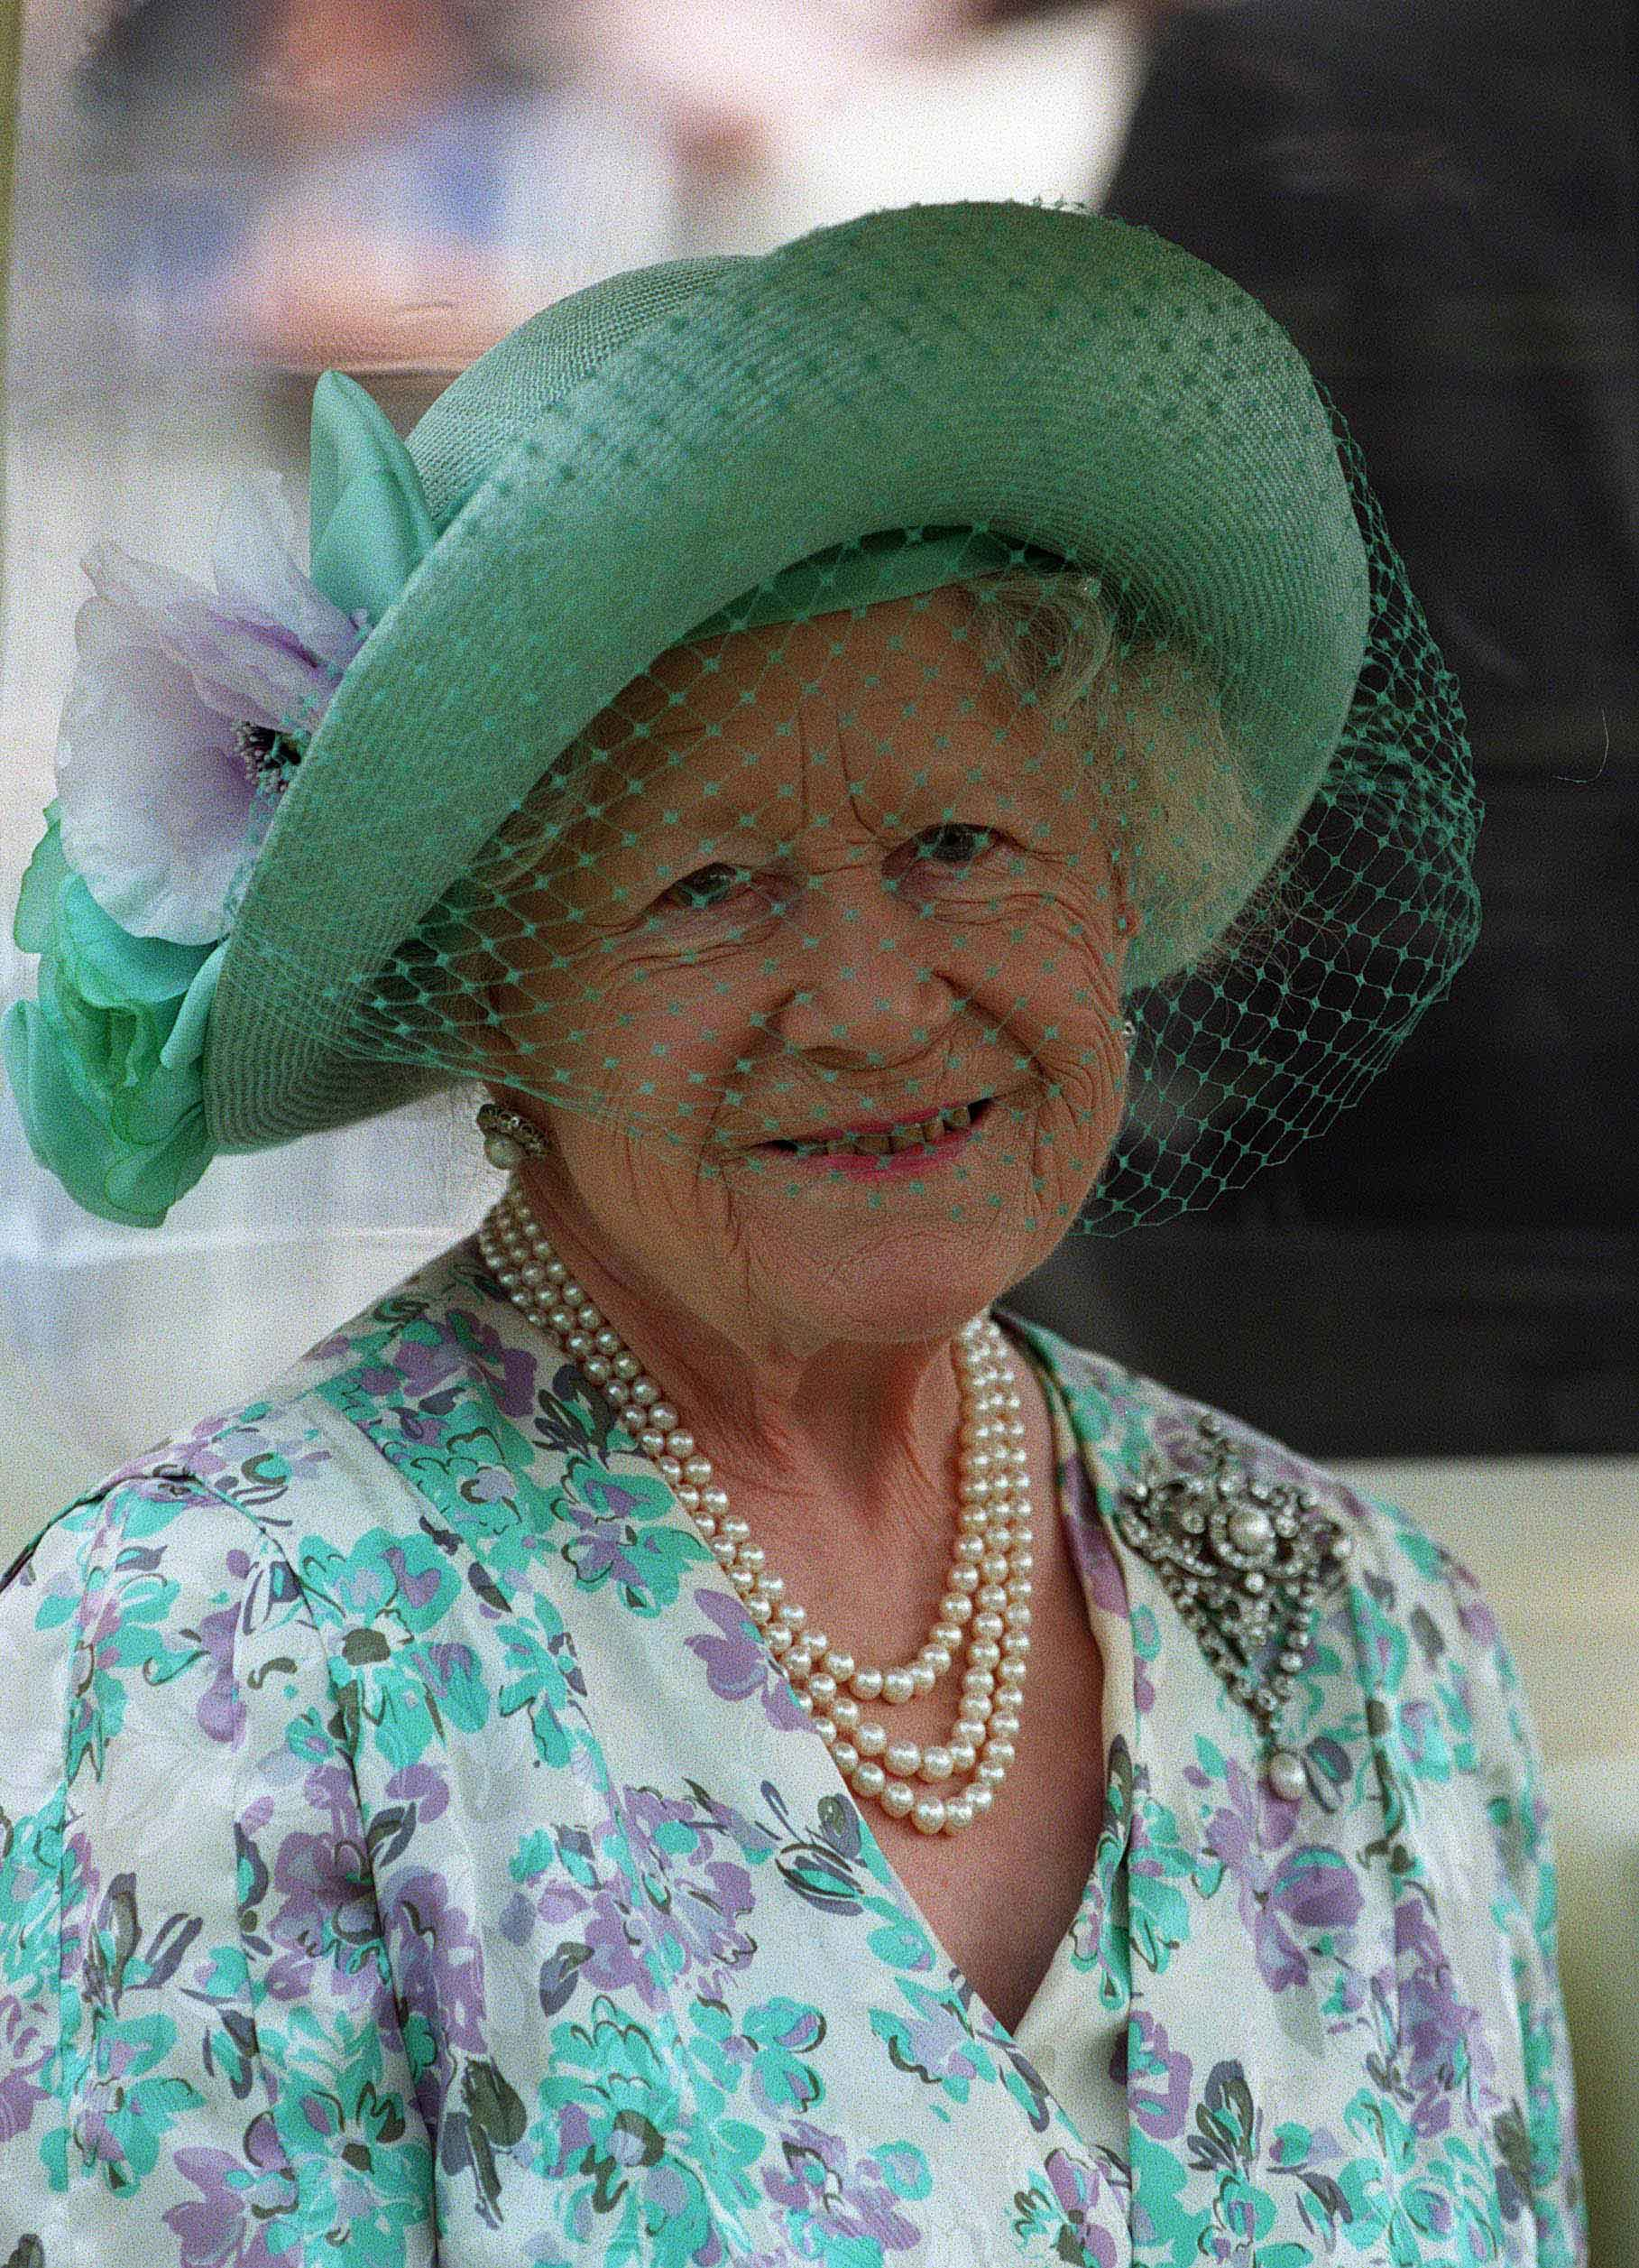
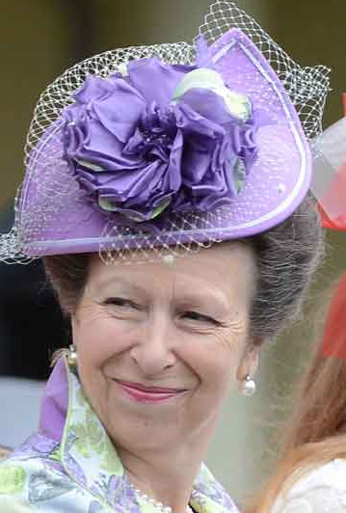
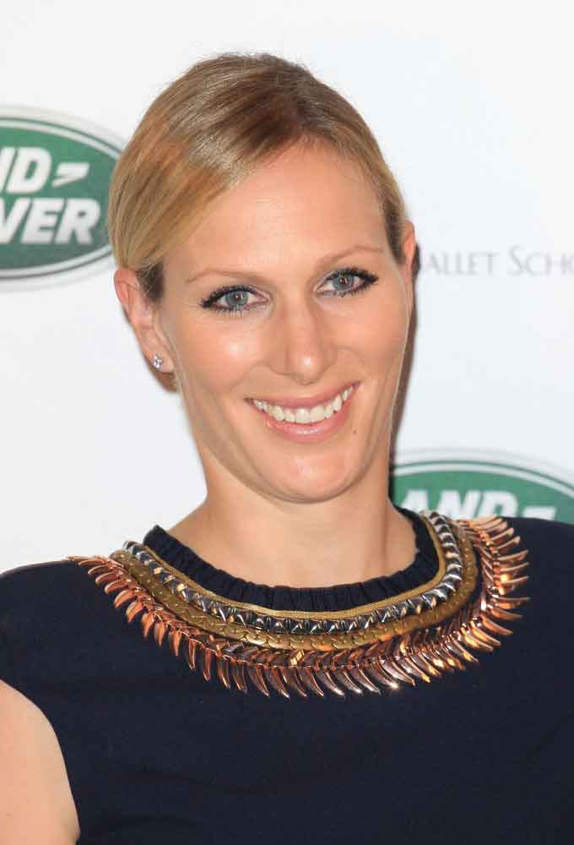

a) How are these people alike? Identify the features that are similar or that the people have in common.

b) For each feature you identified, say whether in a survey you would measure it or count the people with the feature.

Worksheet 1.10.1 Looking more closely at variation

page 2/3
Work with a partner to complete parts c) and d).
c) Look at the picture of snails.
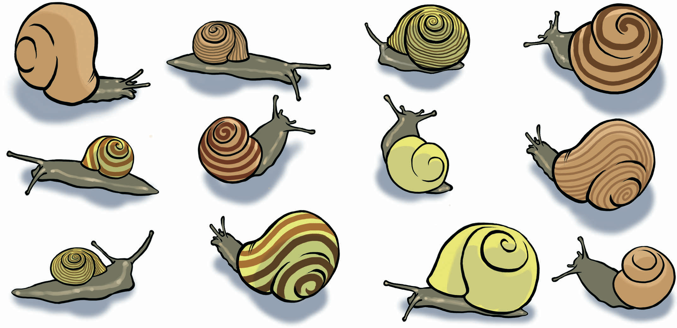

List three features of the organisms that show variation.

d) For each feature you have identified in part c), identify whether you would measure or count it.

2 Looking more closely >>
For parts a) and b) below you need to work in a group of three.
a) Which features vary in humans?

b) What type of variation is each of the features you have identified in part a)?

Worksheet 1.10.1 Looking more closely at variation

page 3/3
For part c) you need to work on your own.
c) Some students took samples of two different varieties of peach. They measured the mass of every peach in each sample. The results are shown in the table.
- Peach | - Mass of peach (g)
- Peach | - Variety 1 | - Variety 2
1 | 140 | 157
2 | 125 | 150
3 | 130 | 151
4 | 120 | 143
5 | 130 | 152
6 | 132 | 149
7 | 135 | 148
8 | 128 | 146
i) Use the data to draw the most suitable graph you can.
ii) What is the range in mass for variety 1?

iii) What is the range in mass for variety 2?

iv) Calculate the mean mass for each variety of peach.

v) Is this an example of discontinuous or continuous variation?

3 Variation and survival >>>
Work in a group to research and answer this question.
What are the advantages and disadvantages of variation to the survival of orangutans?

