Worksheet 1.10.8 Communicating ideas about smoking in pregnancy

page 1/2

1 Evidence and opinion >
Work with a partner to answer these questions.
a) Match each of the words below with its correct definition:
1. Evidence | a. Statement that says something is true
2. Opinion | b. Swaying of results in a particular way
3. Claim | c. Fact or data that supports a claim
4. Bias | d. The viewpoint of an individual

b) In each of the four examples below, identify whether they show evidence, opinion, claim or bias.

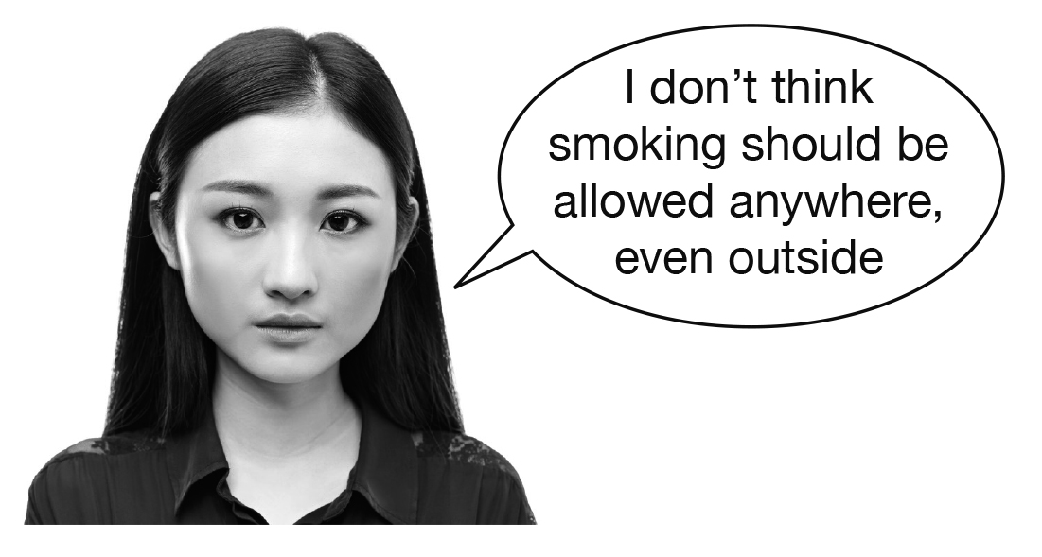
i) ii)

……………………………………………….. ……………………………………………….
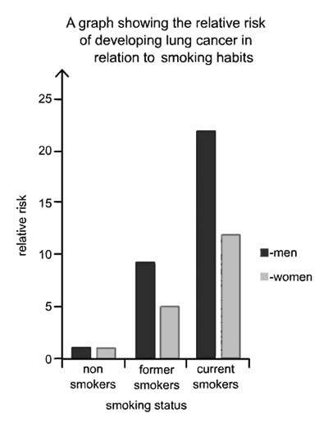

iii) iv)

……………………………………………….. ……………………………………………….
Worksheet 1.10.8 Communicating ideas about smoking in pregnancy

page 2/2

2 Evidence supporting claims >>
The table below lists some examples of data collected during research into the effects of smoking in pregnancy in humans.
 | Research | Result of research
i | The children of 50 women who smoked during pregnancy and 100 children of women who didn’t smoke during pregnancy were studied to find out whether they took drugs when they were teenagers. | Teenagers of mothers who smoked were five times more likely to take drugs than teenagers of mothers who didn’t smoke during pregnancy.
ii | Compared the birth weights of baby monkeys from mothers exposed to nicotine to those of mothers not exposed to nicotine. | The birth weights of both groups were found to be similar.

- For each piece of evidence, write a specific claim that the evidence supports.

b) For each claim, suggest what additional evidence would support it further.

3 Using evidence to persuade >>>
Imagine you are part of the marketing team for a company selling a new food supplement drink, ‘Enerise’. The drink is designed to increase energy levels and decrease tiredness.
Develop a marketing plan to persuade people to buy the supplement. You must include:
a) your claim;
b) a description of the evidence that you may collect to back your claim;
c) an advert to persuade people to buy Enerise.

