Worksheet 1.3.7 Exploring energy transfers

page 1/3

1 Energy transfers >
A bell transfers movement energy (kinetic energy) to energy by sound.
We can write this as an energy transfer diagram as follows:

Kinetic energy Energy by sound

Draw an energy transfer diagram for each of the items shown here.

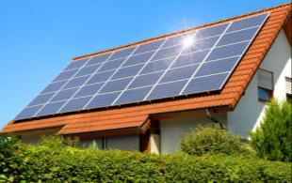

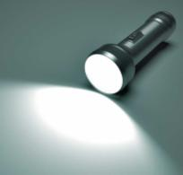
a) b) c)

2 Useless energy transfers >>
Some energy transfers are not useful. For example, when a candle burns some of the chemical energy is transferred by light and some by heat. The energy transferred by heat is not as useful as the energy transferred by light.

Chemical energy Energy by light + Energy by heat

a) For each of the devices in the table on the next sheet, write down:
- how much of the energy that goes into it is wasted
- how the wasted energy is transferred (for example, by heat).
Worksheet 1.3.7 Exploring energy transfers

page 2/3
Device | Input energy | Useful output energy | Amount of wasted output energy | Wasted output energy transferred by
A: Energy- efficient bulb | 10 J of electrical energy | 4 J of light
B: Radio | 10 J of electrical energy | 3 J of sound
C: Car | 100 J of chemical energy | 35 J of kinetic energy
D: Kettle | 50 J of electrical energy | 45 J of heat energy
E: Bow and arrow | 10 J of elastic potential energy | 4 J of kinetic energy
F: Rocket | 100 J of chemical energy | 70 J of kinetic and gravitational energy

b) For each of the devices in the table, on squared paper shade the amount of useful energy and the amount of wasted energy. The first one has been done for you as an example.
Energy-efficient bulb
useful
wasted

Worksheet 1.3.7 Exploring energy transfers

page 3/3

3 Sankey diagrams >>>
On squared paper or graph paper draw a labelled Sankey diagram to show each of the energy transfers shown in the table from task 2. An example is shown here.
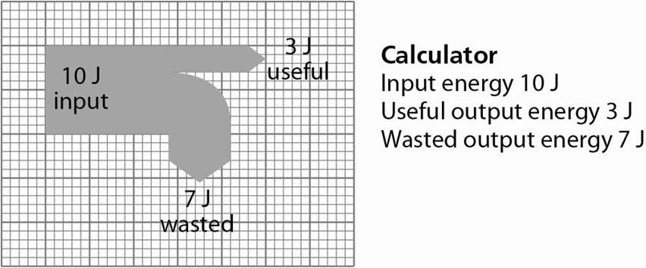

A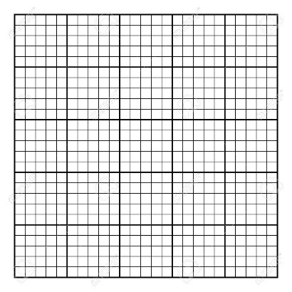 B C

D E F

