Worksheet 1.3.9 Understanding elastic potential energy

1 Energy transfer >
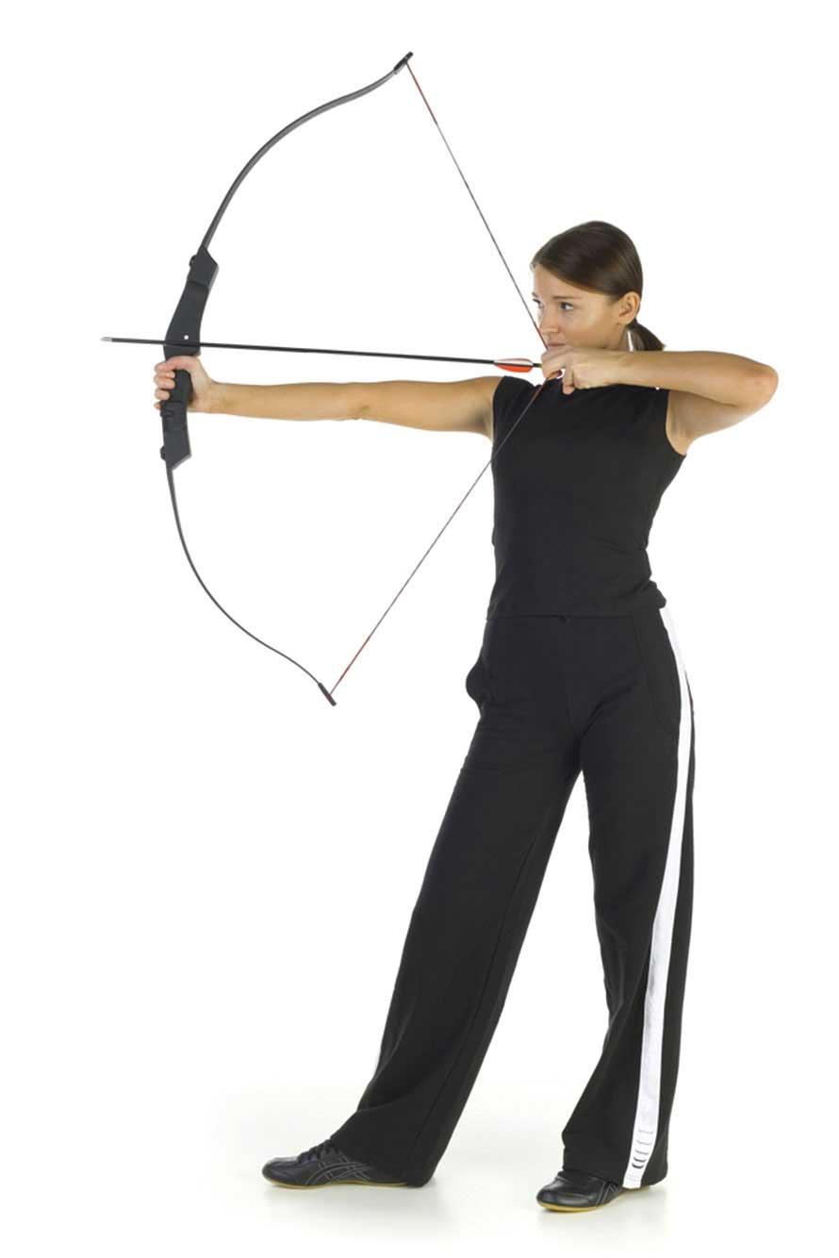
a) Draw an energy transfer diagram to show the energy transfers occurring when a bow is pulled and the arrow released. Include useful and useless energy transfers.

b) Work is done when the arrow is released. What factors will affect how much work is done?
…………………………………………………………………………………………………………………
…………………………………………………………………………………………………………………

2 Elastic potential energy in different materials >>
a) What factors affect how much energy an elastic material can store?
…………………………………………………………………………………………………………………
…………………………………………………………………………………………………………………
b) Explain why a stiff spring is used in car suspensions instead of elastic rope.
…………………………………………………………………………………………………………………
…………………………………………………………………………………………………………………
…………………………………………………………………………………………………………………
…………………………………………………………………………………………………………………

3 Modelling elastic materials >>>
On a plain sheet of paper, draw your own model to represent what is happening to the particles in the coils of a spring when that spring is compressed. How does this compare with what happens to the particles in an elastic rope?

