

Name: _____________________________
Date: ______________________________

  Explain the energy transfers in a hand-crank torch.
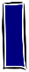  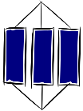  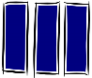  Know -  1 |  |  | Apply  2
Ideas
K1 | We can describe how jobs get done using an energy model where energy is transferred from one store at the start to another at the end. |  | A1 | Describe how the energy of an object depends on its speed, temperature, height or whether it is stretched or compressed.
K2 | When energy is transferred, the total is conserved, but some energy is dissipated, reducing the useful energy. |  | A2 | Show how energy is transferred between energy stores in a range of real-life examples.
 |  |  | A3 | Calculate the useful energy and the amount dissipated, given values of input and output energy.
Key words |  |  | A3
K3 | Thermal energy store: Filled when an object is warmed up. |  | A4 | Explain how energy is dissipated in a range of situations.
K4 | Chemical energy store: Emptied during chemical reactions when energy is transferred to surroundings.
K5 | Kinetic energy store: Filled when an object speeds up.
K6 | Gravitational potential energy store: Filled when an object is raised.
K7 | Elastic energy store: Filled when a material is stretched or compressed.
K8 | Dissipated: Become spread out wastefully.

3 | Extend |  |  | 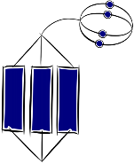
E1 | Compare the percentages of energy wasted by renewable energy sources. |  | E4
E2 | Explain why processes such as swinging pendulums or bouncing balls cannot go on forever, in terms of energy.
E3 | Evaluate analogies and explanations for the transfer of energy.
E5

