

Name: _____________________________
Date: ______________________________

  Review the evidence for theories about how a particular species went extinct.
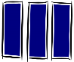  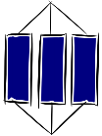  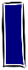  Know - |  |  | Apply  2  1
Ideas
K1 | Natural selection is a theory that explains how species evolve and why extinction occurs. |  | A1 | Use evidence to explain why a species has become extinct or adapted to changing conditions.
K2 | Biodiversity is vital to maintaining populations. Within a species variation helps against environment changes, avoiding extinction. Within an ecosystem, having many different species ensures resources are available for other populations, like humans. |  | A2 | Evaluate whether evidence for a species changing over time supports natural selection.
K2 |  |  | A3 | Explain how a lack of biodiversity can affect an ecosystem.
K2 |  |  | A4 | Describe how preserving biodiversity can provide useful products and services for humans.
Key words
K3 | Population: Group of organisms of the same kind living in the same place. |  | A5
K4 | Natural selection: Process by which species change over time in response to environmental changes and competition for resources.
K5 | Extinct: When no more individuals of a species remain.
K6 | Biodiversity: The variety of living things. It is measured as the differences between individuals of the same species, or the number of different species in an ecosystem. |  | A6
K7 | Competition: When two or more living things struggle against each other to get the same resource.
K8 | Evolution: Theory that the animal and plant species living today descended from species that existed in the past.
3 | Extend |  |  | 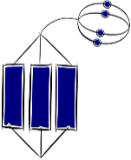
E1 | Predict and explain the changes in a population over time due to natural selection.
E2 | Suggest an explanation, based on data, for how a particular evolutionary change occurred.
E3 | Evaluate ways of preserving plant or animal material for future generations.
E4
E5

