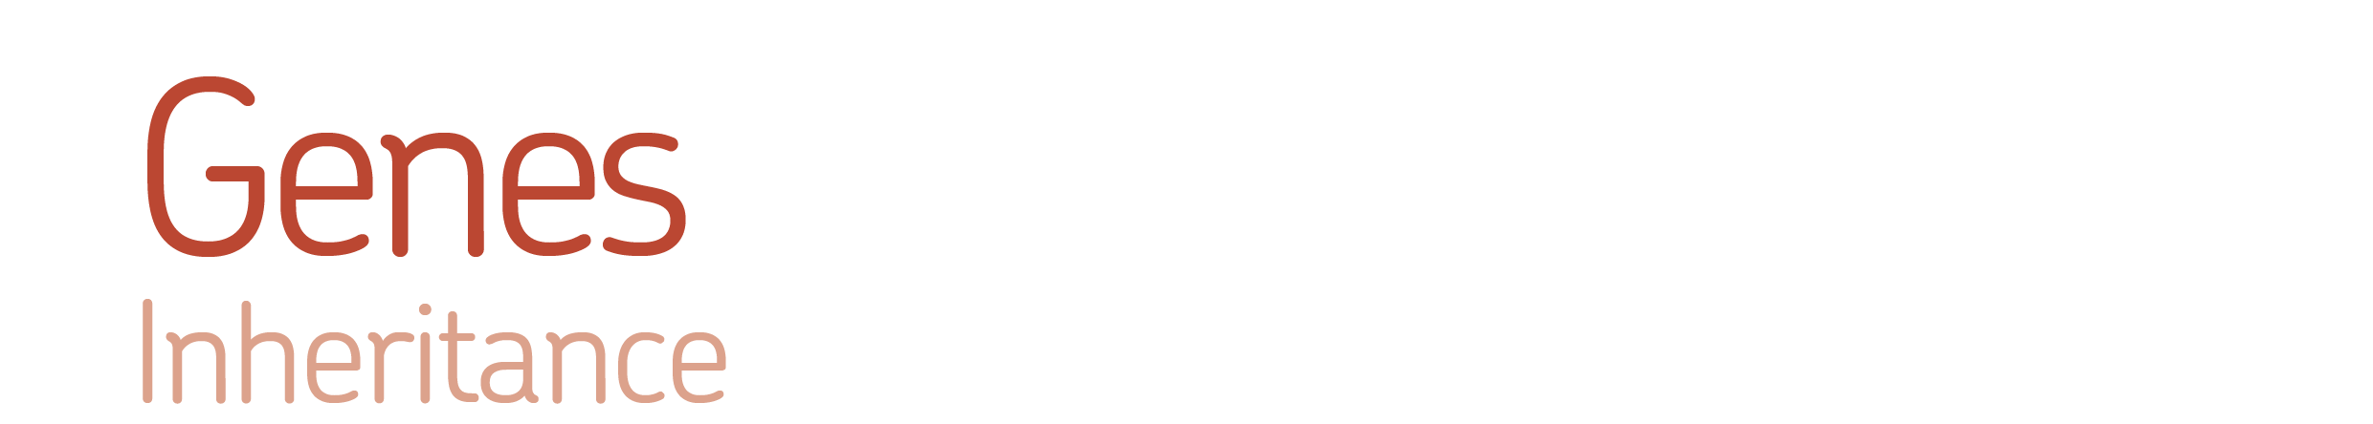

Name: __________________________
Date: ___________________________

   Model the inheritance of a specific trait and explore the variation in the offspring produced.
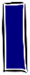  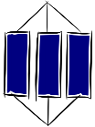  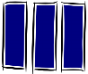  Know - |  |  | Apply  2  1
Ideas
K1 | Inherited characteristics are the result of genetic information, in the form of sections of DNA called genes, being transferred from parents to offspring during reproduction. |  | A1 | Use a diagram to show the relationship between DNA, chromosomes and genes.
K1 |  |  | A2 | Use a diagram to show how genes are inherited.
K2 | Chromosomes are long pieces of DNA which contain many genes. Gametes, carrying half the total number of chromosomes of each parent, combine during fertilisation. |  | A3 | Explain how a change in the DNA (mutation) may affect an organism and its future offspring.
K2 |  |  | A4 | Explain why offspring from the same parents look similar but are not usually identical.
Facts
K3 | The DNA of every individual is different, except for identical twins. |  | A5
K4 | There is more than one version of each gene e.g. different blood groups.
Key words
K5 | Inherited characteristics: Features that are passed from parents to their offspring. |  | A6
K6 | DNA: A molecule found in the nucleus of cells that contains genetic information.
K7 | Chromosomes: Thread-like structures containing tightly coiled DNA.
K8 | Gene: A section of DNA that determines an inherited characteristic.
3 | Extend |  |  | 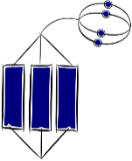
E1 | Suggest arguments for and against genetic modification.
E2 | Suggest benefits from scientists knowing all the genes in the human genome.
E3 | Determine how the number of chromosomes changes during cell division, production of sex cells and fertilisation.
E4 | Find out why scientist Watson, Crick and Franklin were so important.
E5
E6

