
Name: ___________________________
Date: ____________________________



   Use models to evaluate the features of various types of seed dispersal.
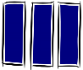  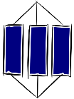  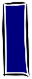  Know -  1  2 |  |  | Apply
Ideas
K1 | Plants have adaptations to disperse seeds using wind, water or animals. |  | A1 | Describe the main steps that take place when a plant reproduces successfully.
K2 | Plants reproduce sexually to produce seeds, which are formed following fertilisation in the ovary. |  | A2 | Identify parts of the flower and link their structure to their function.
 |  |  | A3  A4 | Suggest how a plant carried out seed dispersal based on the features of its fruit or seed.
Facts |  |  | A3  A4
K3 | Flowers contain the plant's reproductive organs. |  |  | Explain why seed dispersal is important to survival of the parent plant and its offspring.
K4 | Pollen can be carried by the wind, pollinating insects or other animals.
Key words
K5 | Pollen: Contains the plant male sex cells found on the stamens.
K6 | Ovules: Female sex cells in plants found in the ovary.
K7 | Pollination: Transfer of pollen from the male part of the flower to the female part of the flower on the same or another plant.
K8 | Fertilisation: Joining of a nucleus from a male and female sex cell.
K9 | Seed: Structure that contains the embryo of a new plant.
K10 | Fruit: Structure that the ovary becomes after fertilisation, which contains seeds.
K11 | Carpel: The female part of the flower, made up of the stigma where the Pollen lands, style and ovary.
3 | Extend |  |  | 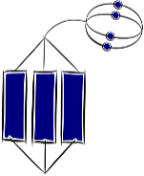
E1 | Describe similarities and differences between the structures of wind pollinated and insect pollinated plants.
E2 | Suggest how plant breeders use knowledge of pollination to carry out selective breeding.
E3 | Develop an argument why a particular plant structure increases the likelihood of successful production of offspring.
E4
E5

