Year 7

SPANISH HOME STUDY BOOKLET

PACK 2

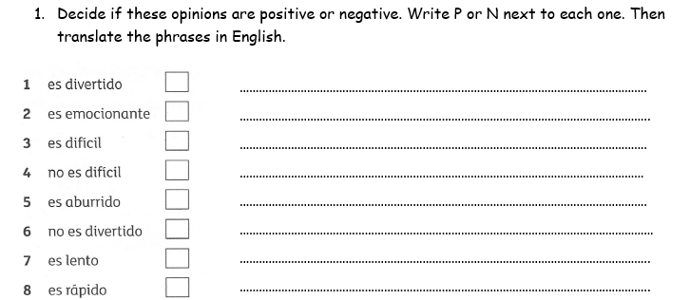

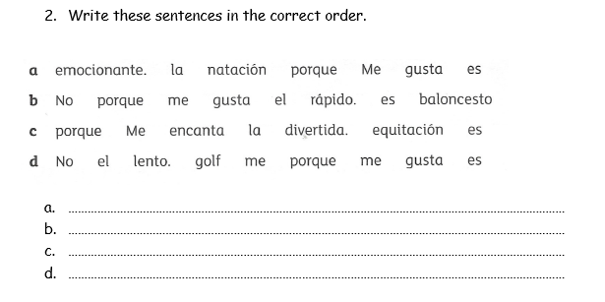
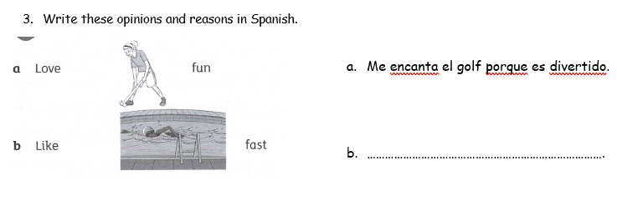



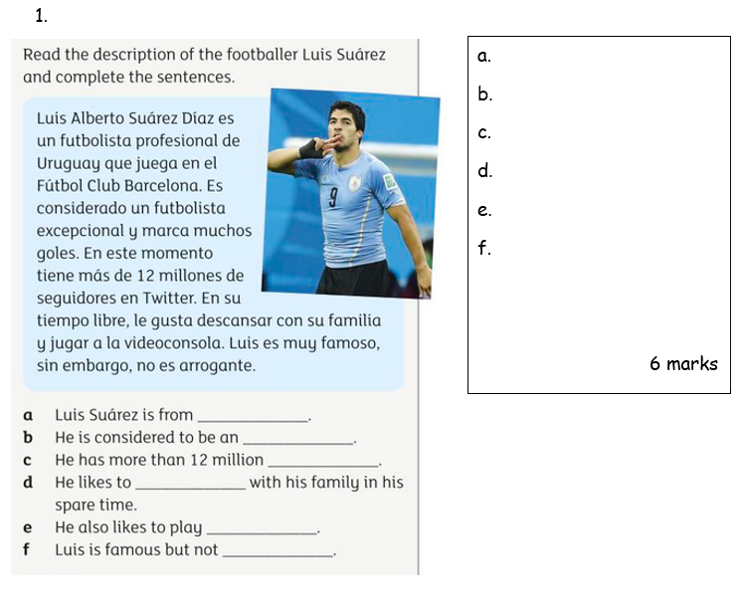
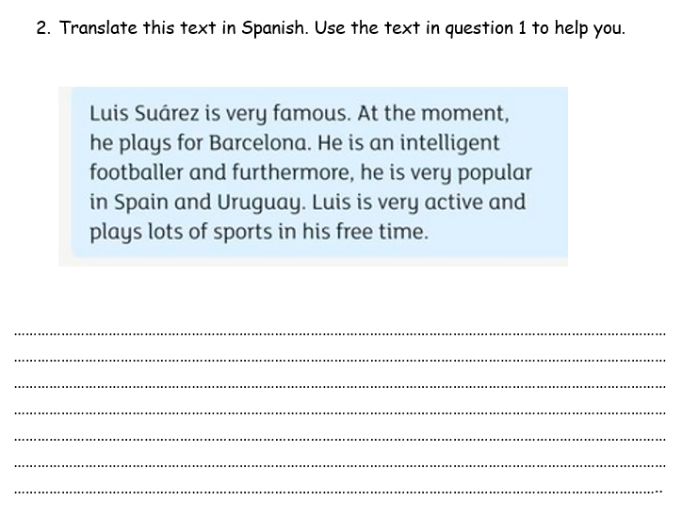
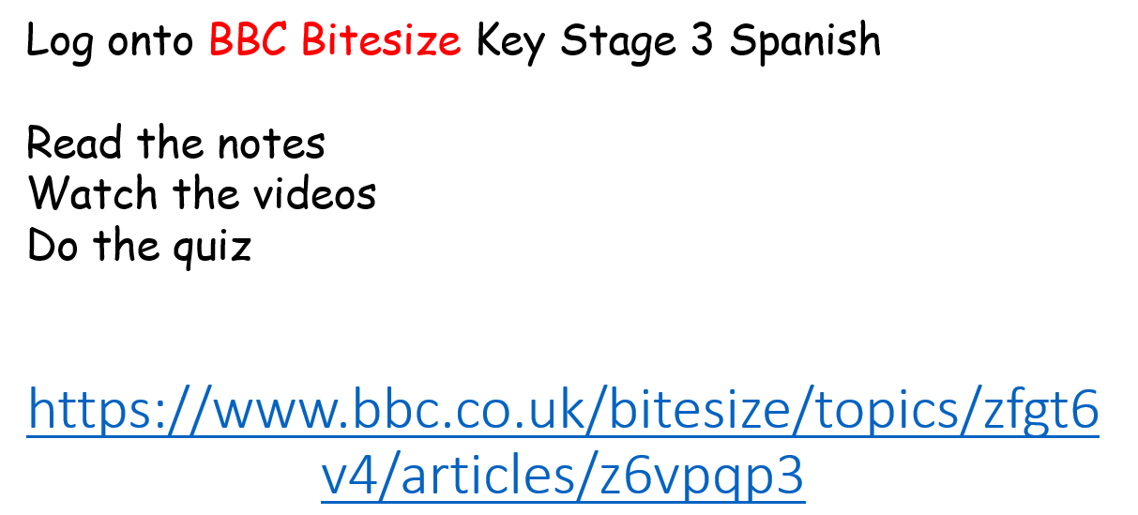
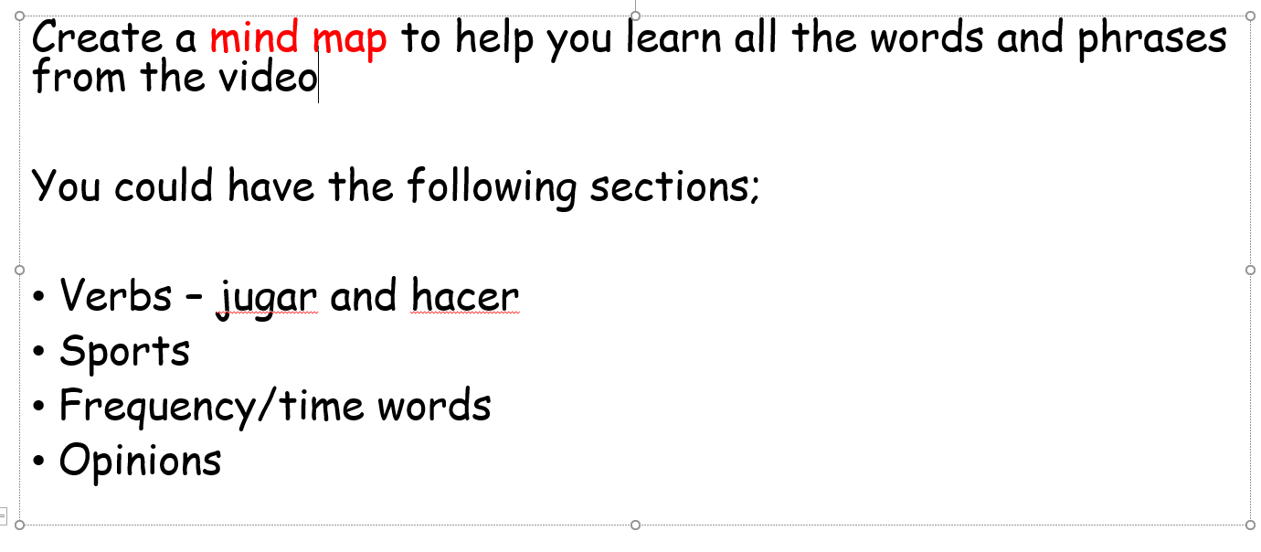
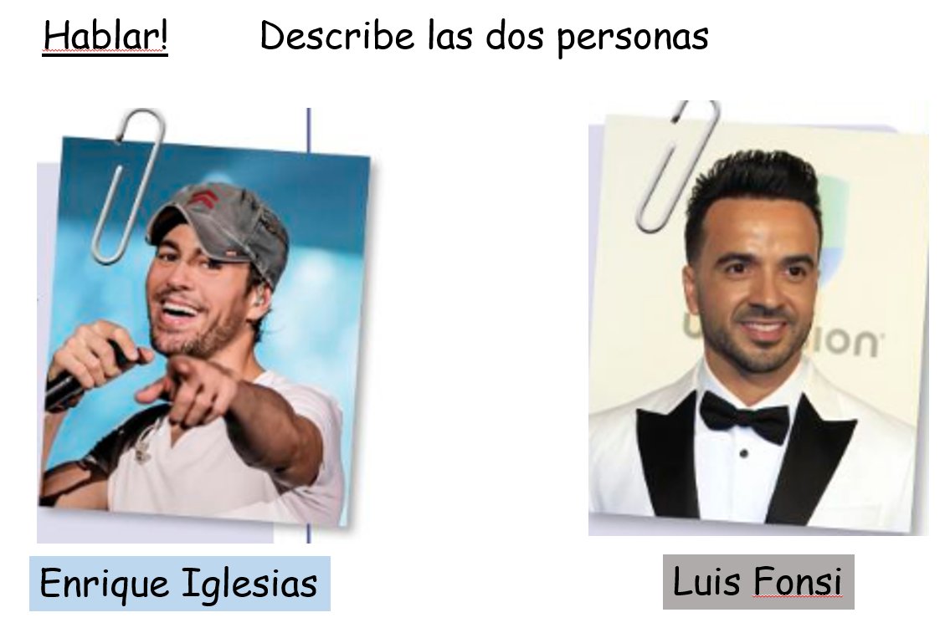

Eg. Se llama… Tiene los ojos… y el pelo …..

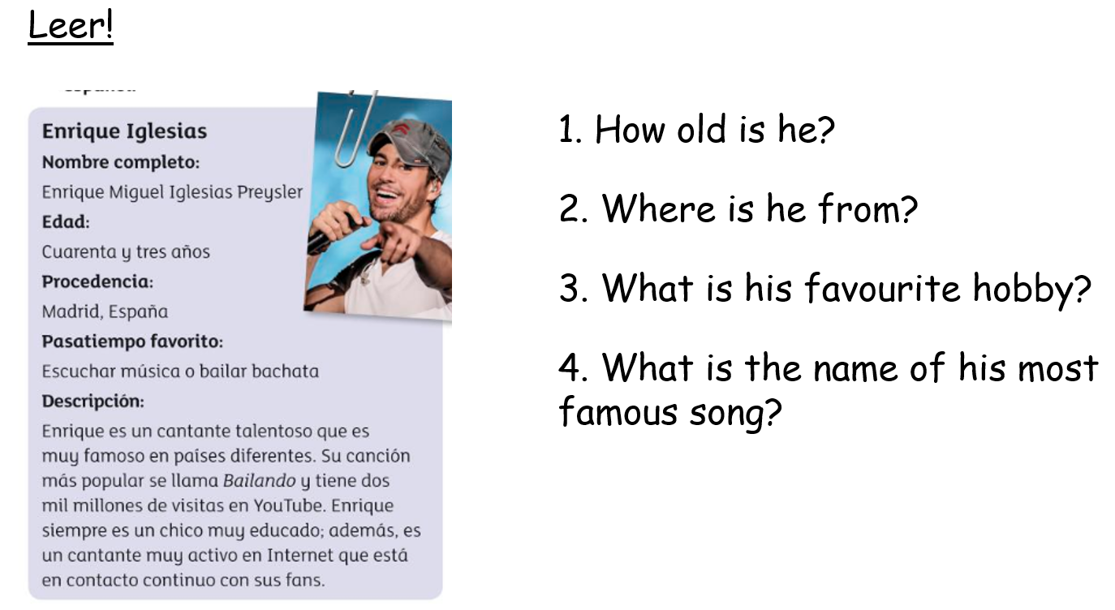
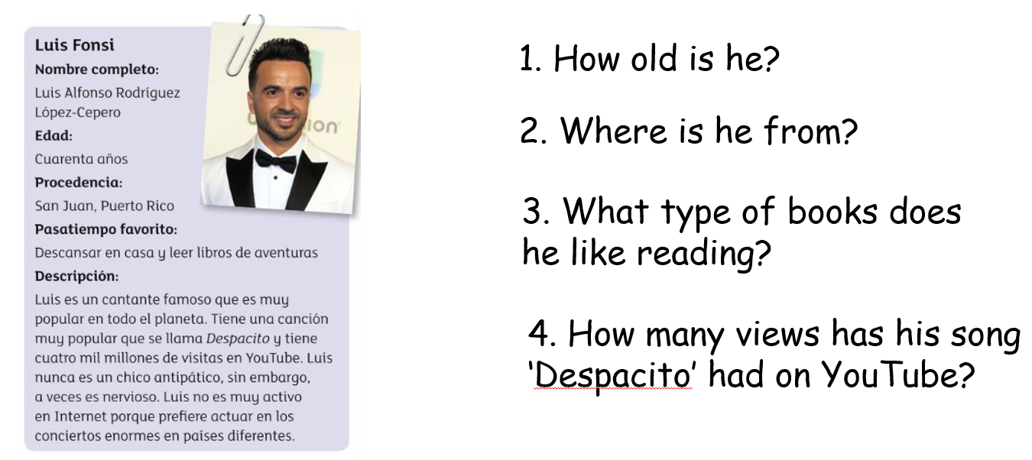

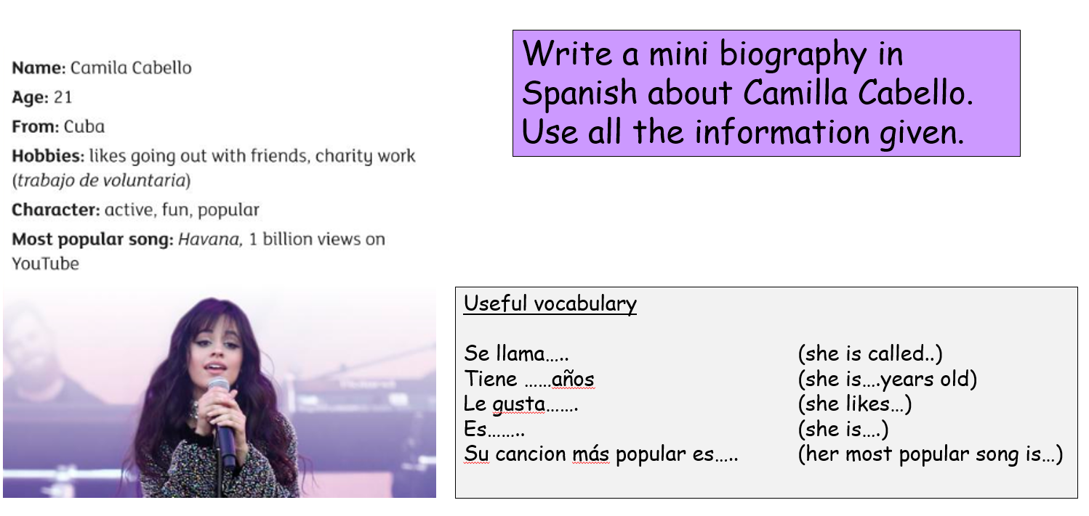
Research a famous Spanish speaking musician and create a fact file about them in Spanish.
Include as many details as you can (age, family, physical appearance, hobbies, most famous song, achievements.
Use your own words – not Google Translate!!!!!!
Email to me either as Word document or Powerpoint

