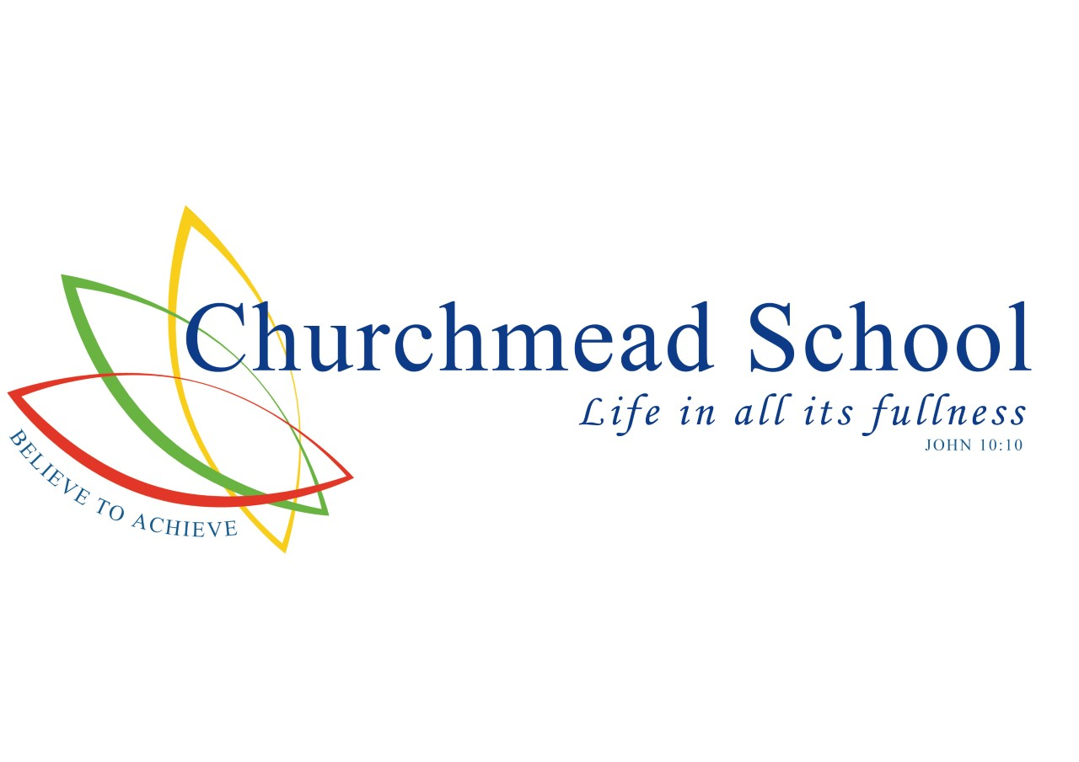

**Accessibility Plan**

Headteacher Mr C Tomes BA (Hons), MA

Churchmead is a secondary school for boys and girls age range 11 – 18. The school comprises of several buildings covering a large site, mostly of one or two storey construction.

The **School’s Aims** embraces a partnership between the school and home and offers to each member the opportunity to grow in knowledge fostered through Christian values and guidance. Every individual has a right to be part of a community where each member is valued and respected for their own worth irrespective of race, colour, creed or ability. Students will be helped to appreciate that they are members of the wider community in its richness and diversity and a curriculum that provides a setting in which all children have an equal opportunity to grow in understanding and in the acquisition of skills, attitudes and values.

The **SEN and Disability Act 2001** extended the Disability Discrimination Act 1995 (DDA) to cover education. The Governing Body has three key duties towards disabled pupils, under Part 4 of the DDA:

* not to treat disabled pupils less favourably for a reason related to their disability
* to make reasonable adjustments for disabled pupils, so that they are not at a substantial disadvantage
* to plan to increase access to education for disabled pupils

This plan sets out the proposals of the Governing Body of Churchmead to increase access to education for disabled pupils in the three areas required by the planning duties in the DDA:

* increasing the extent to which disabled pupils can participate in the school curriculum
* improving the environment of the school to increase the extent to which disabled pupils can take advantage of education and associated services
* improving the delivery to disabled pupils of information, which is provided in writing for pupils who are not disabled

**The purpose and direction of the school’s plan: vision and values**

We are committed to providing a fully accessible environment which values and includes all students, staff, parents and visitors regardless of their education, physical, sensory, social, spiritual, emotional and cultural needs. We are committed to challenging negative attitudes about disability and accessibility and to developing a culture of awareness, tolerance and inclusion.

• The School plans, over time, to increase the accessibility of provision for all students, staff and visitors to the school.

• Improve access to the physical environment of the school, adding specialist facilities as necessary. This covers improvements to the physical environment of the school and physical aids to access education.

• Increase access to the curriculum for students with a disability, expanding the curriculum as necessary to ensure that students with a disability are as equally prepared for life as are the able-bodied students

This covers teaching and learning and the wider curriculum of the school such as participation in after-school clubs, leisure and cultural activities or school visits. It also covers the provision of specialist aids and equipment, which may assist these students in accessing the curriculum.

Improving the delivery of written information to students, staff, parents and visitors with disabilities. Examples might include handouts, timetables, textbooks and information about the school and school events. The information should be made available in various preferred formats within a reasonable time frame. The accessibility plan will be published on the school website.

**Management, coordination and implementation**

**The planning process** – This should be reviewed on a yearly basis. **Coordination** – Our plan is a cohesive part of the running of our school and forms part of our day to day plan in moving forward. **Other policies and plans** – This plan links in with our SEND plan, our health and safety policy, our inclusion policy and our admission policy. **Implementation** – This is overseen by SLT and the Site Team.

**Current facilities**

We have ramp access leading to the reception from the front of the school with double entry doors. There is also ramp access to the sports hall where exams are held, the maths block and 6th form block. There are disabled toilets in the main block, Science & Art block, 6th form block and fitness centre. There is a disabled lift in the 6th form block which is of a newer build. There are classrooms on the ground floor with IT access.

**Future plans**

As and when terrapin blocks are replaced with new builds more provision will be provided with lifts to all 2 storey blocks.