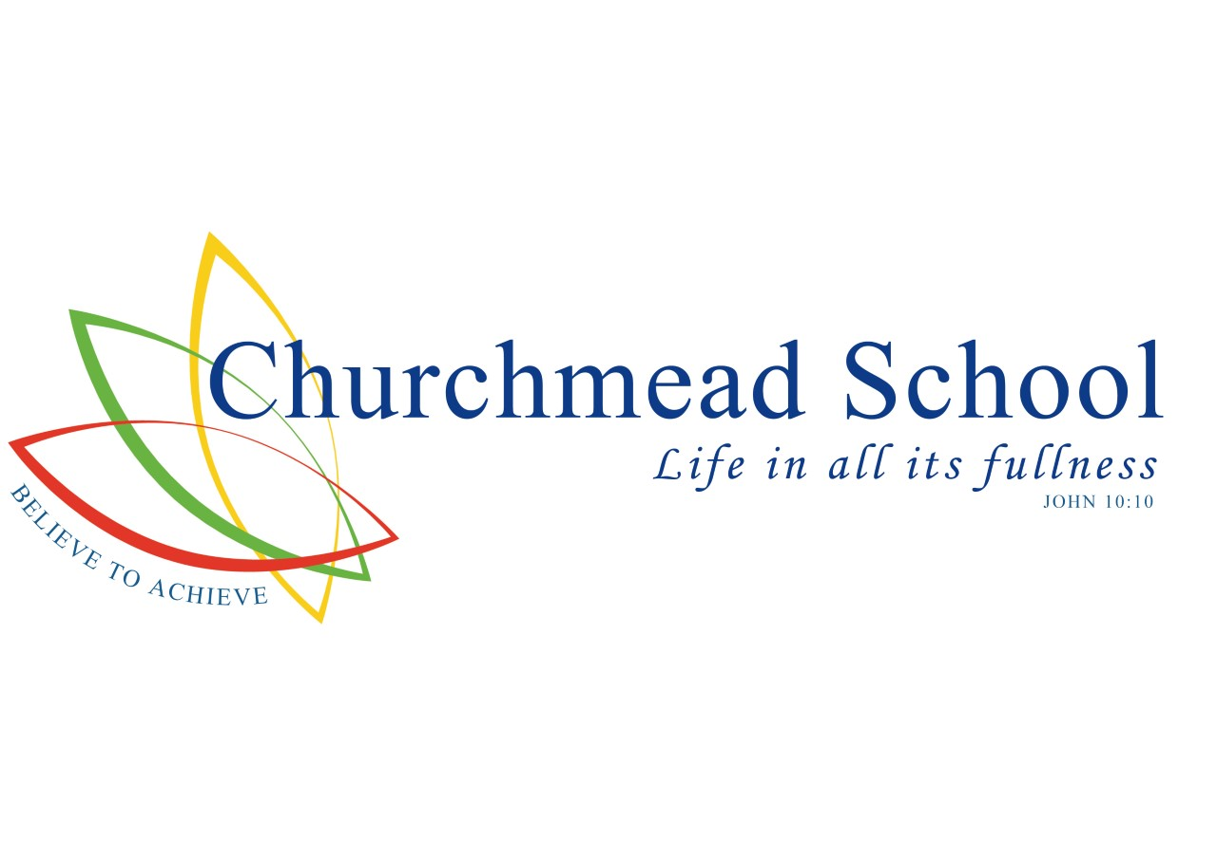
ADMISSIONS POLICY
2025/26

Headteacher
Mr C Tomes BA (Hons), MA

ADMISSION POLICY FOR ENTRY IN ACADEMIC YEAR
SEPTEMBER 2025 – AUGUST 2026
Churchmead School has a distinctive Christian ethos which is at the centre of school life. We provide an inclusive, supportive and caring environment, shaped by Christian values in which children can learn and flourish. We welcome applications from all members of the community without reference to ability or aptitude, and irrespective of whether they are of the Christian faith, another faith or no faith, but we expect parents to respect the Christian ethos of our school.
ADMISSION TO ALL YEAR GROUPS

A. INTRODUCTION
Churchmead School is a voluntary aided co-educational comprehensive school and the Governing Body is the Admission Authority for the school. Governors have carried out an annual review of their admission arrangements in line with the Admissions Code.

This policy should be read together with information about your Local Authority’s coordinated admission arrangements and a copy of the School Prospectus. The school will hold open days for prospective parents to attend and details of these can be found on the school website and in the prospectus. Additionally, parents may telephone the school for an individual appointment to visit the school

B. PUPIL ADMISSION NUMBER AND AGE OF ADMISSION
The admission number for each year group is 120 students.

Children will not be considered for early admission to Year 7 unless there are sound educational reasons for early admission which are endorsed by the LA and they have been working ahead of their year group for several years.

C. MAKING APPLICATION / THE TIMESCALE
Copies of the School Prospectus are available on the school website and by request to the school. Under the co-ordinated arrangements applicants must complete the LA application form for the area in which they reside and meet the closing date for that Local Authority. The Common Application Form will be available through your Local Authority.

The closing date for receipt of applications by the Royal Borough of Windsor & Maidenhead for admission into Year 7 in September 2025 will be 31st October 2024.

If the school is oversubscribed, the Admissions Committee of the Governing Body will determine which applicants can be offered places. Any child not offered a place can be added to a waiting list for places which might occur later. The decisions of Governors will be passed to the LA who will send out the allocation letters to parents on behalf of the Governing Body on 1 March 2025.

Parents who are unsuccessful have the right to appeal. If a parent wishes to do this, they should contact the Headteacher’s PA at Churchmead School and an appeals form will be provided. Admission appeals will be heard by an Independent Panel convened by Oxford Diocese.

D. REPEAT APPLICATIONS
It will be the policy of Governors not to consider repeat applications in the same academic year unless there is a material change of circumstances.

E. CHILDREN WITH EDUCATION HEALTHCARE PLANS (EHCPS)
The law requires Governors to admit pupils with an EHCP where the Local Authority has specifically named Churchmead Church of England School as the most appropriate placement. These applications will usually be agreed in advance of the main allocation process. Where they are a late application to the school, Governors can be required to admit even if the admission number has been reached.

F. CRITERIA FOR ADMISSION
In the event of there being greater demand for admission than there are places available, places will be offered using the following criteria in the order given: -

- Looked After Children (Children in Public Care), including those children who appear (to the admission authority) to have been in state care outside of England and ceased to be in state care as a result of being adopted

2. Families who have exceptional medical or social needs that make it essential that their child attends Churchmead School rather than any other. These needs must be fully supported by written evidence from the appropriate professional person involved with the family. (See Section G)

3. Children who have siblings (see Section H) who will still be on roll at the school, when the applicant
would enter the school.

4. Children who attend a Designated Feeder School as set out in Section I.

5. Children who live in the “designated appropriate” area of the school. (See Section J).

6. All other applicants.

Deciding Factor: If the school does not have places for all the children in a particular criterion, places in that criterion will be awarded on the basis of the proximity of the pupil's home to the school measured by the shortest distance. This is to be a straight line to the front entrance of the main school building from the pupil's home.

G. SOCIAL AND MEDICAL
When applying under criterion 2 (exceptional medical or social needs), you must include supporting evidence from an independent professional person who is aware of the situation and supports your reasons for preferring Churchmead School. This supporting evidence must clearly demonstrate why the school is the most suitable and must illustrate the difficulties that would be caused if your child had to attend another school. The person supplying the evidence should be a doctor, heath visitor, social worker or similar professional who is aware of your child’s or your own case. The school reserves the right to ask for further evidence or clarification where necessary and may seek the advice of appropriate educational professionals where necessary.

H. SIBLINGS AND CHILDREN OF MULTIPLE BIRTHS
By sibling, we mean a brother or sister, half brother or sister or any other child (including adopted child) who permanently resides at the same address and for whom the parent also has parental responsibility. Qualification for sibling status is made on the basis that the student who is the older sibling will be on roll at the school in Years 7-11 on the sibling’s entry to the school.

Where an application is being submitted for a child who has a sibling (or siblings) in the same year group it will be the policy of the Governing Body not to offer a place to one child without offering the sibling (s) of the same age group at the same time. In these circumstances Governors may determine to exceed the number of places temporarily on the understanding that this will not create a new admission number and as soon as children leave, they will revert to the published admission number.

I. DESIGNATED FEEDER SCHOOLS
The following schools are local feeder primary schools: -

Royal Borough of Windsor & Maidenhead | Slough | Buckinghamshire
Datchet St Mary’s CE Primary School | Marish Primary School | Iver Heath Junior School
Wraysbury Primary School | Colnbrook CE Primary School | Iver Village Junior School
St Peters Middle School | Foxborough Primary School
St. Edwards Royal Free Ecumenical Middle School | Pippins Primary School
 | Holy Family Catholic School
 | Ryvers School
 | Langley Hall Primary Academy
 | St Marys CE Primary School (Slough)

J. RESIDENCE IN THE DESIGNATED APPROPRIATE AREA FOR THE SCHOOL
The “designated appropriate” area for the school (sometimes referred to as a catchment area) is defined as the same as that previously used by the RBWM /Slough.

The “home address” is the child’s permanent address at the time the application is considered. It is where the child and parent or guardian lives during the school week, including nights. The school reserves the right to check the validity of any address given, by asking for evidence such as a recent utility bill confirming the name and address or inclusion on the Electoral Roll.

If the child does not live at the parent’s address for valid reasons (e.g., lives with grandparents), we may ask to see official documentation such as a child benefit book or medical card to prove habitual residence of the child. In such cases you will need to state this on the application form. If you do not declare any such arrangements or use a relative’s address for your application, we may consider that you have made a false declaration and withdraw the offer of a place. (Childcare arrangements are not sufficient grounds for naming another address). (See Q. for map).

K. DEFINITION OF PARENT
We define parents not only as both natural parents, but include any person who, although not a natural parent, has parental responsibility for a child; or any person who has formal care of the child. (This excludes child minding arrangements)

L. WAITING LISTS
Unsuccessful applicants will be placed on a waiting list. The list will be held in order of the stated admissions criteria. Late applications will be added to this waiting list dependant on the criteria they fulfill. This means that positions on the list may change over time. Governors will maintain active waiting lists for all year groups.

M. FAIR ACCESS PROTOCOL
The School is required to participate in the Fair Access Protocol. This can, on rare occasions, require the school to be directed to admit a pupil where no alternative school can be found. This could mean such a child being admitted ahead of the waiting list or in very exceptional circumstances even if the year group is full.

N. ADMISSION INTO YEAR GROUPS OTHER THAN THE YEAR OF ENTRY (YEAR 7)
Where applications are made to year groups outside the Year of entry, places will be offered dependent on available vacancies. In the event of more applications than places available the criteria outlined in section F will be applied.

O. FURTHER INFORMATION – NAMED CONTACT
Further details / information may be obtained from the Headteacher’s PA, at the school.

P. Designated area map

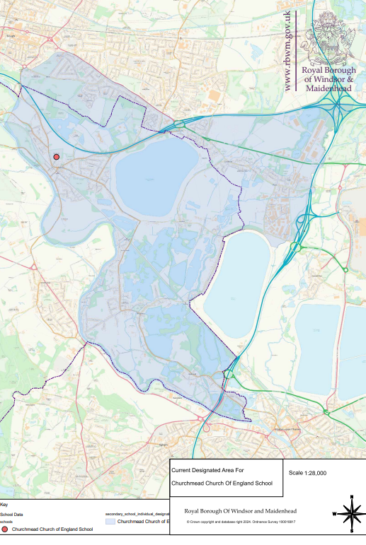
Admission to the Sixth Form [Year 12]

- Introduction

1. The school welcomes students from outside Churchmead [external students], as well as current Year 11 students attending Churchmead at the time of application [internal applicants] to apply to join the Sixth Form. This document sets out the admission arrangements of Churchmead School.

2. Students will be admitted into Year 12 on the understanding that they have a desire to benefit from the programmes available to them and a commitment to meet the appropriate study requirements.

3. External applicants are expected to be aware of the Church School foundation and ethos of Churchmead School and to be able to work within it.

2. Applications

1. Internal applicants must complete a Churchmead Sixth Form application which is available from the school office or school website.

- External applicants must complete a Churchmead Sixth Form application which is available from the school office or on the school website.

3. External applicants should provide verification of their predicted grades, validated by their current school. All applicants must state their chosen subjects.

3. Entry Criteria

1. To determine eligibility for admission into the Sixth Form, Churchmead Sixth Form has specific criteria in relation to minimum entrance requirements for Year 12 based on GCSE grades or equivalent or other measures of prior attainment. For studying at level 3 which will be 5 or more GCSE grades 5 - 9 (or equivalent), all of which must be full GCSE courses or equivalent.

2. Churchmead also has academic entry requirements for each particular course available based upon GCSE grades or other measures of prior attainment.

3. These criteria will be the same for internal and external students and will be published in the Sixth Form course guide.

4. Young people who do not meet the grades for their preferred course option will be offered alternative courses in line with their preferences where available.

5. In exceptional circumstances (for example, interruptions to study during Key Stage 4 resulting from prolonged illness or due to relocation) the school will reserve the right to admit a student who is not able to demonstrate the normally required level of prior attainment.

6. The school will admit any young people whose Education, Health and Care Plan [EHCP] names Churchmead provided they meet the general Sixth Form entry criteria.

4. Oversubscription Criteria

- Oversubscription criteria will be applied if the number of external applicants exceeds the available number of places.

2. Offers will be made to applicants who have applied by the deadline, 1st March 2024 if:
• There are spaces available on all of the applicant’s chosen courses
• The applicant is predicted to meet the academic requirements for all of the courses for which they have applied, as well as the general entry criteria.

3. If both of the above criteria are met, priority will be given according to the order below:

1) Looked-after children and children who were previously looked after, including those children who appear to have been in state care outside England, but ceased to be so as a result of being adopted [see note 2].

2) Applicants whose home address is nearest to the school.

4. Any offer of a place will indicate which courses are available to an applicant, and whilst the offer of a place will remain valid, students’ options will be governed by availability in particular subjects.

5. The school will do its best to accommodate external students on their preferred courses but courses may become full or not be viable, so an offer of a place cannot guarantee entry to a preferred course of study.

6. External students whose applications cannot be accommodated may be placed on a waiting list which will be used to fill any vacancies arising before Year 12 studies commence.

