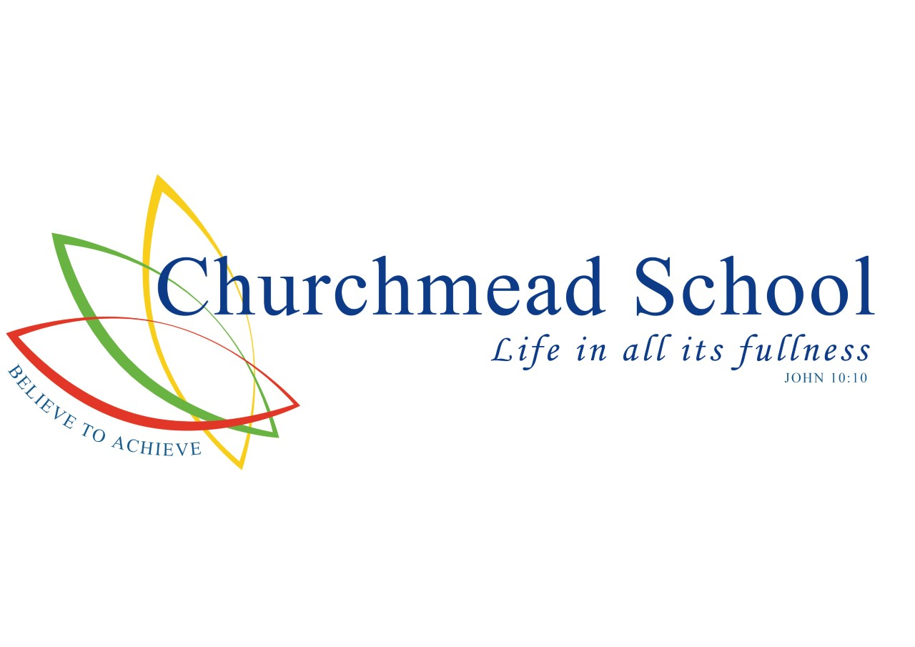

**COLLECTIVE WORSHIP POLICY**

Headteacher

Mr C Tomes BA (Hons), MA

**Collective Worship Policy**

**Legal Status of Collective Worship**

The 1988 Education Reform Act requires that ‘all students in attendance at a maintained school shall on each day take part in an act of Collective Worship.’ We seek to do our best to keep the spirit of this legislation seeking to provide as many high quality acts of worship as is practically possible.

**Aims:**

* To comply with Government legislation.
* To assist in the delivery of spiritual, moral, social, cultural education.
* To create an atmosphere for spiritual, moral, cultural and social development through reflection, prayer and deeper thought.
* To help students to begin to understand the nature and purpose of worship.
* To create a sense of unity within the school and outside the school.
* To provide an opportunity for celebration and praise as part of the students learning experience.
* To develop pupils’ leadership skills by helping and leading collective worship.

**Objectives:**

1. All students to participate in collective worship through whole school worship as well as house and year worship over the two week timetable.

2. Each act of collective worship to provide opportunity for students to reflect on values and beliefs which inform their perspective on life and their patterns of behaviour.

3. Class based acts of collective worship to be provided by form tutors using the ‘thought for the week’ in student ‘life in all its fullness’ reflection diaries. Form tutors to provide time for reflection and/or the school prayer.

**Provision:**

1. All SLT members, Middle Leaders, and Heads of Year to deliver whole school acts of worship on a rotational basis. Weekly theme based on the school calendar, incorporating the distinctively Christian values of the school (courage, compassion, commitment). The school calendar to embed themes allowing reflection and response to the fundamental questions of life and those things that are of eternal concern and value to human beings. Individual member of staff may also base the theme in conjunction with the school needs and world events.

2. Students with leadership roles to deliver whole school assemblies on a rotational basis.

3. Form groups to deliver assemblies on a rotational basis on the ‘thought of the week,’ based on the school calendar.

4. Local clergy to be used to deliver at least one assembly per term on a relevant theme linked to the Christian calendar.

5. Other partner agencies to be asked to deliver assemblies, as required by the school.

6. Aspects of spiritual, moral, social, cultural education are incorporated into the tutorial programme for each year.

7. Students to attend the local church for acts of worship based on the Christian calendar.

8. Churchmead School celebrates and embraces all as unique children of God. As a diverse school, including students from other faith traditions the beliefs and values of those students to be welcomed. Provision for specific religious observances to be made.

9. Celebrate and give thanks for the achievements within the school, local and international, community and occasions of significance, including festivals.

10. SLT to monitor on behalf of Governing Body, that collective acts of worship delivered through whole school or house/year assembly containing an appropriate theme and are not solely a vehicle for the giving of notices.

## Withdrawal:

Every parent or guardian is made aware of their right to withdraw their child from the daily act of worship through the school prospectus.

**Appendix 1: Churchmead School Prayer**

