

Personal Development Curriculum

Information for Families

Courage, Compassion, Commitment

‘Life in all its fullness’ John 10:10

**Our Intent:**

At Churchmead School, our intent is to support, educate and guide our young people to become the best they can be. This is within themselves and for their life beyond education. It is our responsibility within our Personal Development Curriculum to ensure our students become well-rounded members of our modern society, with a positive understanding of mental health and wellbeing and the resilience to overcome challenges that they may face within the modern world.

Our Personal development subjects covered:

* Religious Education
* Social, Moral, Spiritual and Cultural Education (SMSC)
* Relationship and Sex Education (RSE)
* Personal, Social and Health and Economic Education (PSHE)
* Citizenship Education
* Careers
* Mental Health and Wellbeing- Body image.
* Higher education information
* Our Fundamental British Value (FBV)
* Online Safety
* Personal Finance and Money
* Extra-Curricular Activities and Enrichment

**Our Content:**

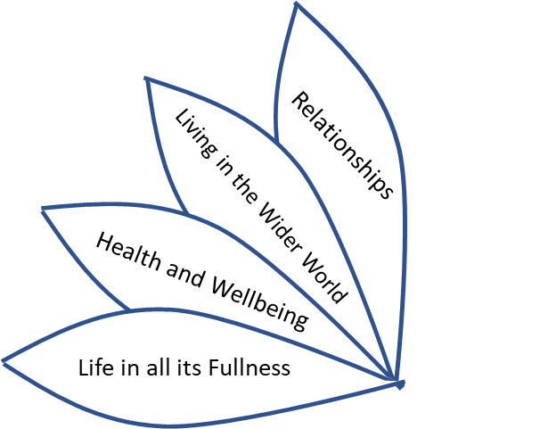At Churchmead School our Personal Development program focuses on these four main themes:

We aim to ensure that our students leave Churchmead with the knowledge and skills to become hard working, respectful, compassionate, tolerant, and successful individuals who believe in themselves and will live their individual lives to its fullness.

Our Content:

|  |  |
| --- | --- |
| Our Themes: | What we want our students to know, understand and develop skills in: |
| Life in all its fullness | Summary:   * To have experiences that will shape their individual opinions. * To encourage a positive Mindsets * To enhance positive mental wellbeing * To build Resilience * To raise positive Self esteem * To encourage Individuality * To show compassions * To show commitment * To show courage |
| Health and Wellbeing | Summery:   * How to keep themselves and others safe * How to keep a healthy mind and body * Understanding different risks as they get older * Understanding their changing bodies and how to manage their feelings and emotions |
| Living in the Wider World | Summery:   * The importance of aspirations, goals, and their personal strengths * Employability * Understanding all types of communities * Exploring Bristish Values and Diversity * Being safe online * How to revise and mange stress |
| Relationships | Summary:   * What healthy friendships and relationships are. * How to keep themselves safe and happy in relationships * Understanding of diversity and individuality. * Safe sex |

Delivering our Curriculum

As well as our daily routines and activities within form times and assemblies, students also take part in PSHEC and RSE timetables lessons and drop-down mornings, these are to build on key knowledge and experiences.

Personal Development opportunities at encourage daily with key learning and skills embedded in our academic curriculum. This is to enable our students to explore deeper into their learning and reflect on this impact into their everyday lives and life beyond education.

Every teacher has the responsibility for our Personal Development Curriculum.

Form tutor and teachers play a key role each day by maintaining high standards, building positive relationships, and ensuring their students are well-planned for learning.

Within subjects, teachers are able to identify opportunities to discuss aspect of personal development within their subject content.

Cross- curricular

Extra-curricular Activities

Trips

Guest Speakers

Thought of the Week

PSHE sessions

Worships

Form Time

All members of staff are key role models in demonstrating our school values and contributing to the personal development of our students.

PSHE, Citizenship and RSE

Our PSHE (personal, social, health education), Citizenship and RSE (relationship and sex education) curriculum has been designed to ensure all students have the ability to understand, reflect and explore all aspects of life beyond education.

This Programme of Study sets out learning opportunities for each key stage, in three core themes: Health and Wellbeing, Relationships, and Living in the Wider World. Our curriculum makes sure that we cover the statutory guidance set out in the Department for Education’s statutory guidance on Relationships Education, RSE and Health education. Our curriculum covers all of the statutory requirements for their phase, within a comprehensive PSHE education programme.

Families will be made aware of any external support coming into school to support our students with any part of our PSHEC and RSE curriculum.

Parents/ Families have the right to request that their student be withdrawn from some or all of sex education (but not Relationships or Health Education) as delivered as part of statutory RSE. Before this request is actioned, a discussion with the students HOY or member of SLT will be had, it is important that both parent/ family and student’s wishes are understood and to clarify the nature and purpose of the curriculum.

Once those discussions have taken place, the school will respect the family's request to withdraw the child, up to and until three terms before the child turns 16. After that point, if the child wishes to receive sex education rather than be withdrawn, we, as a school will make arrangements to provide the child with sex education in an appropriate manner.

Please see our PSHE, Citizenship and RSE Curriculum Map

Curriculum map can be viewed on our website.

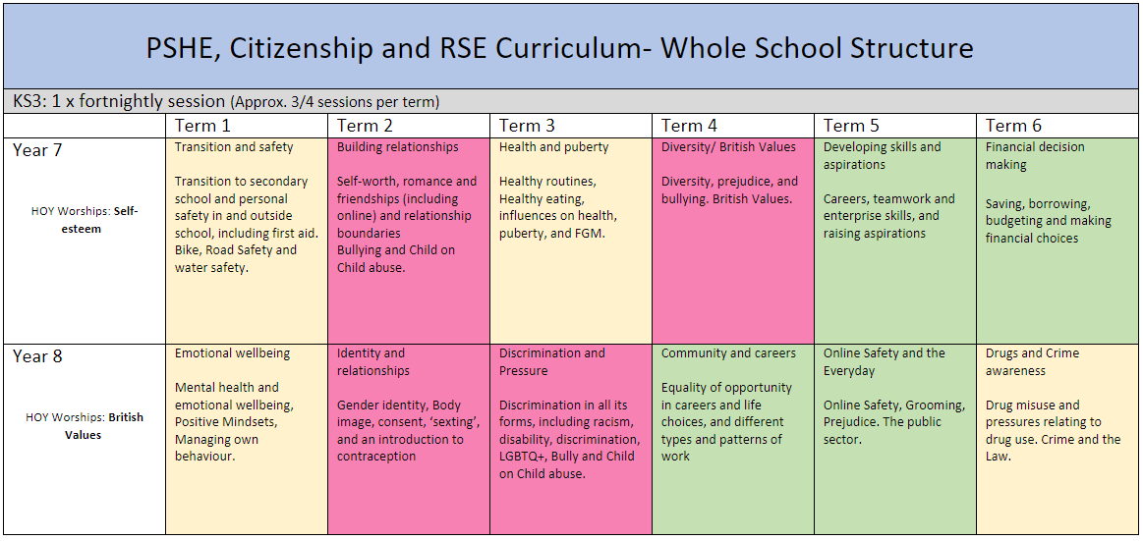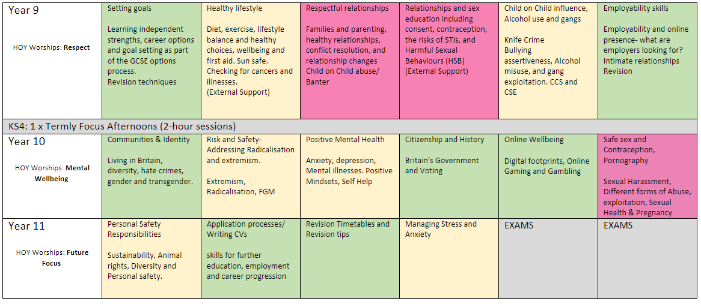

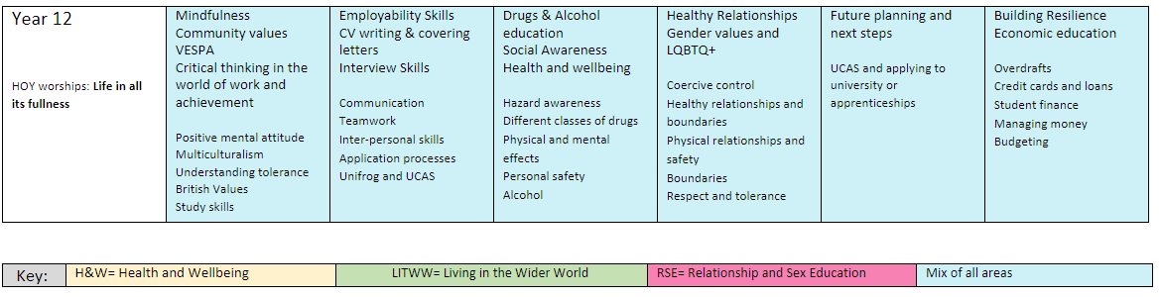

Mental Health and Wellbeing

At Churchmead School, our focus is to promote positive mental health and wellbeing. This is our vision for every individual within our diverse community. We are a small school with a big heart and our aim has always been to build the positive relationships with our students, to know each one individually, and to develop a well-rounded young person for when they entre life outside of education. Our inclusive culture is supported by our school Christian values of Courage, Commitment and Compassions that allows our students to explore challenges, build resilience, and learn from mistakes.

The pastoral teams help to guide students, staff, and parents to secure healthy, happy, and respectful individuals and our student Blue Guardian Angel’s team help our young people feel secure and listened too around the school.  Our bible quote that underpins all that we stand for promotes mutual respect, trust, and diversity, where all are valued and supported so that every child can ‘live life in all its fullness’ John 10:10.

**Mental Health Support:**

Each year students are monitored for any mental wellbeing concerns. If a concern is noted or raised our Mental Health team will indefinity what level of support the young person needs.

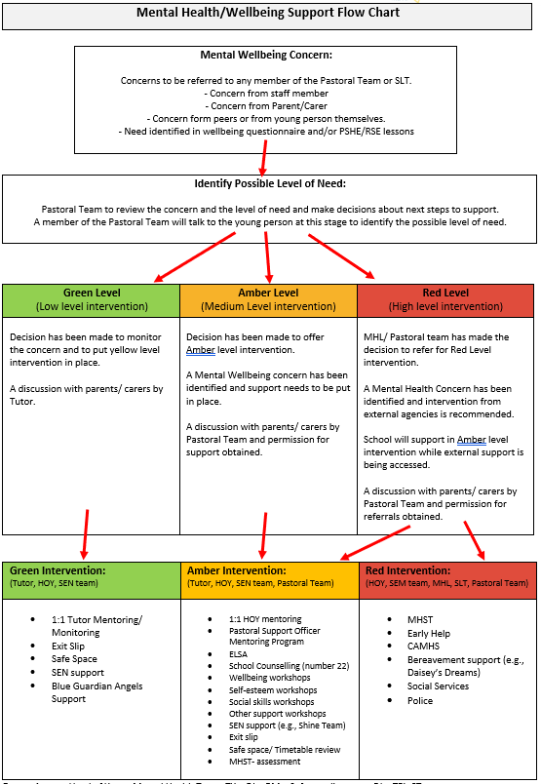

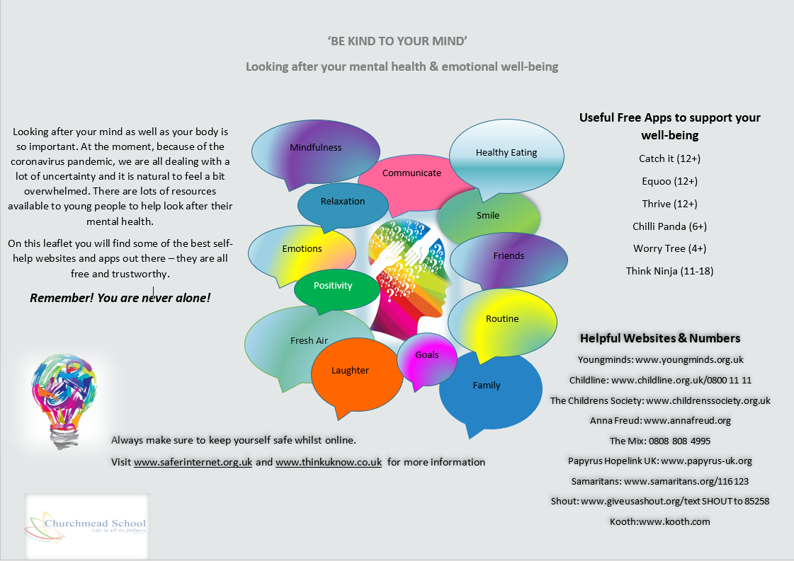

ELSA

**ELSA (Emotional Literacy Support Assistant)**

In our school we provide Emotional Literacy support for pupils, this is referred to as ELSA support.

ELSA is an initiative supported and developed by Educational Psychologists. It recognises young people work better when and are overall happier when both their emotional and academic needs are met.

Our qualified Emotional Literacy Support Assistant here at Churchmead has been trained by Educational Psychologists to plan and deliver support sessions to pupils who are experiencing emotional difficulties or a particular unbalance in their life.

ELSA sessions are held on a one-to-one basis but can also include group sessions to support pupils with social and friendship skills. The sessions are held in the ELSA room which provides a calm, safe place for pupils to feel safe, supported and nurtured.

The sessions are held once a week and the duration is 6 weeks although this can be extended if needed, depending on the progress made by the young person.

ELSA’s can help with:

* Recognising and understanding emotions
* Building self-esteem
* Social skills
* Friendship skills
* Anger and Behaviour management
* Loss and Bereavement
* Relaxation techniques
* Transition and change

ELSA provides emotional support to those who need it. The aim is not to “fix the problem,” but to provide pupils with knowledge of strategies, relaxation methods and a space to reflect where they are able to openly share their thoughts and feelings.

For further information you can contact our school ELSA:

Mrs Matharoo - [rmatharoo@churchmead.org](mailto:rmatharoo@churchmead.org)

Careers

In keeping with our commitment to provide students with outstanding careers guidance and tailored support when choosing their next step after school, we use Unifrog; an award-winning, online careers platform. All students in Years 7, 8, 9, 10 and 11 will have access to this excellent website for support in next steps.

The Unifrog platform is designed to support learners in making the most informed decisions about their futures and has a range of tools that are suitable for all year groups. Each student has their own personal account that provides a wide range of information related to their interests and aspirations. Key features of the platform include:

* Exploring Pathways – personality quizzes, career and subject profiles, MOOCs and webinars
* Recording – self-reflection about extracurricular activities and key employability skills
* Opportunities – search tools showing live vacancies/courses/placements for apprenticeships, universities (in the UK and abroad), FE, virtual work experience and much more
* Applications – tools to help students build applications for a range of pathways (e.g., CVs, Personal Statements, Common App Essays)

Students access the platform by clicking a link in their welcome email, where they create a password and can begin using the platform.They login to Unifrog using their email address and password and they can do so from any computer, tablet or smartphone. We would encourage you to use the platform with your child so you can support them through the process of deciding their next step.

The new Unifrog platform provides opportunities for students to be introduced to all pathways for KS5 and apprenticeships opportunities that they can apply for. This is in conjunction with our Careers Adviser meetings, that are provided by Adviza Company. Students are encouraged to sit and have a 1-2-1 with a dedicated careers advisor professional to discussing their dreams and aspirations including interests and hobbies.

The 1-2-1 Adviza sessions also include: CV writing, filling in application-forms, interview preparation, and help to encourage students to thinks about their future.

 

Form Time Activities

Form time is an excellent opportunity to enhance the personal development of our students. Our Form time runs from 8.30am till 8.50am each day, we have a program of activities that enables the students to explore key areas of the curriculum, listen to current affairs and reflect on their own views and the views of others. It is also a vital time to enable us to build and strengthen positive relationships we have with each other.

There are two tutor timetables that support our week 1 and week 2 curriculum. Each week we have a ‘Thought of the week’ which highlights important values and subjects we feel students’ need to reflect upon. This gives staff the opportunity to promote, reflect and explore students’ views and address any misconceptions.

Planned activities linking to literacy, numeracy, current affairs, and team building reinforce key knowledge and give opportunity to discuss and debate.

Attendance reviews, Uniform and Equipment checks, and behaviour monitoring are standard practise in ALL form groups.

Form time activities are quality assured by leaders to ensure consistency and impact.

Weekly Worships

Twice a week, students attend a school assembly which contains an act of Collective Worship. The SMSC theme of the week is planned for the academic year ahead. Each assembly is led by a member of staff, normally in the form of a presentation and students will lead in school prayer along with other readings. On all other days, there is worship for each Year group or House before lessons commence.

The Bible is used throughout all our collective worships. Leaders use our thought for the week as starting point for worship. Leaders will use their life experience and faith to create engaging worships that allow the whole school community to reflect and develop spiritually.

Our Worship Committee compromising of students and staff meet once a term to review, discuss and plan the Religious Life of our school, and find ways to develop our Christian character. Various topics such as whole school worship, prayer spaces, school values, development of school prayer, charitable work and whole school projects are all part of the themes during each meeting. Pupils have the opportunity to help develop worship at Churchmead school. Pupils can volunteer to become part of the worship committee. The committee help with leading worship and preparing the prayer for the week and helping our local parish church with services and events.

Helping during worship is not exclusive to the worship committee and all pupils are encouraged to help with collective worship during whole school worship, year worships and house group worships.

|  |  |  |  |
| --- | --- | --- | --- |
| Alter Colour |  | Theme | PSHE Link |
| Term 1  1 | 04/09/2024 | New Beginnings  Jeremiah 29:11  Our values: Courage, Compassion & Commitment | Living in the wider world |
| 2 | 09/09/2024 | Commitment  Matthew 5:41 | Relationships |
| 3 | 16/09/2024 | Compassion  Parable of the Lost Sheep  Matthew 18:12-14 | Relationships |
| 4 | 23/09/2024 | Courage  Story of Daniel  Daniel 6:1-28  European Languages Day Thursday 26th September 2024 | Living in the wider world |
| 5 | 30/09/2024 | Inspirational People  Black History Month  2 Timothy 1:7 | Living in the wider world |
| 6 | 07/10/2024 | Helping Others  The Good Samaritan  Luke 10:25  Culture Week | Relationships |
| 7 | 14/10/2024 | Reading  Romans 15:4 | Health and Wellbeing |
| 8 | 21/10/2024 | Keeping Active  Isaiah 40:31 | Health and Wellbeing |
| 9 | 04/11/2024 | Life in all its fullness  John 10:10 | Living in the wider world |
| Alter Colour |  | Theme |  |
| Term 2  10 | 11/11/2024 | Peace and Reconciliation  Ephesians 6:10-17  Armistice Day Saturday 11th November 2024  Remembrance Sunday 10th November 2024  National Anti-Bullying Week 11th-17th November 2024 | Relationships and Living in the wider world |
| 11 | 18/11/2024 | Actions Speak Louder  James 3:4-6 | Relationships |
| 12 | 25/11/2024 | Using Talents  Matthew 25:14-29 | Living in the wider world |
| 13 | 02/12/2024 | Advent  Isaiah 7:14 | Living in the wider world |
| 14 | 09/12/2024 | Resilience  Isaiah 41:10 | Health and Wellbeing |
| 15 | 16/12/2024 | Christmas  Luke 2:1-20 | Living in the wider world |

|  |  |  |  |  |  |  |
| --- | --- | --- | --- | --- | --- | --- |
| Alter Colour | |  | Theme | | |  |
| Term 3  16 | | 06/01/2025 | New Year  2 Corinthians 5:17 | | | Living in the wider world |
| 17 | | 13/01/2025 | Health, Well-Being & Mindfulness  Romans 12:2 | | | Health and Wellbeing |
| 18 | | 20/01/2025 | Spirituality around the world 1 Corinthians 2:15 | | | Health and Wellbeing |
| 19 | | 27/01/2025 | Learning From Mistakes  Parable of the Lost Son  Luke 15:11  Holocaust Memorial Day 27th January 2024 | | | Health and Wellbeing |
| 20 | | 03/02/2025 | Recall and Retrieval  Philippians 4:9 | | | Living in the wider world |
| 21 | | 10/02/2025 | Inspirational People  Hebrews 13:7 | | | Living in the wider world |
| Alter Colour | |  | Theme | | |  |
| Term 4  22 | | 24/02/2025 | Reading  Ephesians 3:4 | | | Health and Wellbeing |
| 23 | | 03/03/2025 | Lent  Mark 1:12-15  Word book day 6th March 2025  Fairtrade Fortnight 3rd -16th March 2025 | | | Living in the wider world |
| 24 | | 10/03/2025 | Contemplation  Psalm 46:10 | | | Health and Wellbeing |
| 25 | | 17/03/2025 | Forgiveness  Colossians 3:13 | | | Relationships |
| 26 | | 24/03/2025 | The Lord’s Prayer  Matthew 6:9-13  Luke 11:1-14 | | | Living in the wider world |
| 27 | | 31/03/2025 | Making Sacrifices  Easter  Luke 23:32-49  Easter Service Wednesday 2nd April 2025 | | | Relationships |
| Alter Colour | |  | Theme | | |  |
| Term 5  28 | | 21/04/2025 | New Life Resurrection  Luke 24  St Georges Day 23rd April 2025 | | | Living in the wider world |
| 29 | | 28/04/2025 | British Values  Colossians 3:13-17  Year 11 Exam Blessing | | | Living in the wider world |
| 30 | | 06/05/2025 | Believe to Achieve  Galatians 6:9 | | | Health and Wellbeing |
| 31 | | 12/05/2025 | Serving Others  Philippians 2:3-8  Christian Aid Week 12th-18th May 2024 | | | Relationships |
| 32 | 19/05/2025 | | | Friendship  1 John 4:7 | Relationships | |
| Alter Colour |  | | | Theme |  | |
| Term 6  33 | 02/06/2025 | | | Ecco Challenge and Volunteering  James 1:2-4 | Living in the wider world | |
| 34 | 09/06/2025 | | | Pentecost  Acts 2:1-4 | Living in the wider world | |
| 35 | 16/06/2025 | | | Sound of Worship  Psalm 95:1 | Health and Wellbeing | |
| 36 | 23/06/2025 | | | Supporting Community  Romans 12:9-17 | Living in the wider world | |
| 37 | 30/06/2025 | | | Making Judgements  Matthew 7:1-6 | Living in the wider world | |
| 38 | 07/07/2025 | | | Fruits of the Spirit  Galatians 5:22-23 | Health and Wellbeing | |
| 39 | 14/07/2025 | | | Celebration  Romans 12:12 | Health and Wellbeing | |
| 40 | 21/07/2025 | | | Looking Back, Looking Forward (Reflection)  Proverbs 19:20 | Living in the wider world | |

Student Leadership

Churchmead recognises the importance for students to experience leadership opportunities during their time with us, to learn the art of building relationships within teams, defining identities, and achieving tasks effectively. These leadership opportunities also provide an opportunity to learn to identify and display effective communication and interpersonal skills. Opportunities here differ depending on the Key stage and experience of the student. We value the benefits of offering these roles to our students and giving them the tools to flourish, grow throughout at Churchmead.

At KS3 the following student leadership roles are available to apply for:

* Jr. Leader- This role is extremely prestigious, and Jr. Leaders are asked to assist with parent evenings, school tours, open evenings and school worships. This role is appointed depending on interview and application letter.
* Eco Ambassador- These leaders have a passion for creating and sustaining an eco-friendly school and community.
* Student Council- Responsible for making decisions that benefit the whole school.
* Worship Council-Responsible for planning, leading and assisting with worship. They are called upon to help with church services and key events in our Christian calendar.
* Subject specific ambassadors- These leaders support and assist in departments that they are passionate about.
* Choir leader- These leaders are responsible for arranging rehearsals and selecting music for church services.

At KS4 the following student leadership roles are available to apply for:

* Churchmead Guardian Angels- These leaders are incredibly important to our school. They act as mentors for all year groups and are given extensive training in how to do this. They run sessions and clubs for the lower school peers and are a calming influence around school. This role is appointed depending on interview and application letter.
* Eco Ambassador- These leaders have a passion for creating and sustaining an eco-friendly school and community.
* Student Council- Responsible for making decisions that benefit the whole school.
* Worship Council-Responsible for planning, leading and assisting with worship. They are called upon to help with church services and key events in our Christian calendar.
* Subject specific ambassadors- These leaders support and assist in departments that they are passionate about.
* Prefects- As students move up the school, they can apply to become a Prefect and to take on more responsibility.
* Senior Prefects- Our Senior Prefects are awarded to Year 10 students after interview. Senior prefects take on a whole school project and work closely with the staff senior leadership team.
* Gold Tie Prefects- Our Gold Tie Prefects are awarded to Year 10 going into Year 11 students after interview and written application. These are our Head girls and boys who are role models to others. They work on school initiatives, present to parents and the community and they work extremely closely with the Head teacher and the staff senior leadership team.
* Gospel Choir leader- These leaders are responsible for arranging rehearsals, performing in worships and selecting music for church services for the gospel choir

Extra-Curricular & Enrichment

The extra-curricular programme is part of a comprehensive educational experience for our students. We believe that an important part of our work at Churchmead is the personal and social education of our pupils and nowhere is this more effectively achieved than in the area of extra-curricular activities. It helps provide children with a rounded, culturally rich education through activities that enhance their learning. With over 26 weekly clubs and enrichments activities to choose from and we hope that, as well as working hard in the classroom, students will find the time and be enthusiastic to participate in some of the very many activities which are provided by staff volunteers and specialist coaches, usually out of school hours.

Students are able spend up to two hours a day pursuing a wide array of activities that encourage them to build on current talents or develop new ones from creative, sporting, or academic approaches. We work with our teachers and support staff to provide meaningful outcomes for all students who are involved, allowing our students to celebrate life in all its fullness. A communication will be sent out with details of after-school clubs at the start of each school term. These activities are offered on the understanding that they will only take place provided that there are a suitable number of students interested to make the club viable.

Extra-Curricular

Below is an example of our weekly extra-curricular programme, please be aware that this timetable will change termly:

Within the PE (Physical Education) department we offer a wide range of sporting activities for students at both a recreational and competitive level.

At a competitive level, students are selected by the PE department based on effort and engagement during core PE lessons, attendance to after school clubs and overall athletic ability. The core philosophy surrounding this is of a reward-based system that allows all students who wish to be involved equal opportunities regardless of pure sporting prowess. These students will compete at local level against surrounding schools. During this time, parents are welcome to attend.

All sports clubs run during break/lunch time and from 3.00pm to 4.00pm daily, with competitive activities finishing up to 5.30-6.00pm.

During extra-curricular time students are able to pursue the following:

|  |  |  |
| --- | --- | --- |
| **Team** | **Individual** | **Health and wellbeing** |
| Football | Squash | Fitness |
| Netball | Badminton | Dance |
| Rugby | Trampolining | Engineering Club |
| Cricket | Athletics | Art Club |
| Handball | Table Tennis | Drama Club |
| Basketball | Tennis | Homework Club |
| Rounders | Gymnastics | Reading Club |
| Softball |  |  |
| Volleyball |  |  |

Should any further activities, not listed, be of interest for your child, this may be accommodated through contact with the PE department and run-in accordance with student interest and attendance.

Enrichment

At Churchmead our learning philosophy expands way beyond the classroom. Our students are independent, talented and curious learners and we believe it is essential to nurture these attributes so students can become successful global citizens. To promote this within our community we further provide a number of internal and external workshops, educational trips, visits within the local area and beyond, all designed to give students the opportunity to try something new or develop their existing skills.

Cultural and enrichment opportunities prepare students for the real world. Students get to experience another culture, travel, and create amazing lasting memories. They are suitable for all learning styles; we learn best when we can see, hear, and experience things first-hand. Below are some of the benefits a cultural and enrichment trip can provide:

* Develop a sense of responsibility.
* Be character building, develop students’ self-esteem, self-confidence, and self-belief.
* Help improve social/interpersonal skills - the ability to communicate or interact well with other people.
* The opportunity to experience cultures, respect differences, and develop new friendships with their peers.
* Broaden their horizons and knowledge.
* Encourages problem solving and teamwork.
* Provides fond memories and long-lasting positive benefits.

These activities and experiences provide students with a unique and positive time for all involved and offering a valuable educational experience through engagement, inspiration, and challenge. All our trips and workshops offer the best possible value, making learning outside the classroom more accessible and more affordable for more families.