Unit 3- Lesson 3: Character Encoding (ASCII/UNICODE)



**Task 1:**

a.

I) Explain how ASCII is used to represent text in a computer system. [3]

II) What is meant by the character set of a computer? [1]

III) Explain the possible limitations of using the ASCII character set for global communication. [4]

b. Using ASCII numbers, create a coded phrase yourself in ASCII and see if someone else can decode it. Your code message must not be more than 5 words long.

Provide the encoded & decoded REPL message underneath once it has been solved. Use this link if you need assistance: [www.asciitable.com](http://www.asciitable.com) & use the Oct value.

**Task 2:**

a. Using REPL.IT, research the commands to convert between character and ASCII (look at the Task 2 slide for the starting points):

1. Convert 97 integer to an ASCII character -
2. Convert character “A” to ASCII value -
3. Convert character “5” to ASCII value -
4. Convert 10 integer to ASCII value -
5. Convert 10 ASCII value to a character -

b. Try out these past paper questions and provide your answers in the table below:

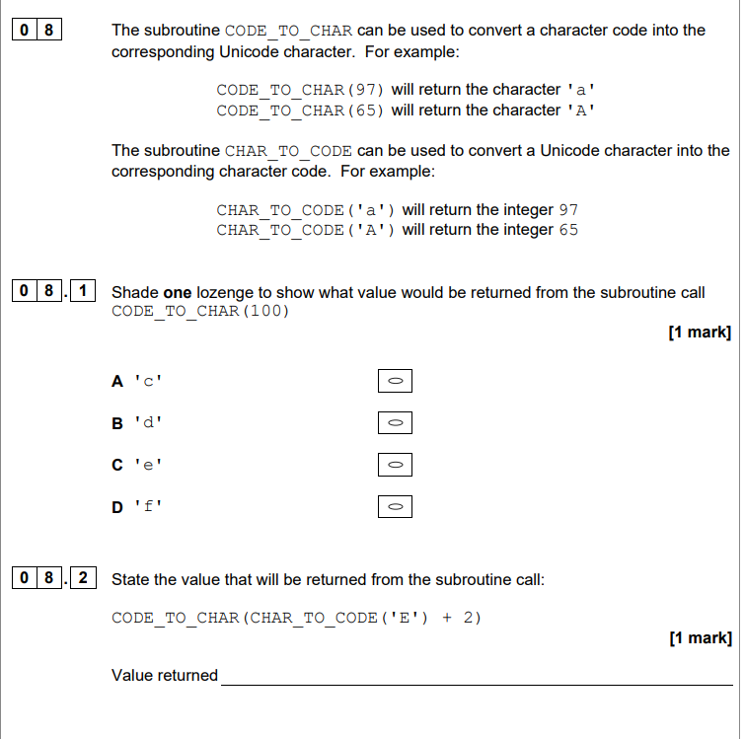

|  |  |
| --- | --- |
| Question Number | Answer |
| 8.1 |  |
| 8.2 |  |



**Task 3:**

a. Find how to encode in Unicode in your programming language (use the ord value)

b. Find the character codes for the following characters/symbols:

|  |  |
| --- | --- |
| UNICODE VALUE | Answer |
| É |  |
| ą |  |
| ö |  |
| ÷ |  |
| Ċ |  |
| ű |  |
| ° |  |
| © |  |

**Challenge 1:**

For Unicode values ‘**É ą ö**’, what is the binary representation for each character in UTF-16?

**Challenge 2:**

Try out this examination question from Paper 1 2020

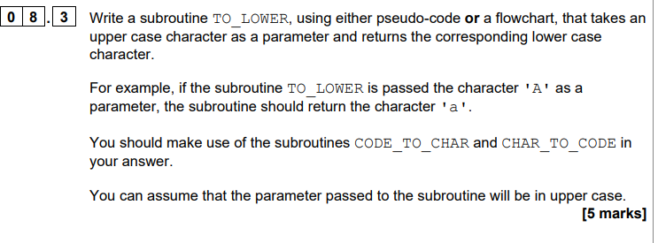

|  |
| --- |
| Challenge Question Answer Box |
|  |