Task 1:
Year 7- Cubism – Pablo Picasso
Complete the questions below, these all linked to the art movement Cubism. You will need a computer to research some of the questions.
1, Describe this painting in your own words:

What do you see? How do you think it was painted? What techniques?

Now use the internet to help answer these questions:

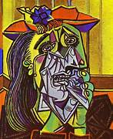

2, In what year was this painted and what is it’s name?

___________________________________________

4, Pablo Picasso is an amazing Cubist painter. Research and write down 6 facts you can find about Picasso and his art works.
1,
2,
3,
4,
5,
6,
Can you name 2 other paintings by the artist, Pablo Picasso?
1.
2.
3.

3.

5, What is your personal opinion about Pablo Picassos art work?

