**Task 1**:

**Year 8- Impressionism – Claude Monet**

Complete the questions below, these all linked to the art movement Impressionism. You will need a computer to research some of the questions.

1, Describe this painting in your own words:

What do you see? How do you think it was painted? What techniques?

Now use the internet to help answer these questions:

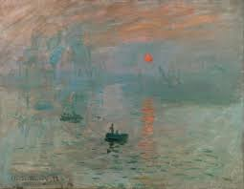

2, In what year was this painted and what is it’s name?

___________________________________________

3, Can you name 3 other painting by the artist, Claude Monet?

1.

2.

3.

4, Claude Monet is an amazing Impressionist painter. Research and write down 6 facts you can find about Monet and his art works.

1,

2,

3,

4,

5,

6,

5, What is your personal opinion about Claude Monet’ art work?