Edexcel
English Literature
Mark Scheme Booklet

EDEXCEL English Literature Mark Scheme Booklet

PAPER 1 – Shakespeare & Post-1914 Play/Novel

Q1a-6a – Shakespeare (AO2)
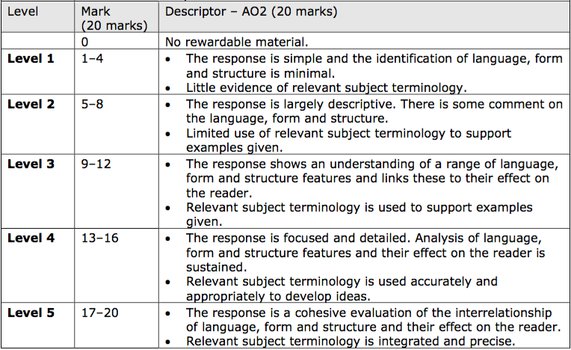

Q1b-6b – Shakespeare (AO1&3)
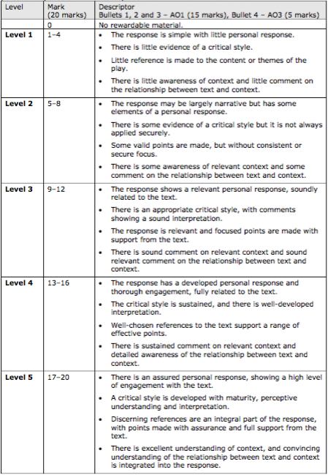
Q7-22 – Post-1914 Play/Novel (AO1&3)
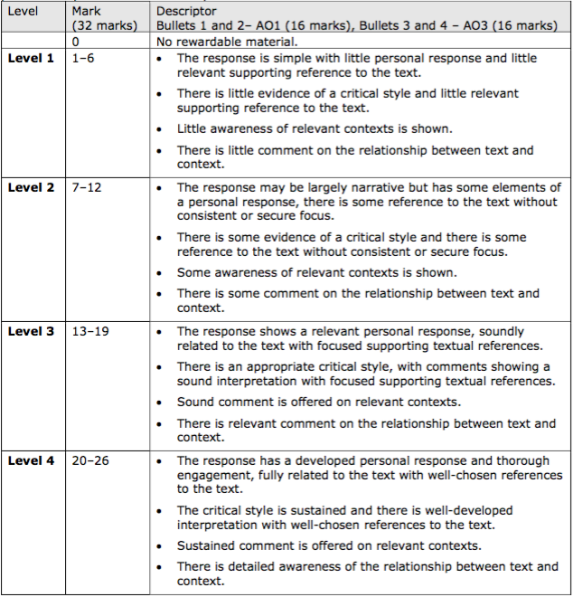
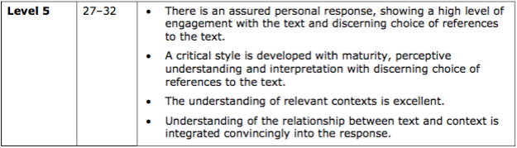

Q7-22 – Post-1914 Play/Novel (AO4)
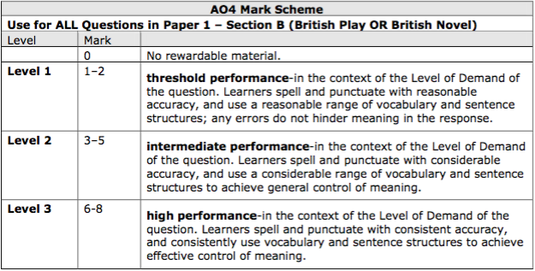

PAPER 2 - 19th Century Novel, Poetry Anthology & Unseen Poetry

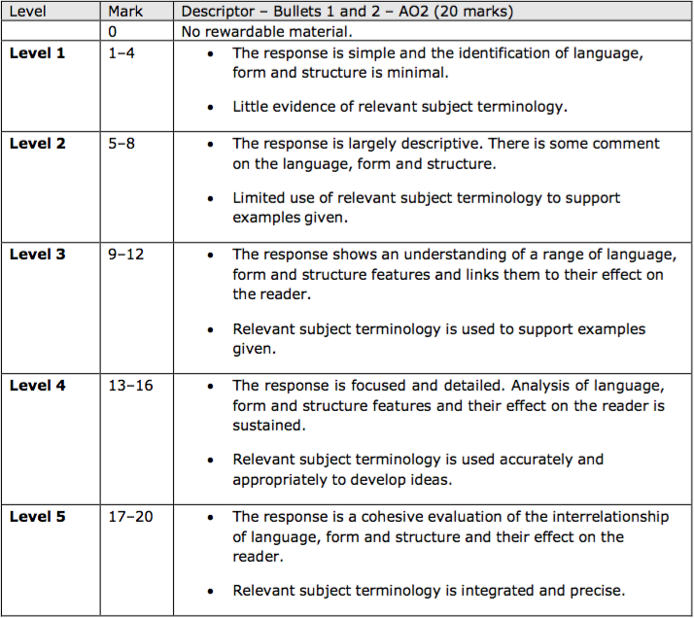
Q1a-7a – 19th Century Novel (AO2)

Q1b-7b – 19th Century Novel (AO1)
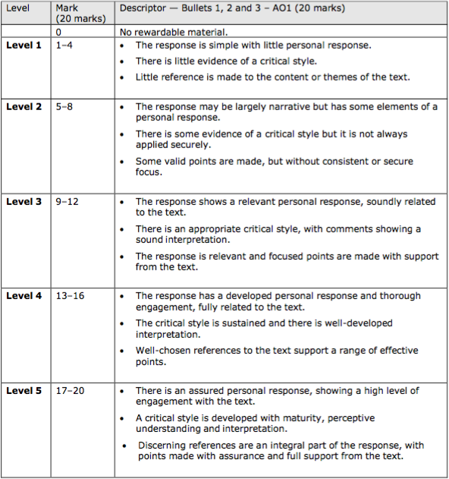

Q8-10 – Poetry Anthology (AO2&3)
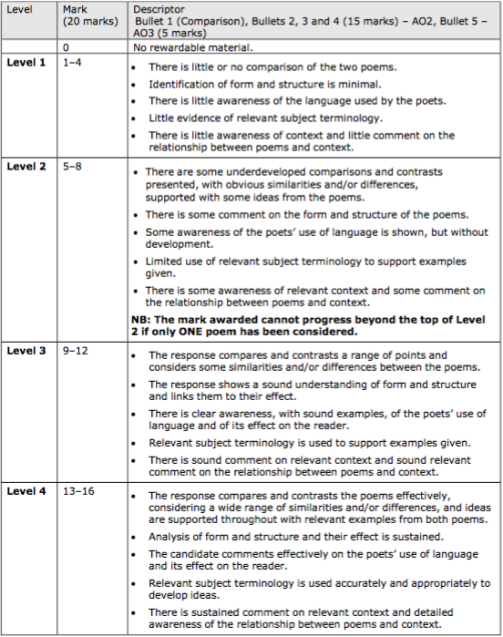
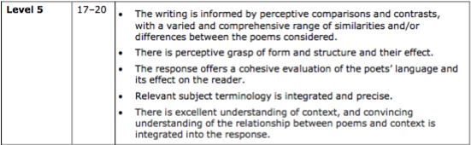
Q11 – Unseen Poetry (AO1&2)
