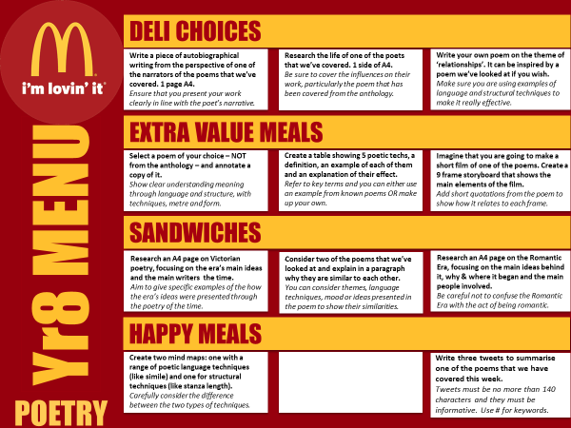

3. Use imagery, metaphors and similes to write a poem about a busy café.

**Choose the lyrics from a favourite song. Pick out the metaphors and similes.** How do they improve the meaning / description of the song?

**Research an A4 page on War Poetry. Focus on the main ideas behind it, why and where it began, and the main people involved**.

**Imagine that you are going to make a short film of one of the poems you have studied. Create a 9-frame storyboard that shows the main elements of the film.** Add short quotations from the poem and how it relates to each frame.

**Create a table showing 5 poetic techniques, a definition, an example of each, and an explanation of their effect.** Refer to key terms and find your own example or use one from a poem.

**Consider two of the poems we have looked at and explain on one side of A4 why they are like each other.** Consider theme/mood and language. Use quotes to support your ideas.

1. Research a poem of your choice and annotate it, mentioning all the poetic devices you can find.

**Find poetic devices/techniques from a poem we have studied.** What are these techniques? What effect do they have on the reader?

**Write your own poem using elements from the poems you have studied.** Use effective techniques and structure that we have studied.

**Consider two of the poems that we’ve studied and compare them.** Consider themes, language, techniques and mood to show their similarities. Quote from the poem to prove your ideas.

**Write three tweets to summarise one of the poems that we have covered this week.** Tweets must be informative. Use # for keywords.

**Research William Wordsworth and write 10 facts about his life and poems.**