Edexcel
English Language
Mark Scheme Booklet

EDEXCEL English Language Mark Scheme Booklet

PAPER 1 – Reading Unseen 19th Century Fiction

Q3 (AO2)
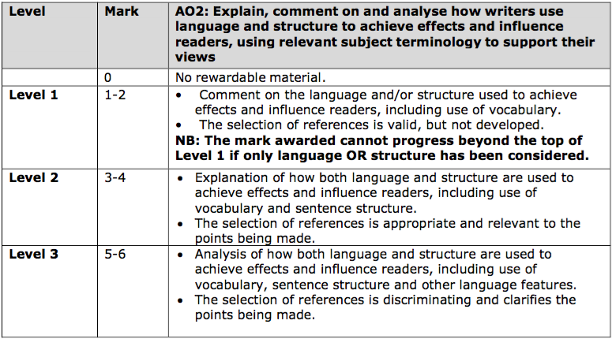

Q4 (AO4)
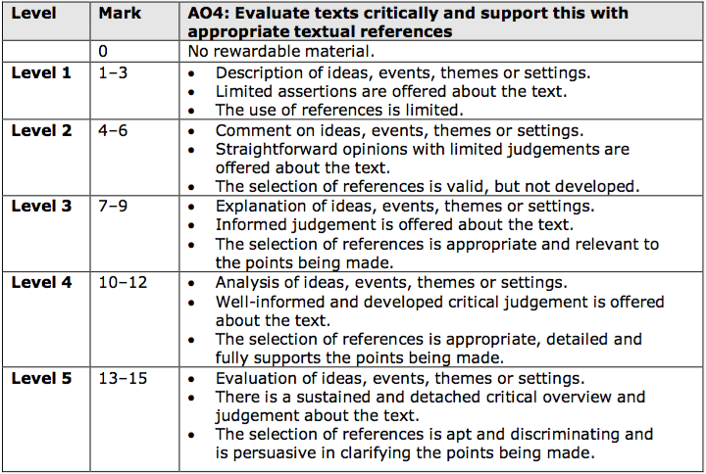

PAPER 2 – Reading Unseen Non-Fiction

Q3 (AO2)
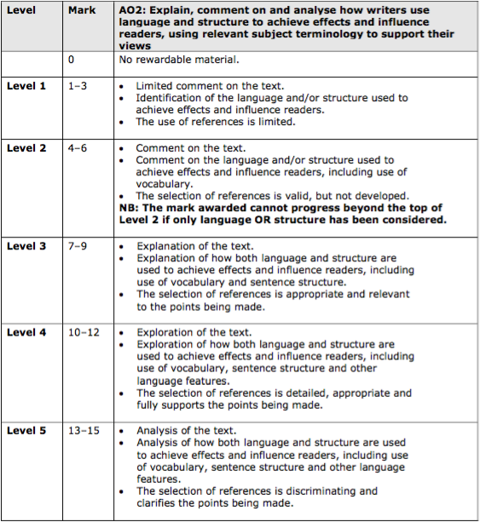

Q6 (AO4)
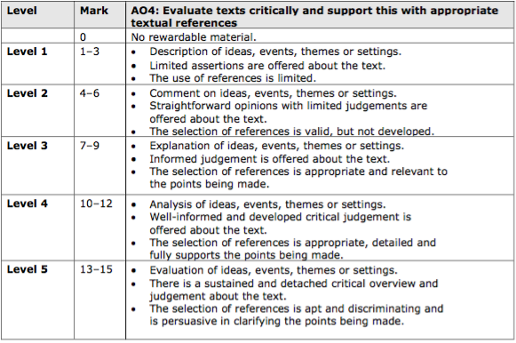

Q7a (AO1)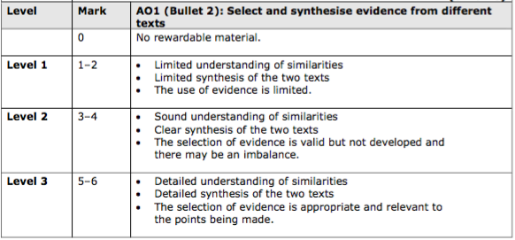

Q7b (AO3)
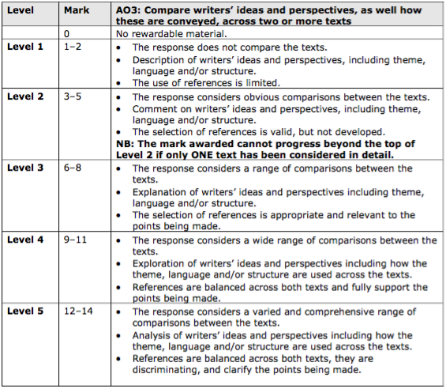

PAPER 1 – Imaginative Writing & PAPER 2 – Transactional Writing

AO5
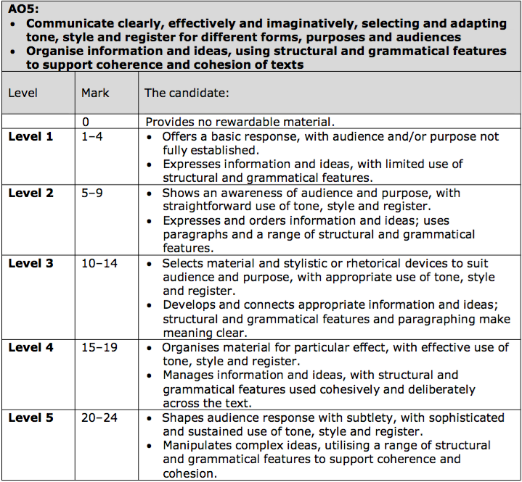

AO6
