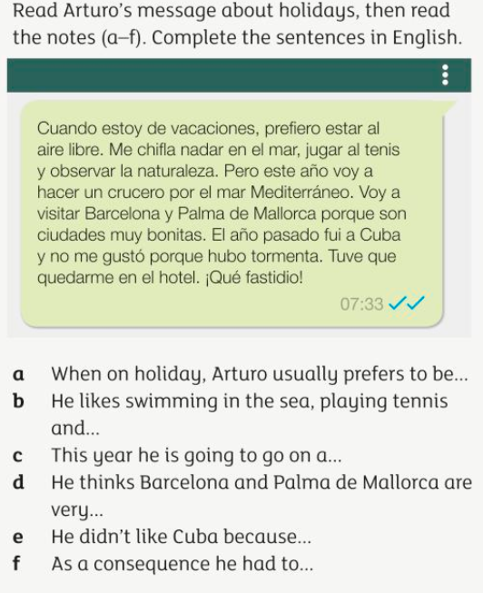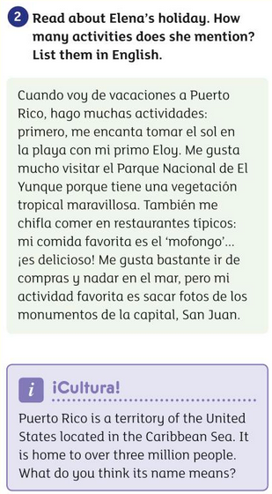

Year 8 Spanish – Home study Booklet
HOLIDAYS
3. ¿Que hay en la foto?
Write 5 sentences in Spanish
- ………………………………………………………………………………
- ………………………………………………………………………………
- ………………………………………………………………………………
- ………………………………………………………………………………
- ………………………………………………………………………………
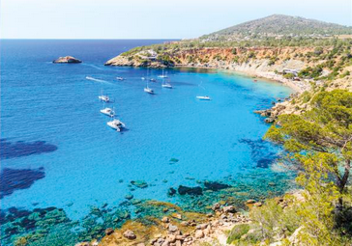
Hay = there is azul = blue tranquilo = quiet
Playa = beach barco = boat arboles = trees
Agua = water vacaciones = holiday personas = people
Mar = sea rocas = rocks sol = sunny

4. Read the text about Eloy’s trip to Guatemala and summarise in English what you have understood (He mentions who he went with, how he travelled, what it was like, where he went, what he saw, what he ate……)

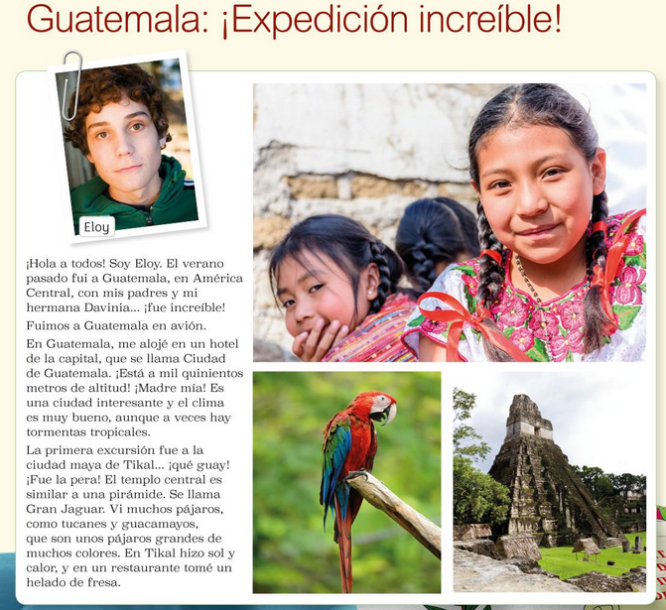
…………………………………………………………………………………………………………………………………………………………………………………………………………………………………………………………………………………………………………………………………………………………………………………………………………………………………………………………………………………………………………………………………………………………………………………………………………………………………………………………………………………………………………………………………………………………………………………………………………………………………………………………………………………………………………………………………………………………………………………………………………………………………………………………………………………………………………………………………………………………………………………………………………………………………………………………………………………………………………………………………………………………………………………………………………………………………………………………………………………………………………………………………………………………………………………………………………………………………………………………………………………………………………………………………………………………………………………………………………………………………………………………………………………………………………………………………………………………………………………………………………………………………………………………………………………………………………………………………………………………………………………………………………………………………………………………………………………………………………………………………………………………………………………………………………………………………………………..

5.
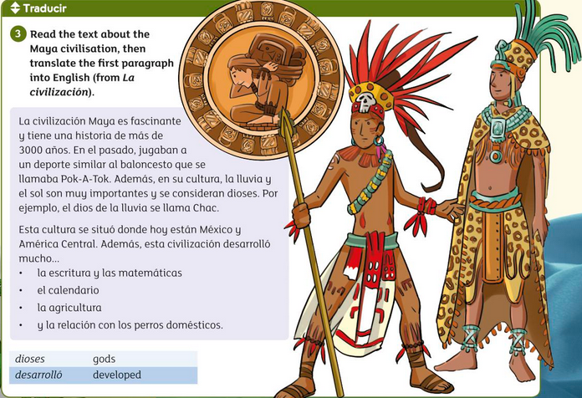

……………………………………………………………………………………………………………………………………………………………………………………………………………………………………………………………………………………………………………………………………………………………………………………………………………………………………………………………………………………………………………………………………………………………………………………………………………………………………………………………………………………………………………………………………………………………………………………………………………………………………………………………………………………………………………………………………………………………………………………………………………………………………………………………………………………………………………………………………………………………………………………………………………………………………………………………………………………………………………………

6. Design a tourist leaflet for Guatemala.
Mention;
- Location
- Mayan history
- What there is for tourists
- Climate

7. Vocabulary: Translate into English
Activities

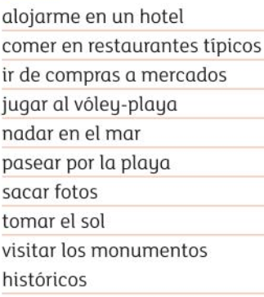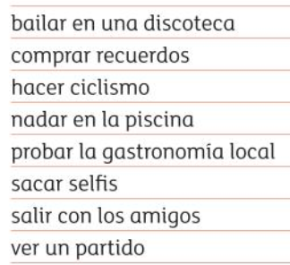
Opinions
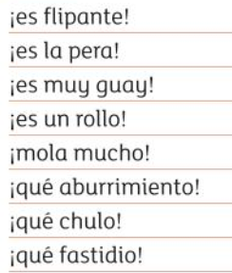

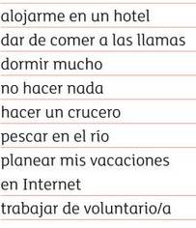
Time expressions
Past
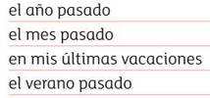
Future
