Y7 FRENCH BOOKLET
- Write four similar sentences about you
Je m’appelle Luc.
J’habite en France.
Je suis français.
Je parle français.

1……………………………………………………………………………………………………………………………………………………………………………………………………………………………………………….
2……………………………………………………………………………………………………………………………………………………………………………………………………………………………………………….
3…………………………………………………………………………………………………………………………………………………………………………………………………………………………………………………
4………………………………………………………………………………………………………………………………………………………………………………………………………………………………………………..

- Translate:
- Je m’appelle Bruno………………………………………………………………………………..

- J’habite en Italie…………………………………………………………………………………..

- J’ai onze ans…………………………………………………………………………………………..

- Je suis italien…………………………………………………………………………………………

- Je parle italien……………………………………………………………………………………..

- Fill in

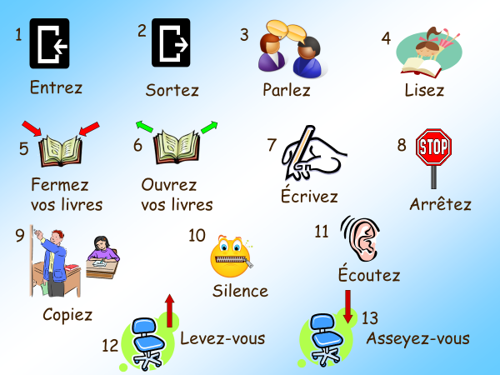

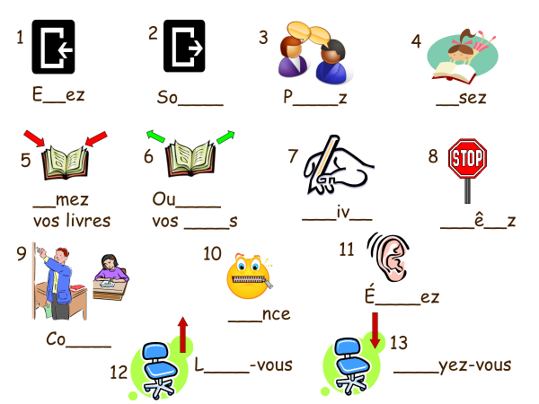

- Answer the questions:

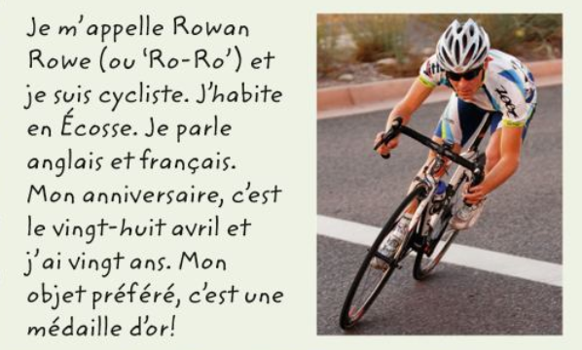
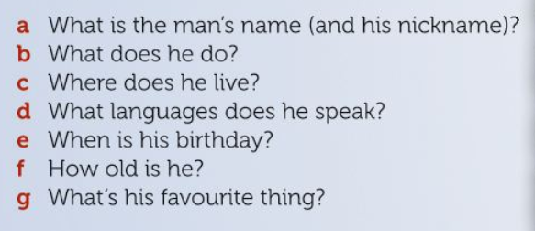

- Complete the missing letters (colours)

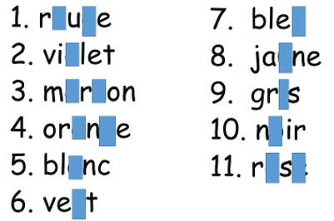

- Who is it?

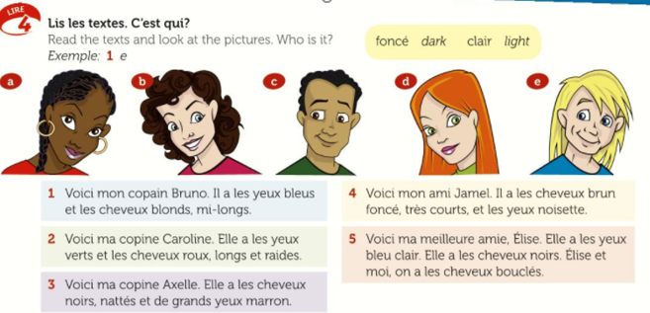

- Now describe yourself
…………………………………………………………………………………………………………………………………………………………………………………………………………………………………………………………………………………………………………………………………………………………………………………………………………………………………………………………………………

- Match up:

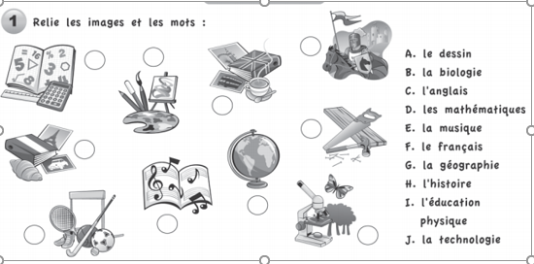
9 Read and fill in the grid:

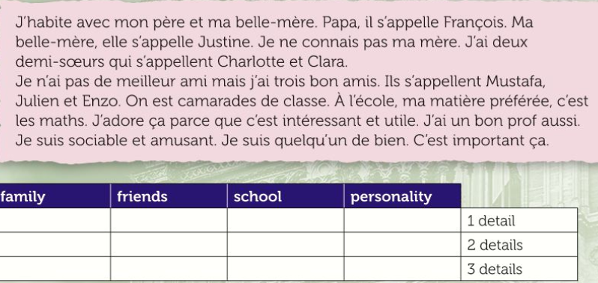

10
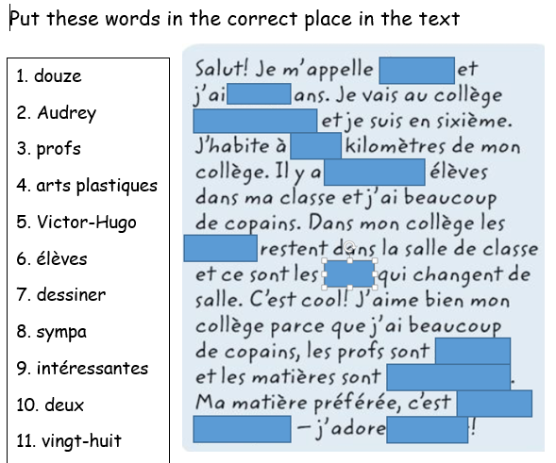

11 LABEL PHOTOS:
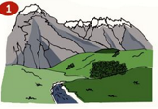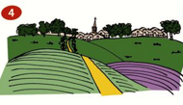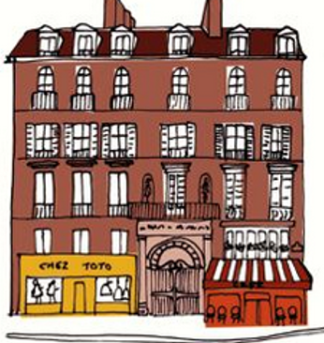
à…………………………… à ………………………… en …

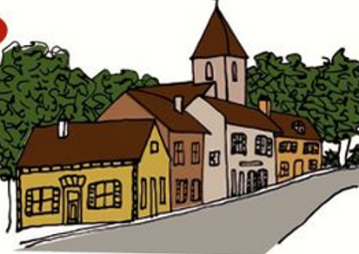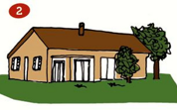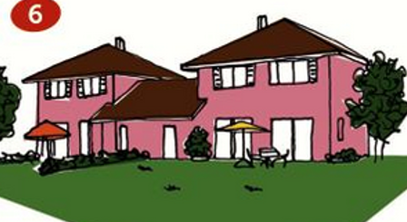
dans………………………… un ………………………… Une………………………………

12 Describe your look:
