Y8 FRENCH BOOKLET

1 Translate both letters
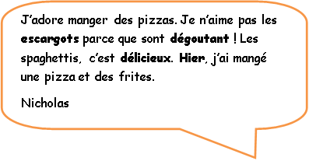
Je suis végétarien. J’aime manger les œufs et j’aime boire le lait. Hier, j’ai mangé un paquet de bonbons. J’adore les bonbons.
Sandrine.

……………………………………………………………………………………………………………………………………

……………………………………………………………………………………………………………………………………

……………………………………………………………………………………………………………………………………

……………………………………………………………………………………………………………………………………

……………………………………………………………………………………………………………………………………

……………………………………………………………………………………………………………………………………

……………………………………………………………………………………………………………………………………

…………………………………………………………………………………………………………………………………….

……………………………………………………………………………………………………………………………………

…………………………………………………………………………………………………………………………………..

…………………………………………………………………………………………………………………………………..

2 Answer the questions:

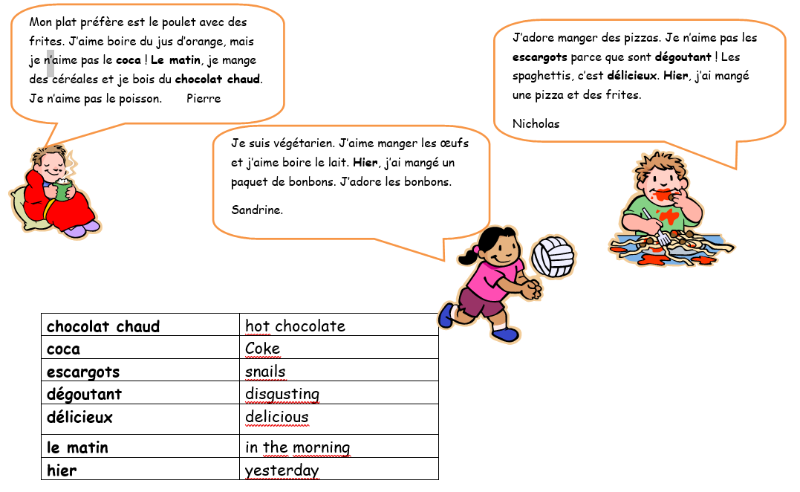

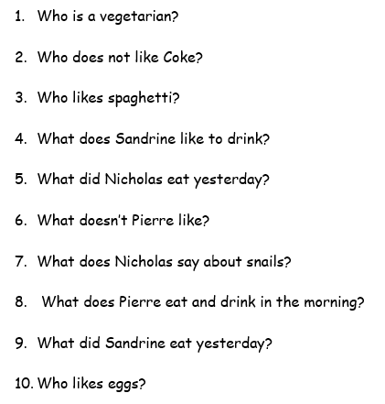

3
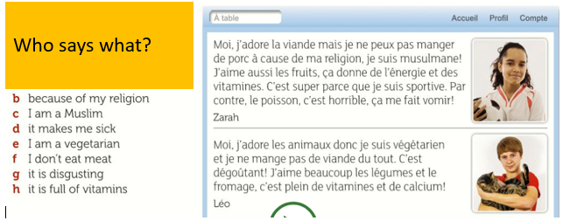

4 Who is it?

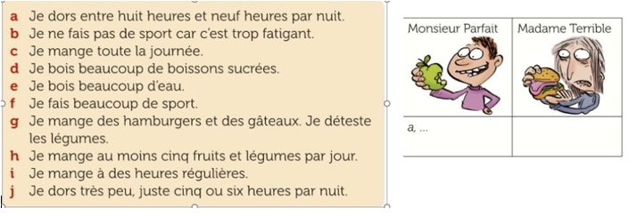

a………………………………………………… f…………………………………………………………

b……………………………………………….. g………………………………………………………..

c………………………………………………… h………………………………………………………..

d………………………………………………. i…………………………………………………………

e………………………………………………. j………………………………………………………

5 Translate a dialogue

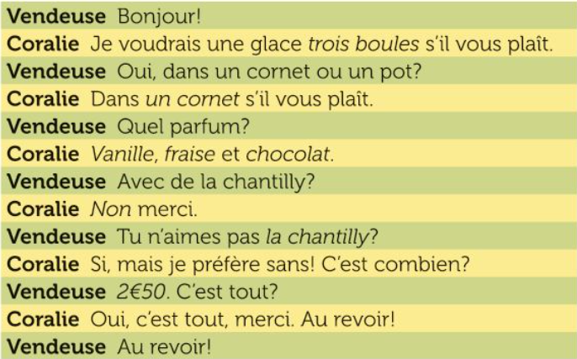

……………………………………………………………………………………………………………………………………

……………………………………………………………………………………………………………………………………

……………………………………………………………………………………………………………………………………

……………………………………………………………………………………………………………………………………

……………………………………………………………………………………………………………………………………

……………………………………………………………………………………………………………………………………

……………………………………………………………………………………………………………………………………

……………………………………………………………………………………………………………………………………

……………………………………………………………………………………………………………………………………

……………………………………………………………………………………………………………………………………

……………………………………………………………………………………………………………………………………

…………………………………………………………………………………………………………………………………..

6 True or false

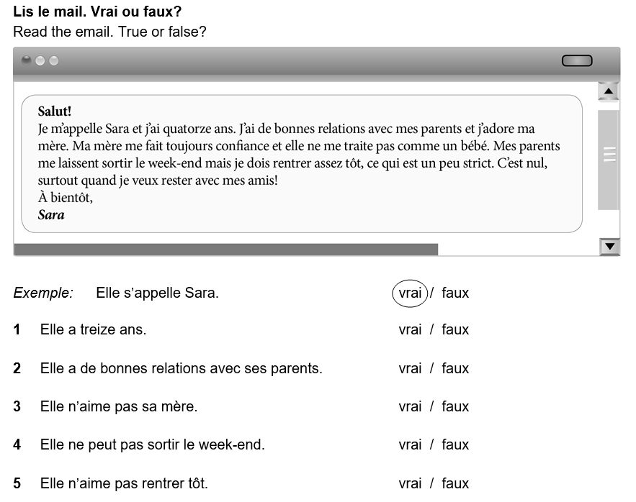
…………………………………………………………………………………………………………………………..
7
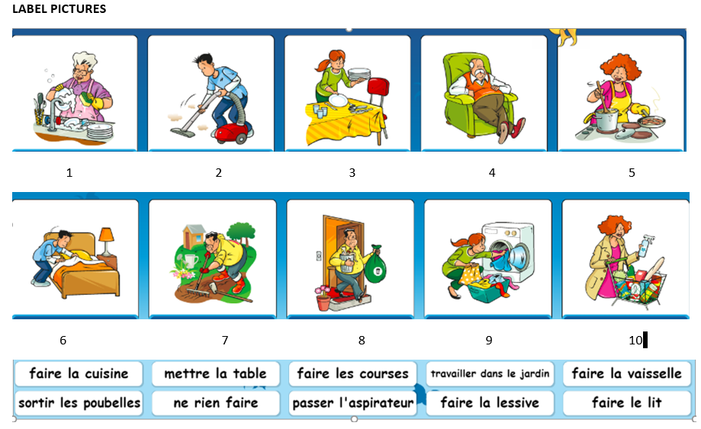

8
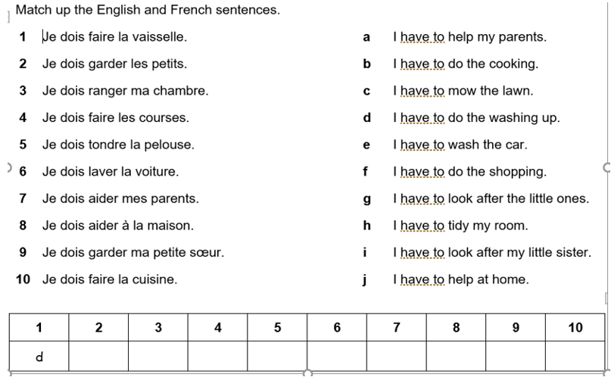
……………………………………………………………………………………………………………………………..

9 Who is it? Florian (F) or Lauren(L)

