Task 1:
Year 7- Cubism – Georges Braque
Complete the questions below, these all linked to the art movement Cubism. You will need a computer to research some of the questions.
1, Describe this painting in your own words:

What do you see? How do you think it was painted? What techniques?

Now use the internet to help answer these questions:
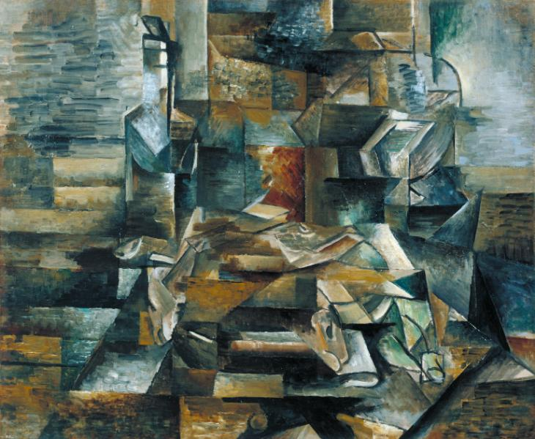

2, In what year was this painted and what is it’s name?

___________________________________________

3, Can you name 3 other painting by the artist, Georges Braque?
1.

2.

3.
4, Georges Braque is an amazing Cubist painter. Research and write down 6 facts you can find about Braque and his art works.
1,
2,
3,
4,
5,
6,

5, What is your personal opinion about Georges Braque’s art work?

Task 2:
Research Task-
Either on powerpoint, a word document or by hand complete a research task about the art movement Cubism.

Within your research you should include the following:

- Written information about Cubism. This must be done in your own words.
- You must name 2 artists that were part of the Cubism movement and explain why.
- You must also collect and add 4-5 images of Cubistic work. – include its name, who painted it and when.
- You must include your own personal opinion on the Cubism movement.

You can present this however you want! Colourful, exciting, creative! It is up to you!

Task 3: If you have access to pencil and paper only.
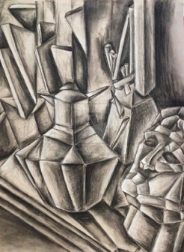
Looking at a piece of Cubism work, recreate the work as a drawing! Try and use tone, shade, detail and proportion!

Make sure you label your piece with the name of the artist and the name of the piece of work!
The art department are excited to see it and mark it!

