Task 1:
Year 8- Impressionism – Claude Monet
Complete the questions below, these all linked to the art movement Impressionism. You will need a computer to research some of the questions.
1, Describe this painting in your own words:

What do you see? How do you think it was painted? What techniques?

Now use the internet to help answer these questions:

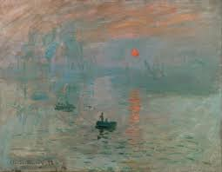

2, In what year was this painted and what is it’s name?

___________________________________________

3, Can you name 3 other painting by the artist, Claude Monet?
1.

2.

3.
4, Claude Monet is an amazing Impressionist painter. Research and write down 6 facts you can find about Monet and his art works.
1,
2,
3,
4,
5,
6,

5, What is your personal opinion about Claude Monet’ art work?

Task 2:
Research Task-
Either on powerpoint, a word document or by hand complete a research task about the art movement Impressionism.

Within your research you should include the following:

- Written information about Impressionism. This must be done in your own words.
- You must name 2 artists that were part of the Impressionist movement and explain why.
- You must also collect and add 4-5 images of impressionist work. – include its name, who painted it and when.
- You must include your own personal opinion on the Impressionist movement.

You can present this however you want! Colourful, exciting, creative! It is up to you!

Task 3: If you have access to pencil and paper only.
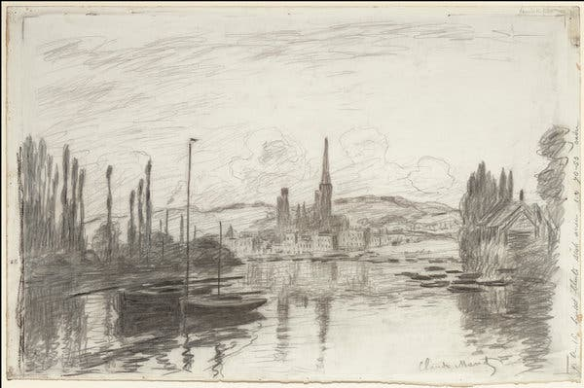
Looking at a piece of Impressionist work, recreate the work as a drawing! Try and use tone, shade, detail and proportion!

Make sure you label your piece with the name of the artist and the name of the piece of work!
The art department are excited to see it and mark it!

