Lesson Activities
Workbook 1
GCSE (9-1) Computer Science
Pearson Edexcel Level 1/Level 2 GCSE (9-1) in Computer Science (1CP1)

LESSON ACTIVITIES FOR SPRING/SUMMER TERM YEAR 9

Week 1

Lesson 1 activities

Activity 1.1.1
Open a bitmap image (such as a photograph) in a graphics software package. Resize the image so that the dimensions are doubled then save it again. Compare the file sizes of the two versions.
Version 1:
Version 2:

Compare the clarity of the two images. Which is clearer?

Why do you think this is the case?

How big can you make the image before it gets blurry?

What happens if you make the original image smaller?

Reload the original image and change its colour depth. Summarise what happens as the colour depth decreases.

Activity 1.1.2
Complete this table:
Colour Depth | Number of colours | Range
1 bit | 2 | 0 – 1

0 = black and 1 = white
Fill in the grid to reveal what character this code produces.
Binary code
0000
0111
0111
0001
0111
0111
0000
0 = black and 1 = white
Produce the binary code to produce the letter G in the grid below.
Binary code

Activity 1.1.3 (homework)
Using a colour depth of 2 bits, produce the binary code for a smiley face.
Search for bitmap image example online to get you started.

Binary code:
Colour:

Week 1

Lesson 2 activities

Activity 1.2.1
Create a new Python file with the following code in it:
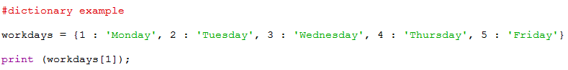

- Run the code. You should see ‘Monday’ displayed. This is because the print statement contains workdays[1] – where workdays is the name of the dictionary and 1 is a key within the dictionary. When you pass a dictionary a key it will return the associated data.

- Try replacing the 1 in workdays[1] with other numbers between 1 and 5. The correct day should be displayed.

- Try replacing the key with a key that doesn’t exist in the dictionary. What happens? Why?

- Try replacing the key with a piece of values (such as ‘Monday’) from the dictionary. What happens? Why?

Activity 1.2.2
Create another Python file with the following code in it:
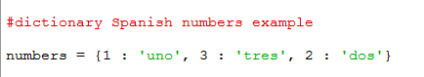

- You should be able to use the work you did in Activity 1.2.1 to display any Spanish number between 1 and 3 using the relevant key. Notice that the order of the data in the dictionary doesn’t cause any problems.

- Try putting:

print(list(numbers.keys()))

at the end of the code and run. What does it do?

- Remove the line of code you added in 2). Now add:

for num, Spanish in numbers.items():
print(num, Spanish)

What does it do?

- Use https://docs.python.org/3/tutorial/datastructures.html#dictionaries to find out how to programmatically add that four is ‘cuatro’ in Spanish to the dictionary.

- Try deleting items from a dictionary and the other features in the Python documentation.

Activity 1.2.3
Write a program that allows the user to input a three-letter version of the day (e.g. Mon), look this up in a dictionary and then display the full word (e.g. Monday).

Activity 1.2.4 (homework)
Ask students to research some use-cases of dictionaries.

Week 2

Lesson 1 activities

Activity 2.1.1
Use the Bitmap Activity spreadsheet and worksheet to create bitmap images (your teacher will give you the URL link to this).

Activity 2.1.2
- Calculate the file size of an image with dimensions of 3 inches x 4 inches, a pixel density of 300 pixels per inch and a colour depth of 8 bits.
Give your answer in bytes.
Hint: The formula for calculating the file size of a bitmap image is (height x pixel density) x (depth x pixel density) x colour depth and there are 8 bits in a byte.

- Calculate the file size of an image with dimensions of 5 inches x 7 inches, a pixel density of 400 pixels per inch and a colour depth of 3 bits.
Give your answer in bytes.

Activity 2.1.3
Units of measurement
Use a calculator to calculate the number of bytes
Units of measurement | Number of bytes
1 kilobyte (KB) = 1024 bytes
1 megabyte (MB) = 1024 kilobytes
1 gigabyte (GB) = 1024 megabytes
1 terabyte(TB) = 1024 gigabytes

Answer these questions (giving all answers to 2 decimal places):
Question | Answer
What are 92,400 MB in GB?
Ann has a 750 MB file and Nicky has a 550 MB file. Will both files fit on Ann’s 2 GB pen drive?
Jo has 250 500 KB images. How much space does she need on her hard drive to store them? Give your answer in megabytes.
Nicky has 30 hours of MP3 recordings stored in the cloud. How many gigabytes of storage would she need to download them onto her phone?
Hint: MP3 audio generates approximately 1 MB of data per minute.
Ann’s video camera produces video data at the rate of 2.5 GB per hour. How big will a 20 minute recording be? Give your answer in megabytes.

Question | Answer
How much storage space is required for 50 images, each with dimensions of 3 inches x 4 inches, a bit-map density of 300 pixels per inch and a colour depth of 8 bits?
Give your answer in megabytes to 1 decimal place.

Week 2

Lesson 2 activities
In the following activities you are going to design and implement a program that will:
- Display a menu offering the user the choice of converting from °C to °F or °F to °C
- Once a choice has been made a subroutine will run that will perform the relevant conversion

Activity 2.2.1
Find out how to convert from °C to °F and °F to °C.
Formula to convert from °C to °F:

Formula to convert from °F to °C:

Activity 2.2.2
Break the task down into manageable sections and decide on the order you will tackle these:

Activity 2.2.3
Find out what a stub is in relation to programming. How might stubs be useful for implementing this program?

Activity 2.2.4 (homework)
- Do some research to find out what top design is.
- Note the URL’s of the web pages that you have used.
- Summarise the content in in your own words and and be prepared to discuss in class.

Week 3

Lesson 2 activities

Activity 3.2.1
Programming challenge 2, part one: Maths quiz
Students should write a program that will ask the user five simple maths questions that consist of two random numbers either added or subtracted from each other.
The quiz will tell the use if each answer is correct or incorrect and give a total out of five at the end.
Requirements:
- The quiz will ask five questions.
- Each question will have two random numbers and will either be an addition question or a subtraction question.
- The random numbers should be between 0 and 10.
- One question should be displayed at a time.
- Once the user has entered an answer the quiz should state ‘correct’ or ‘incorrect’.
- A running total out of five should be displayed at the end.
Hints:
- The questions should be generated by a suitably named subroutine.
- The formatting onscreen should be easy to read. Assume the quiz is to be used by primary school students.
You need to:
- Plan the program using pseudocode.
- Implement the program.

Extensions:
- As soon as the program is run the user should be prompted to enter his/her name. Final grade output should make use of the user’s name.
- Extend the types of question that the quiz asks.

Week 4

Lesson 1 activities

Activity 4.1.1
Draw an analogue sound wave and label:
- amplitude
- time
- analogue signal
- sampling period.
Describe the process of converting analogue sound waves into digital data.

Activity 4.1.2 (Homework)
Representation of sound and other analogue data
Answer these questions:
Question | Answer
What is the difference between analogue and digital data?
What is meant by the term ‘sampling rate’?
What did Nyquist have to say about sampling rate?
What is the sampling rate for CD audio?
Give your answer in kHz.
In the context of digital sound, what is meant by the term ‘bit depth’?
How many bits per sample are used for CD audio?
What about DVD audio?
Is a high frequency sound high- or low-pitched?
What is the highest frequency the human ear can detect?
Why do most sound recordings have two channels?
Calculate the file size of a CD quality, stereo sound track that is 2.5 minutes long.
Give your answer in megabytes to 1 decimal place.
Calculate the bit depth of a 10.3 MB, 3-minute, stereo sound track, with a sampling rate of 30kHz.
An analogue-to-digital converter samples the temperature of a furnace every two hours. Each sample is stored as a 32-bit number. How many bytes of data are stored in a week?

Week 4

Lesson 2 activities

Activity 4.2.1
Programming challenge 2, part two:
Maths quiz scenario and requirements
Students should write a program that will ask the user five simple maths questions that consist of two random numbers either added or subtracted from each other.
The quiz will tell the use if each answer is correct or incorrect and give a total out of five at the end.
Requirements:
- The quiz will ask five questions.
- Each question will have two random numbers and will either be an addition question or a subtraction question.
- The random numbers should be between 0 and 10.
- One question should be displayed at a time.
- Once the user has entered an answer the quiz should state ‘correct’ or ‘incorrect’.
- A running total out of five should be displayed at the end.

Test No. | Purpose of the test | Test data | Expected result

Week 5

Lesson 1 activities

Activity 5.1.1
Use the function to identify the hardware component.
Function | Hardware component
A temporary storage area for data and program instructions while a program is running
A microprocessor that carries out the instructions in computer programs by performing arithmetic and logic operations, and controls inputs and outputs
A persistent data storage area for data and program instructions
To provide connections to the input and output peripherals such as printers, mouse, keyboard, touch screen, speakers, networks, and so on

Activity 5.1.2
This diagram represents the way in which buses connect the main hardware components in a digital computer. Copy and complete the diagram using these labels:
- CPU

- Memory
- Input/output devices
- Data, control and address bus

Activity 5.1.3
From the function given, identify and insert the name of the correct bus.
Function | Type of bus
Sends and receives signals that control the CPU and other parts of the computer system
Carries the address of memory locations used to store data and program instructions
Transfers the binary data around the computer

Activity 5.1.4
Label the following on the picture of the Raspberry Pi®:
- SD card (memory)
- CPU processor and RAM memory
- Ethernet network connection
- Two USB connectors (mouse and keyboard)
- HDMI connector for monitor
- Audio
- Power supply

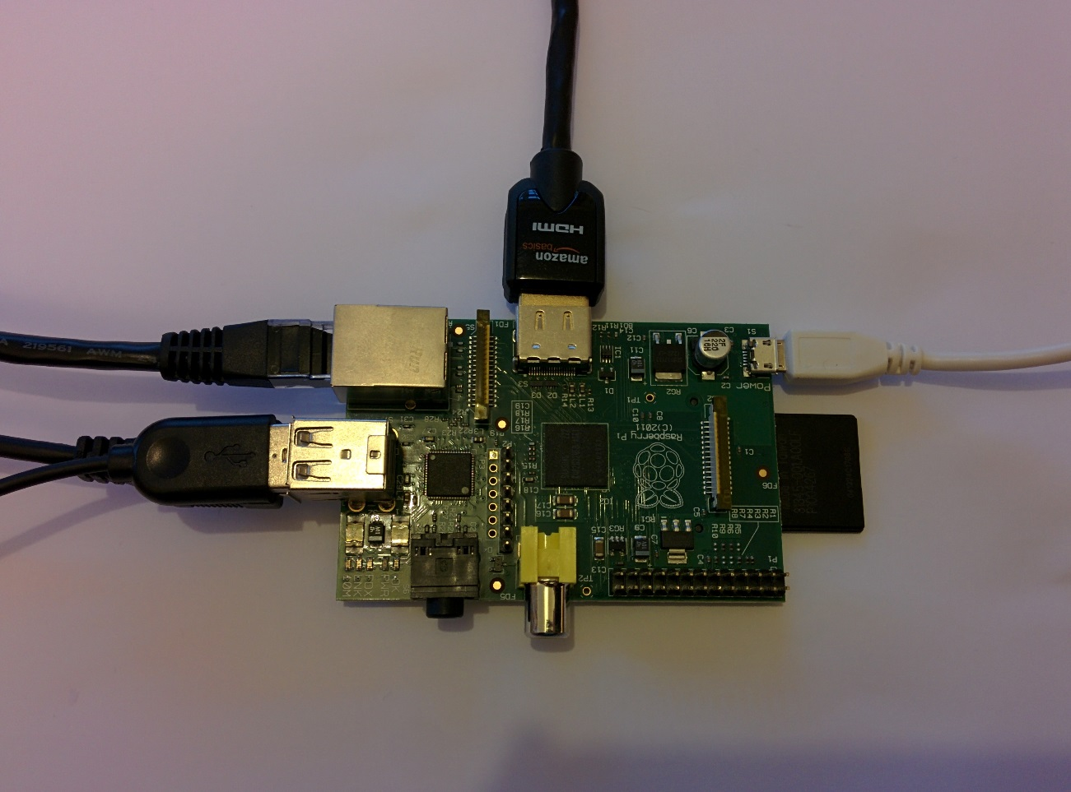

Activity 5.1.5 (homework)
Search for an image that shows the components that make up a different type of digital computer (e.g. a tablet computer or a smart phone). Label the main components that make up that computer including CPU (processor), memory, power supply, secondary storage, input and output devices. Compare your labelled image with someone else in your class who chose a different digital computer. What are the similarities and differences?

Week 5

Lesson 2 activities

Activity 5.2.1 (homework)
Work through the task at the URL at the end of this activity. It will guide you through a problem solving task and the point is to problem solve rather than just watch. Make a blog and note down what you are thinking (e.g. about the problem, what might happen next etc.) whenever you are asked to pause and think.
https://www.khanacademy.org/math/math-for-fun-and-glory/puzzles/brain-teasers/v/finding-heavier-ball.

Week 6

Lesson 1 activities

Activity 6.1.1
The speed of a computer system is measured in frequency (cycles per second) using the unit hertz (Hz). One hertz is one cycle per second. This means that one instruction is executed per second.
For many years computers were measured in megahertz (MHz).
1 megahertz = 1,000, 000 hertz or 1,000 instructions per second.
Modern computers are so fast they are measured in gigahertz (GHz).
1 gigahertz = 1,000,000,000 hertz or 1,000,000,000 instructions per second.
Find the speed of the processor in the computer systems you use and calculate how many instructions they can process each second.

Type of computer | Clock speed | Instructions per second

Activity 6.1.2
Your teacher will run this activity. The instructions are here for information only.
Resources:
- A class of pupils
- A room such as a hall or an open space
- On/off card
Explain that the class is going to act out the role of transistors in a CPU. When they are on they stand up (show ON) and when they are off they sit down (show OFF). (This works best if they are on the floor not on seats).
The students should stand apart from each other (stretch arms out so they cannot touch each other). Show the ON and OFF cards slowly to start with and then speed up. Ask how warm the class is feeling (they should be getting warmer just like a CPU).
Then explain that more and more transistors are being placed closer together to make computers faster and able to perform more calculations.
Get the class to stand closer to each other. Then repeat the process, getting faster and faster. Ask how warm the class is feeling now.
This demonstrates how CPUs generate heat from the switching of thousands of transistors.

Activity 6.1.3 (homework)
Watch all of the Royal Institution lecture ‘Breaking the speed limit’ https://www.youtube.com/watch?v=FTpdAjre8LU) and then answer these questions:
- What is a semi-conductor?
- What is a transistor?
- Why are ‘bunny suits’ used when manufacturing microprocessors?
- What is meant by ‘parallel processing’?

Week 6

Lesson 2

Activity 6.2.1

Using a flowchart, pseudocode or both, create an algorithm for calculating the mean. You should assume that the numbers will be stored within the program in a list.

Check the logic of your algorithm with a friend, and update if necessary.

Now implement the algorithm in Python and test the results.

Activity 6.2.2

Create a flowchart showing how a linear search works.

Activity 6.2.2 (continued)
Now write the pseudocode for a linear search. You should assume that the numbers will be stored within the program in a list.
Your teacher will now show you a pseudocode algorithm. How is this different to our own?
Update your algorithm if necessary, then implement it in Python and test.

Activity 6.2.3 (homework)
Find out about other types of searches and fill in the table. The number of rows in the table is not relevant; add more if you need to.

Search | Advantages | Disadvantages

Week 7

Lesson 1 activities

Activity 7.1.1
The main memory (or RAM) is made up of memory locations. Each memory location has a unique address assigned to it. Data and instructions are stored in memory when programs and applications run.
Place the following data and instructions into the memory location at the correct address:
- At address 0011, store the ASCII binary for ‘c’.
- At address 0100, store the ASCII binary for ‘a’.
- At address 0101, store the ASCII binary for ‘t’.
- At address 1001, store the binary value for 4.
- At address 1100, store the binary value for 65.
- At address 1110, store the binary value for 201.
- Store the first three letters of your name starting at address 0000.

Address | Memory location | Address | Memory location
1111 |  | 0111
1110 |  | 0110
1101 |  | 0101
1100 |  | 0100
1011 |  | 0011
1010 |  | 0010
1001 |  | 0001
1000 |  | 0000

Activity 7.1.2
Calculating the maximum capacity of main memory
- A processor with a 4 bit address bus can create 2⁴ (or 16) addressable memory locations.
- A processor with an 8 bit address bus can create 2⁸ (or 256) addressable memory locations.
Calculate the maximum number of addressable memory locations for address buses of the following sizes.

Size of address bus | Maximum number of addressable memory locations
4 bit | 16
8 bit | 256
16 bit
32 bit
64 bit

Activity 7.1.3
This activity gives you an opportunity to find out how much memory there is in the computers you use.
Either check the system settings or search online for the technical specifications of your computers, and complete the table below. Add more rows if you need to.

Type of computer | Main memory

Activity 7.1.4
Sort the stages of a memory read into the correct order:
- Processor sets the read line on the control bus.
- Contents of the memory location are conveyed along the data bus into the processor.
- Processor places the address of the required memory location on the address bus.

Step 1
Step 2
Step 3

Sort the stages of a memory write into the correct order:
- Processor places the data to be written to memory on the data bus.
- Processor places the address of the required memory location on the address bus.
- The data is conveyed along the data bus to the memory location.
- Processor sets the write line on the control bus.

Step 1
Step 2
Step 3
Step 4

Activity 7.1.5 (homework)
Search online for companies that sell memory (such as http://uk.crucial.com/gbr/en) Find three facts about memory that you can share with the class.

Fact 1
Fact 2
Fact 3

Week 7

Lesson 2 activities

Activity 7.2.1
Enter the data below into a spreadsheet then create a CSV file.
Dan | 8
Lily | 8
James | 7
Stephanie | 10
Chris | 9
Peter | 6
Mary | 4
Jessica | 9

Activity 7.2.2
Research why CSV files are used:

Activity 7.2.3
Type in the following code; change the path and filename as required.

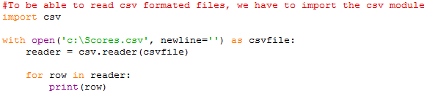

Week 8

Lesson 1 activities

Activity 8.1.1
Use the labels below to complete the diagram.
- Memory
- Arithmetic and logic unit (ALU)
- Control unit
- Registers
PROCESSOR

Control bus
Address bus
Data bus

Draw lines to match the parts of the processor with the correct function.
Accumulator register |  | Sends out signals to other parts of the computer system and fetches, decodes and executes instructions.
Control unit |  | Carries out arithmetic and logic operations.
Registers |  | Individual storage locations that hold an instruction, data or address of a memory location.
Arithmetic and logic unit (ALU) |  | Holds the instruction that is currently being executed by the processor.
Program counter register |  | Holds the accumulated total of results performed in the ALU.
Instruction register |  | Holds the address of the main memory location storing the next instruction.

Activity 8.1.2 (homework)
You have been learning about cache memory in this lesson. For homework, find out what browser cache does. Make notes below:

Week 8

Lesson 2 activities

Activity 8.2.1
Try the following code, look at the CSV file generated and explain how it works.

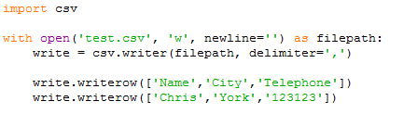

Activity 8.2.2
Try the following code, look at the CSV file generated and explain how it works.

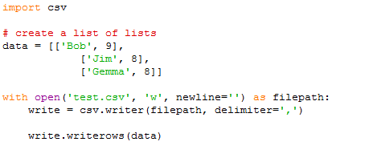

Activity 8.2.3
Key in the following code, try it out and examine the CSV file saved by the program.
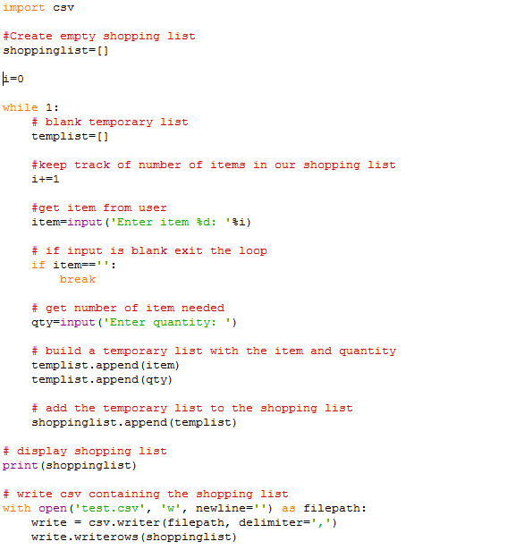

Week 9

Lesson 1 activities

Activity 9.1.1
Authentication
Answer these questions:
Question | Answer
What is authentication?

How do you create a strong password?

What should you avoid when creating a password?

Who should you give your password to?

Activity 9.1.2
Physical Access
Answer these questions:
Question | Answer
What is physical security?

Why is it important?

How can access to servers and network hardware be controlled?

How could you record details of who access hardware on certain times/dates?

Week 9

Lesson 2 activities

Activity 9.2.1
Answer these questions:
Question | Answer
What is a patent?

What should you do before you apply for a patent?

Does a patent mean the company is going to make the software/device?

What are the potential problems with patents?

How is the UK technology industry being threatened by overseas competitors?

What is a patent troll?

Activity 9.2.2
Answer these questions:
Question | Answer
What is ‘patent infringement’?

If someone infringes your patent what can you do about it?

What is a patent war?

How might a company acquire the patents of another company?

Activity 9.2.3 (homework)
Students should look for recent news articles regarding copyright/patents. At the time of writing, articles about why the Grooveshark/Piratebay website was taken down are interesting to students.

Week 10

Lesson 1 activities

Activity 10.1.1
Answer these questions:

- What is phishing?

- Create a flow chart showing how an email phishing attack might work. Start with the victim receiving a phishing email that looks like it is from their bank.

- Write a list of rules aimed your parents/grandparents explaining how to avoid a phishing attack.

Activity 10.1.2
Research shoulder surfing.

- What is it?

- How can shoulder surfing be defeated?

Activity 10.1.3 (homework)
Ask your parents/carers – do they know what phishing is? Have they ever received a phishing email? How did they know it wasn’t really from the supposed sender?

Students should record their answers and bring to class.

Week 10

Lesson 2 activities

Activity 10.2.1
Ask students to write a balanced argument explaining the advantages/disadvantages of proprietary and open-source software.

Activity 10.2.2 (homework)
Download and install Libreoffice/Openoffice and familiarise yourself with this software.
Answer these questions:

- Would you use Libreoffice/Openoffice instead of MS Office? Give reasons.

- Why is MS Office still so widely used when free alternatives exist?

Week 11

Lesson 1 activities

Activity 11.1.1
Ask students to create a poster or presentation suitable for Key Stage 3. It should explain what a cyberattack is and include USB devices, digital devices and eavesdropping.

Activity 11.1.2 (homework)
Look for a news article on a recent cyberattack. Make notes and be ready to discuss in a future class.

Week 11

Lesson 2 activities

Activity 11.2.1 (homework)
Research and create a poster that explains how the merge sort works and compare the merge sort algorithm with the bubble sort algorithm.

Week 12

Lesson 1 activities

Activity 12.1.1
What are your top five tips for keeping code secure?
Number | Secure code tip
1
2
3
4
5

Activity 12.1.2
Answer these questions:
Question | Answer
What is a code review?

What is a peer code review?

What is an automated code review?

Why might some companies not regularly use code reviews?

Activit7 12.1.3 (homework)
Peer review a classmate’s code and make notes on whether it fits with the top five secure code tips that you wrote this lesson.

Week 12

Lesson 2 activities

Activity 12.2.1 (homework)
Ask pupils to write an extended answer to the question: ‘A binary search (divide and conquer) is always more efficient than a linear search (brute force). Discuss.’
Answers should include definitions of what is meant by the terms
- ‘efficient’
- ‘brute force’
- ‘divide and conquer’
and
- a description of how each algorithm works
- an explanation of why a binary search is usually more efficient linear search algorithm and situations where this is not the case, that is when the list is unsorted list or when it is very short

Week 13

Lesson 1 activities

Activity 13.1.1

Students should research what actions can be taken to secure a network.
They should produce a list of top tips either aimed at home users or small businesses.

Activity 13.1.2 (homework)
Students should conduct a security audit of some of the devices used at home.
- Is up-to-date anti-virus installed?
- Are passwords used?
- Do regular backups take place?
- Is suitable encryption used on wireless networks?

Week 13

Lesson 2 activities

Activity 13.2.1 (homework)
Use the winsound module to play the audio Morse code message.

Week 14

Lesson 1 activities

Activity 14.1.1
Audit Trails
Use www.csrc.nist.gov/publications/nistbul/itl97-03.txt, www.networkworld.com/article/2193990/tech-primers/using-logs-for-forensics-after-a-data-breach.html and your own research to answer the following questions:

- What is an audit trail?

- Why might they be useful? (You should have at least two different scenarios as part of this answer.)

- What kind of details could be recorded? Add more rows if you need to.

- What are the potential problems with audit trails?

Activity 14.1.2
Protecting software from cyberattacks
Answer these questions:
Question | Answer
What is ‘ethical hacking’?

What is ‘penetration testing’?

Why would a company pay for a ‘pen test’?

What activities might a pen tester use?

Activity 14.1.3 (homework)
Watch https://www.youtube.com/watch?v=-rXdWb-8_Xo. The video shows a phone being hacked live on-air and the hacker being able to spoof calls.

Week 14

Lesson 2 activities

Activity 14.2.1 (homework)
Look at the FizzBuzz solutions in other languages on the Rosetta code website http://rosettacode.org/wiki/Rosetta_Code.

Make notes on these questions:
- What do you think of other languages?
- Are there any you’d like to experiment with?

