Task 1
This should take 2 periods
Statement of aims
Component 3 – non-exam assessment
In this component you are being asked to:
- Create a media product, for example a magazine front cover, a DVD cover, a billboard, etc.
- You will also be asked to write a 250 word statement of aims.

You are all at different stages of your magazine front cover. Some of you have planned it out but not started on photoshop, some of you have started but have not finished and others have theirs complete. As you all have the planning stage complete you are all to write a statement of aims.

Statement of aims
You will be required to complete a brief outline of your aims for your magazine front cover. This will be assessed with the production and will enable you to explain the reasons why you have created/ started to create the magazine the way you have done.

Include in your answer:
What is your genre of magazine?
Who is your target audience? (3/4 sentences describing this)
What type of magazines inspired yours?
Why have you used that model/ image? How does it relate to your genre?
Why did you use the colours/font? What do they connote?
Describe the layout and how it relates to other magazines.

Task 2

Media Language
1. Explore how the GQ front cover uses the following elements of media language
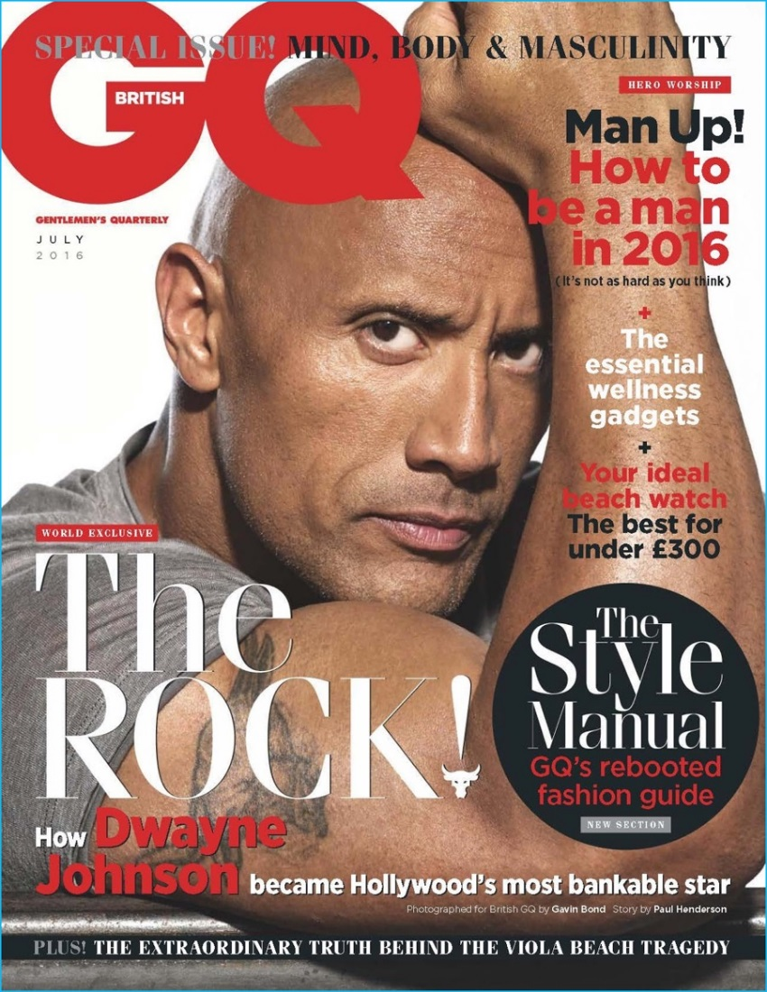
Media Language
Connotation/connotes Anchorage text Hegemonic stereotype
Denotation/denotes Masthead Metrosexual
Signifies, represents, symbolises Foreground/background Spornosexual
Mise-en-scene Serif/sans-serif typography Female Gaze
Camera shots/angles Direct address
Colour palette Ideology
Primary optical phase Patriarchal

What are the denotations?
____________________________________________________________________________________________________________________________________________________________________________________________________________________________________________________________________________________________________________________________________________________________________________________________________________________________________________________________________________________________________________
What are the connotations?
____________________________________________________________________________________________________________________________________________________________________________________________________________________________________________________________________________________________________________________________________________________________________________________________________________________________________________________________________________________________________________

Describe the camera shot and angle.
____________________________________________________________________________________________________________________________________________________________________________________________________________________________________________________________________________________________________________________________________________________________________________________________________________________________________________________________________________________________________________

What colours are used? Why?
____________________________________________________________________________________________________________________________________________________________________________________________________________________________________________________________________________________________________________________________________________________________________________________________________________________________________________________________________________________________________________

How does the text anchor the image?
____________________________________________________________________________________________________________________________________________________________________________________________________________________________________________________________________________________________________________________________________________________________________________________________________________________________________________________________________________________________________________

Describe the font and explain why they have used this font.
____________________________________________________________________________________________________________________________________________________________________________________________________________________________________________________________________________________________________________________________________________________________________________________________________________________________________________________________________________________________________________

Explain how this magazine uses direct address.
____________________________________________________________________________________________________________________________________________________________________________________________________________________________________________________________________________________________________________________________________________________________________________________________________________________________________________________________________________________________________________

Task 3

