Exploring Aboriginal Art!
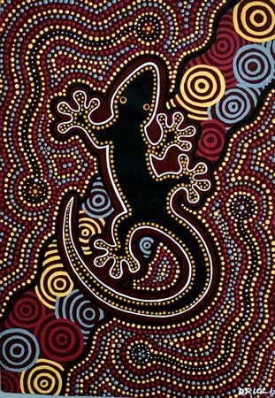
Aboriginal art is traditional art that was created in Australia by the first people to inhabit Australia.

Task 1:

Create a research document all about aboriginal art. You must include detailed information on aboriginal art and why is was created. You must also include research into symbols that the aboriginal use and what they mean. You must include images of aboriginal art.

Task 2:

Create and produce a piece of aboriginal art! It is up to you how you create this and what you design! Enjoy!

