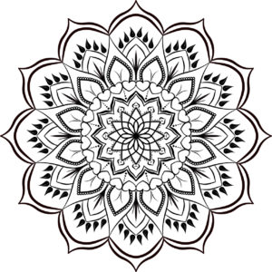
Mandala Art

Mandalas are circular designs symbolizing
the notion that life is never ending

Task 1:

Create a research document all about Mandala art. You must include detailed information on Mandala art and why is was created. You must also include research into symbols that are used in Mandala and what they could mean. You must include images of Mandala art.

Task 2:

Create and produce a piece of Mandala art! You must use black ink and design! Have fun with it and create a interesting pattern!

