Step Up

[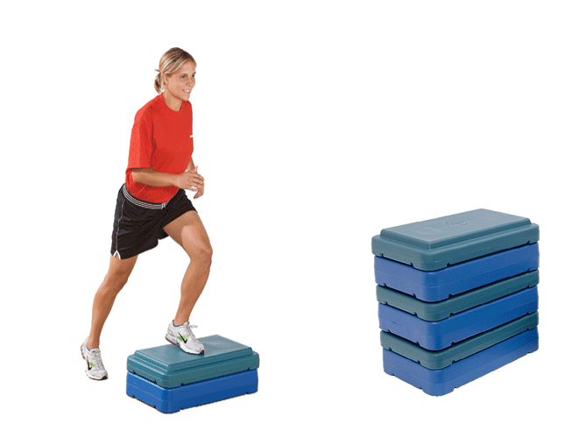](http://www.google.co.uk/url?sa=i&rct=j&q=&esrc=s&source=images&cd=&cad=rja&uact=8&ved=0CAcQjRxqFQoTCJ7VwP7jzsgCFcI7FAod23kPyw&url=http://www.performbetter.com/webapp/wcs/stores/servlet/Category4_10151_10751_2010009_-1_2009009_2009009_image_0&psig=AFQjCNF--Ew5IGx4O1Ov1bVz50eWeCnMuw&ust=1445352536178887)

1 minute = 10 calories

Challenge: 14 calories at high intensity

Press ups

[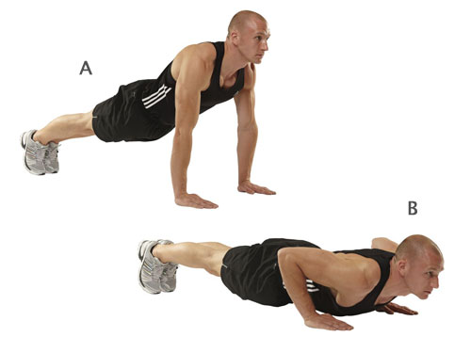](http://www.google.co.uk/url?sa=i&rct=j&q=&esrc=s&source=images&cd=&cad=rja&uact=8&ved=0CAcQjRxqFQoTCMLu-uDkzsgCFUJEFAodd5UDBA&url=http://www.menshealth.co.uk/building-muscle/bodyweight-exercises/3-press-up-variations&bvm=bv.105454873,d.cWw&psig=AFQjCNH17P8-iWCb-STQl_hzSFcoYqL5bQ&ust=1445352751809882)

30 reps = 10 calories

Challenge: 30 Decline press up = 15 calories

Speed bounce

[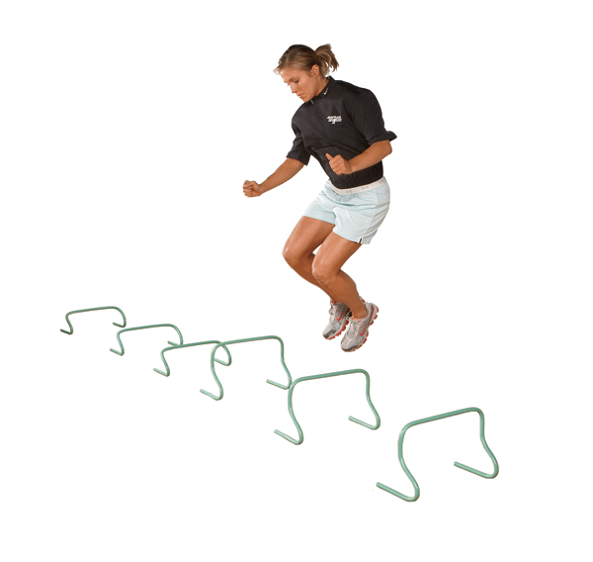](https://www.google.co.uk/url?sa=i&rct=j&q=&esrc=s&source=images&cd=&cad=rja&uact=8&ved=0CAcQjRxqFQoTCKmUtKrlzsgCFcNtFAodzHcCFQ&url=https://www.performbetter.com/webapp/wcs/stores/servlet/PBOnePieceView?storeId%3D10151%26catalogId%3D10751%26pagename%3D486&bvm=bv.105454873,d.cWw&psig=AFQjCNFADvpt6q42rVcG8HR36EW_LokTtw&ust=1445352892991419)

40 reps = 15 calories

Challenge: 40 tuck jump speed bounces = 20 calories

[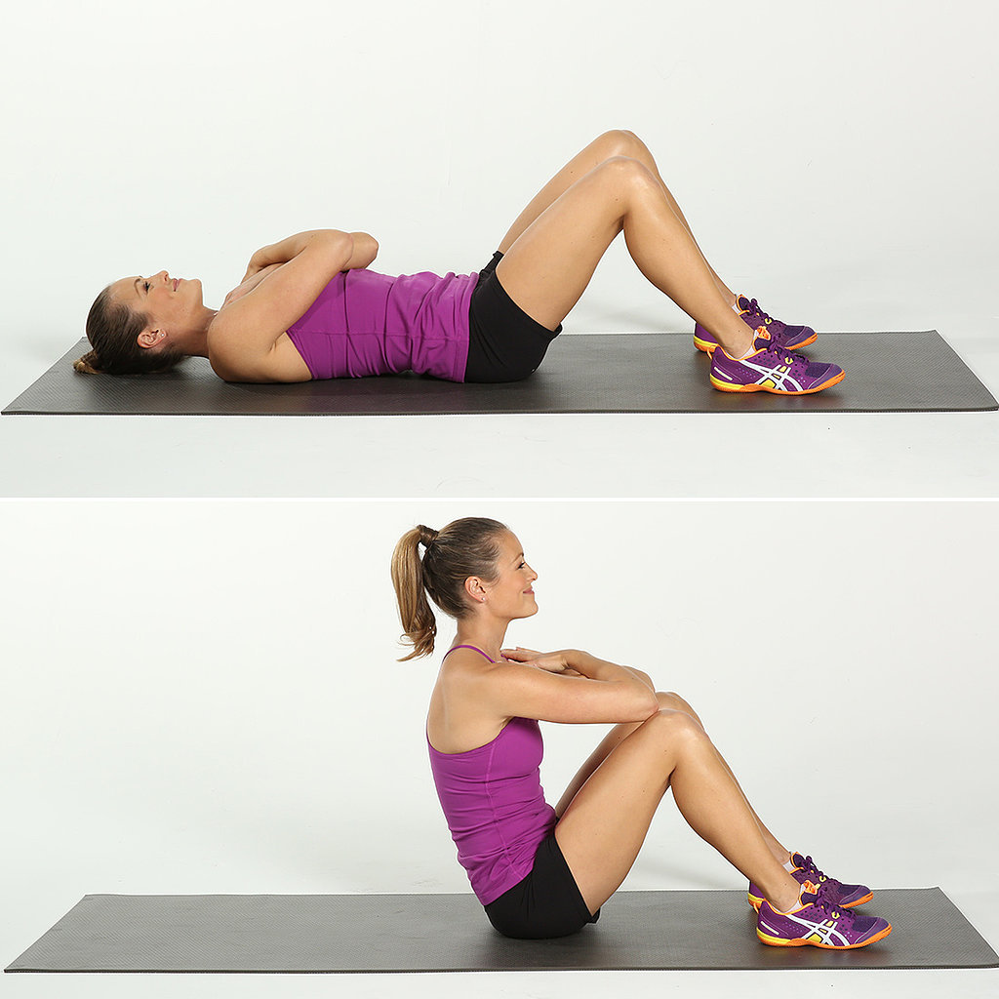](http://www.google.co.uk/url?sa=i&rct=j&q=&esrc=s&source=images&cd=&cad=rja&uact=8&ved=0CAcQjRxqFQoTCJCiz9flzsgCFYG_FAodJ8UPyA&url=http://www.popsugar.com/fitness/photo-gallery/34376556/image/34377573/Core-Full-Sit-Ups&bvm=bv.105454873,d.cWw&psig=AFQjCNFZRVI8vb-VDer1pzx4o7_1DQ9fQQ&ust=1445353005290451)Sit ups

30 reps = 10 calories

Challenge: 30 crunches = 15 calories

Squats

[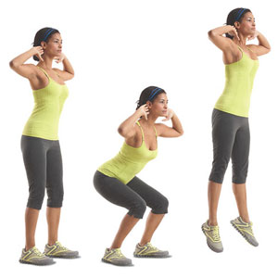](http://www.google.co.uk/url?sa=i&rct=j&q=&esrc=s&source=images&cd=&cad=rja&uact=8&ved=0CAcQjRxqFQoTCMjL4J7mzsgCFUy-FAodXcQLvw&url=http://www.womenshealthmag.com/fitness/squat-jump&bvm=bv.105454873,d.cWw&psig=AFQjCNGIvVGs5LijpHi2-YJxQ2VrgQGqrg&ust=1445353140352128)

40 reps = 15 calories

Challenge: 40 squat jumps = 20 calories

Mountain climbers

[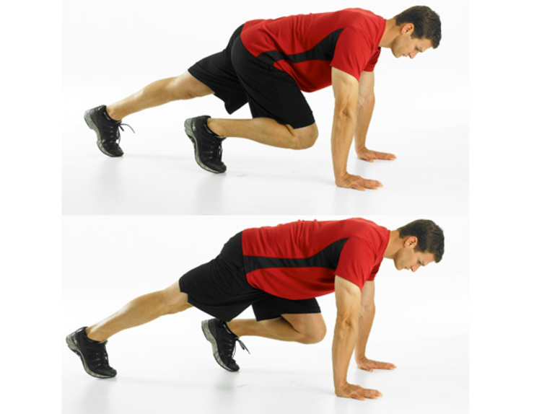](http://www.google.co.uk/url?sa=i&rct=j&q=&esrc=s&source=images&cd=&cad=rja&uact=8&ved=0CAcQjRxqFQoTCN3B-efmzsgCFQG8FAod2ioCYw&url=http://www.menshealth.com/fitness/10-flat-belly-exercises&bvm=bv.105454873,d.cWw&psig=AFQjCNE5zsWA6YxU81FZHTC6tMtJMHbh0g&ust=1445353225236050)

1 minute = 10 calories

Challenge: 14 calories at high intensity

Tyre flips

[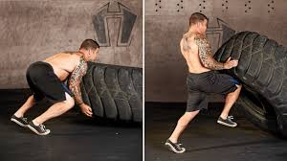](https://www.google.co.uk/imgres?imgurl=https%3A%2F%2Fcdn-maf0.heartyhosting.com%2Fsites%2Fmuscleandfitness.com%2Ffiles%2Fstyles%2Ffull_node_image_1090x614%2Fpublic%2Fmedia%2Ftire-flip.jpg%3Fitok%3DvDN-W5ti%26timestamp%3D1430366278&imgrefurl=https%3A%2F%2Fwww.muscleandfitness.com%2Fworkouts%2Ffull-body-exercises%2Ftire-flip-cardio-workout&docid=MpaBA8zHKrFU4M&tbnid=0ZzrEEhxrLTfSM%3A&vet=10ahUKEwinjp-h59XZAhWEIsAKHXRSDeoQMwihAShQMFA..i&w=1092&h=614&safe=strict&bih=739&biw=1607&q=tyre%20flipping&ved=0ahUKEwinjp-h59XZAhWEIsAKHXRSDeoQMwihAShQMFA&iact=mrc&uact=8)

20 reps = 15 calories

Challenge: Jump in between tyre between reps: 20 reps = 20 calories.

Kettlebell swings

[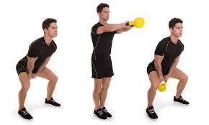](https://www.google.co.uk/imgres?imgurl=https%3A%2F%2Fstatic1.squarespace.com%2Fstatic%2F550834a0e4b02aa6c3780c07%2F55748b87e4b055e0375db9c0%2F57e2e3e1d1758e79ed7aef72%2F1474503198769%2FCopy%2Bof%2BKB%2BShoulder%2BSwing%2BStep.jpg%3Fformat%3D1500w&imgrefurl=http%3A%2F%2Fwww.tfwdupage.com%2Ftfw-dupage-blog%2F2016%2F9%2F21%2Fthe-two-handed-kettlebell-swing-should-it-be-retired&docid=AK9LYquS0eAwvM&tbnid=78flM6nZQhPgPM%3A&vet=10ahUKEwj2ur6G6NXZAhUCQMAKHYxeA_kQMwj0ASgXMBc..i&w=1500&h=900&safe=strict&bih=739&biw=1607&q=kettlebell%20swing&ved=0ahUKEwj2ur6G6NXZAhUCQMAKHYxeA_kQMwj0ASgXMBc&iact=mrc&uact=8)

40 reps = 10 calories

Challenge: Add burpee between reps. 40 reps = 20 calories.

Box jumps

[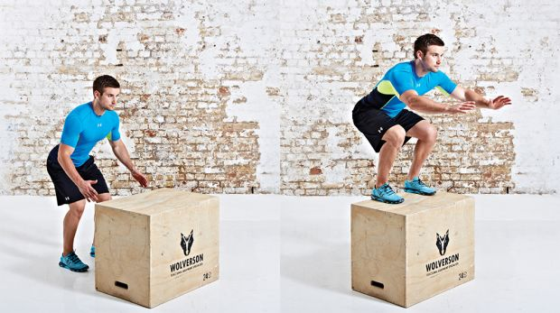](http://www.google.co.uk/url?sa=i&rct=j&q=&esrc=s&source=imgres&cd=&cad=rja&uact=8&ved=2ahUKEwjlorbQ6NXZAhVHB8AKHePKAwEQjRx6BAgAEAY&url=http%3A%2F%2Fwww.coachmag.co.uk%2Fleg-exercises%2F6458%2Fhow-to-do-box-jumps&psig=AOvVaw08A-QOmO7EFYS6doa-cSHx&ust=1520361109565237)

30 reps = 15 calories

Challenge: Add burpees. 30 reps = 25 calories.

**Churchmead Calorie Challenge**

|  |  |  |
| --- | --- | --- |
| Name: | | |
| Exercise | Reps / time | Calories |
| Press ups |  |  |
| Step ups |  |  |
| Speed bounce |  |  |
| Sit ups |  |  |
| Mountain climbers |  |  |
| Tyre flips |  |  |
| Kettlebell swings |  |  |
| Box jumps |  |  |
| Squats |  |  |