Core PE Tasks
https://www.youtube.com/watch?v=aHVR2FnTpdk

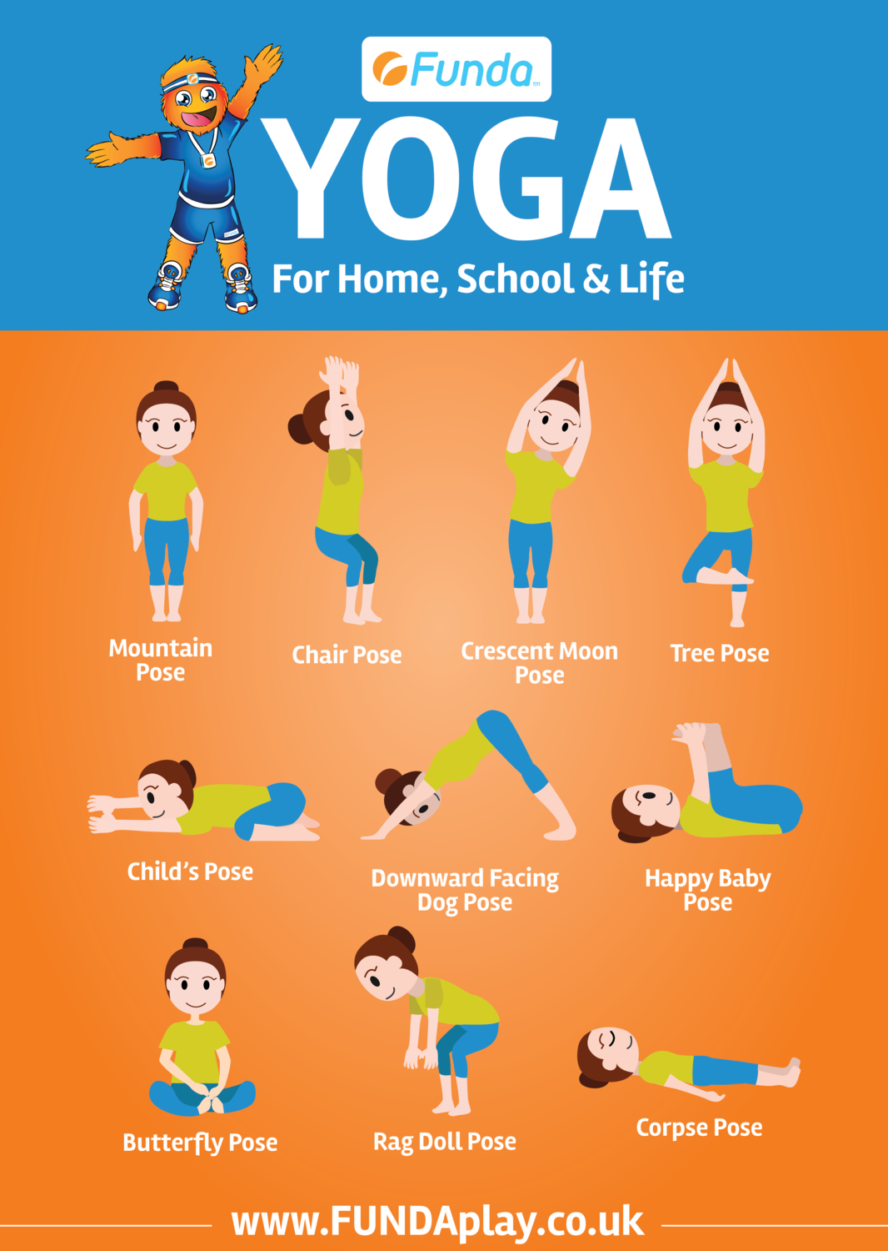

Olympic Hot Spot Challenge
You can also play a structured game like "Olympic Hot Spot Challenge." Clear out some space and create "hot spot" stations with different activities for fun and variety. The idea is to get the children moving from one station to the next every 30-45 seconds. Here are some station ideas:
- Push-ups (against the wall, on their knees, or full push-ups).
- Sit-ups.
- Jump rope.
- Step-ups (either with a "step" or up and down the stairs).
- Circle jumps (small rings or hula hoops or tape marks).
- Jumping jacks.
- Squats.
- Balance on one leg.
- Ball toss (with a partner).
To make it more challenging, you can:
- Increase time at each hot spot: so 30, 45, 60 seconds.
- Increase number of times you do the complete hot spot circuit, so 2, 3, 4 or 5 times.
- Mix-up the hot spots or doing them in a different order.
- Creating new hot spot activities of your own.
- Adding new hot spot props like soup can weights.

