Brutal Attack on Pensioner
A lonely pensioner was brutally beaten up by a mugger, just yards from her own front door. All she had on her was £7.00.

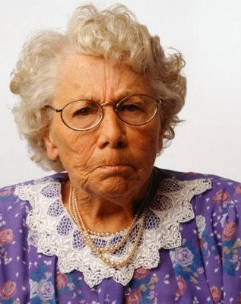
Mary Evans, 86, is now too scared to go out alone. She is angry that she no longer feels safe!
I was just walking home from my weekly lunch at the local Day Centre,” says widow Mary Evans, 86, of South Court, Devenish.
It wasn’t even dark, only 3pm on a July afternoon. And this isn’t a big city. Are we safe anywhere these days?
Not safe in our own streets!
D.C. Matthew Johns of Green Lane Police Station, Wilborough said, “This is a really nasty attack on a defenceless old lady. It’s not even as though she had anything on her worth stealing.”
So, now we can’t even feel safe in our own street. When are the government going to wake up and realise they’ve got to do something about it? After all, we’re the ones who put them there. Shouldn’t they earn their keep by looking after us and making sure that old ladies don’t have to live in fear?
Random Street Crime IS Rising
A national survey conducted by the Police Federation, reveals that we really are less safe on the streets than we were ten years ago.
The attack on Mrs Mary Evans, brought the issue of street muggings back to the public’s attention. The publication of this report will simply confirm what many ordinary people have felt for some time: that police efforts to control street crime have failed.
“It is now a matter of urgency that the government should recognise that it is its responsibility to tackle this issue. It cannot be right that the elderly should have to take their lives in their hands every time they step beyond their own front doors,” said Help The Aged’s spokesperson Helen Smith.
“We claim to be a civilised country, yet it seems that our streets are not as safe as we should like to think. Perhaps it is time to reassess the priorities of the police force and target the unglamorous side of community policing: drugs seizures are undoubtedly important, but so is the day to day safety of vulnerable members of the community.”

